16 March, 2023

**PRESS RELEASE**

###### JOB VACANCIES: 4th QUARTER 2022

**Job Vacancy Rate 1,9%**

The number of job vacancies in the 4th quarter of 2022 reached 7.821. The number of job vacancies decreased by 1.822 (-18,9%) compared to the same quarter of the previous year where the number was 9.643. Compared to the 3rd quarter of 2022 the number of job vacancies decreased by 1.353 (-14,7%). (Table 1)

The job vacancy rate in the 4th quarter of 2022 was 1,9%, while the job vacancy rate in the previous quarter and the 4th quarter of 2021 was 2,2% and 2,4% respectively. The largest job vacancy rates in the 4th quarter of 2022 were observed in the Sectors of Accommodation and Food Service Activities (3,0%), Water Supply, Sewerage, Waste Management and Remediation Activities (2,9%) and were followed by the Sectors of Financial and Insurance Activities, Administrative and Support Service Activities and Education with the same rate (2,5%). (Table 2)

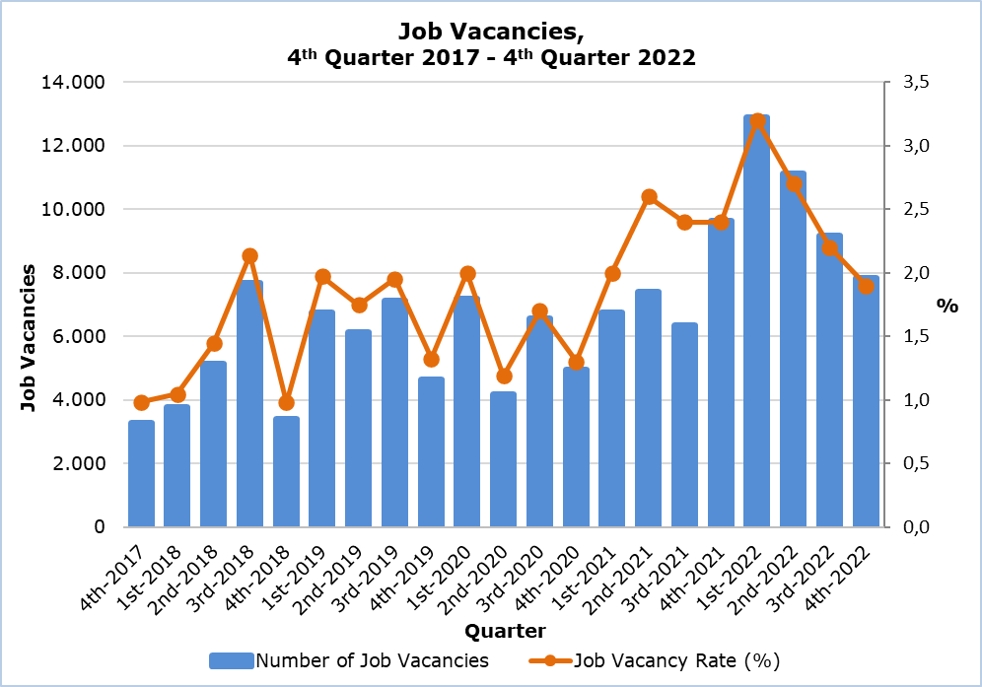

|  |  |  |  |  |  |  |  |
| --- | --- | --- | --- | --- | --- | --- | --- |
| **Table 1** | | | | | | | |
| **Nace Rev.2** | **Economic Activity** | **Number of Job Vacancies** | | |  | **% Change** | |
| **Q4**  **2021** | **Q3 2022** | **Q4 2022** |  | **Q4 2022/ Q3 2022** | **Q4 2022/2021** |
| B | Mining and Quarrying | 3 | 3 | 10 |  | 233,3 | 233,3 |
| C | Manufacturing | 1.071 | 586 | 471 |  | -19,6 | -56,0 |
| D | Electricity, Gas, Steam and Air Conditioning Supply | 0 | 4 | 32 |  | 700,0 | n.a. |
| E | Water Supply, Sewerage, Waste Management and Remediation Activities | 34 | 114 | 93 |  | -18,4 | 173,5 |
| F | Construction | 374 | 337 | 353 |  | 4,7 | -5,6 |
| G | Wholesale and Retail Trade, Repair of Motor Vehicles and Motorcycles | 2.277 | 1.393 | 1.158 |  | -16,9 | -49,1 |
| H | Transportation and Storage | 251 | 801 | 340 |  | -57,6 | 35,5 |
| I | Accommodation and Food Service Activities | 1.541 | 2.446 | 1.415 |  | -42,2 | -8,2 |
| J | Information and Communication | 585 | 394 | 234 |  | -40,6 | -60,0 |
| K | Financial and Insurance Activities | 324 | 413 | 515 |  | 24,7 | 59,0 |
| L | Real Estate Activities | 22 | 45 | 8 |  | -82,2 | -63,6 |
| M | Professional, Scientific and Technical Activities | 857 | 823 | 736 |  | -10,6 | -14,1 |
| N | Administrative and Support Service Activities | 369 | 303 | 408 |  | 34,7 | 10,6 |
| O | Public Administration and Defense, Compulsory Social Security | 671 | 452 | 727 |  | 60,8 | 8,3 |
| P | Education | 653 | 476 | 849 |  | 78,4 | 30,0 |
| Q | Human Health and Social Work Activities | 434 | 340 | 304 |  | -10,6 | -30,0 |
| R | Arts, Entertainment and Recreation | 101 | 63 | 80 |  | 27,0 | -20,8 |
| S | Other Service Activities | 76 | 181 | 88 |  | -51,4 | 15,8 |
|  | **Total** | **9.643** | **9.174** | **7.821** |  | **-14,7** | **-18,9** |

n.a.: Not applicable

|  |  |  |  |  |
| --- | --- | --- | --- | --- |
| **Table 2** | | | | |
| **Nace Rev.2** | **Economic Activity** | **Job Vacancy Rate**  **(%)** | | |
| **Q4 2021** | **Q3 2022** | **Q4 2022** |
| B | Mining and Quarrying | 0,7 | 0,6 | 1,9 |
| C | Manufacturing | 3,0 | 1,6 | 1,3 |
| D | Electricity, Gas, Steam and Air Conditioning Supply | 0,0 | 0,3 | 2,0 |
| E | Water Supply, Sewerage, Waste Management and Remediation Activities | 1,1 | 3,5 | 2,9 |
| F | Construction | 1,1 | 0,9 | 0,9 |
| G | Wholesale and Retail Trade, Repair of Motor Vehicles and Motorcycles | 3,1 | 1,9 | 1,6 |
| H | Transportation and Storage | 1,5 | 4,5 | 2,0 |
| I | Accommodation and Food Service Activities | 3,3 | 4,6 | 3,0 |
| J | Information and Communication | 4,2 | 2,7 | 1,6 |
| K | Financial and Insurance Activities | 1,5 | 2,0 | 2,5 |
| L | Real Estate Activities | 0,7 | 1,4 | 0,2 |
| M | Professional, Scientific and Technical Activities | 2,5 | 2,3 | 2,1 |
| N | Administrative and Support Service Activities | 2,8 | 1,9 | 2,5 |
| O | Public Administration and Defense, Compulsory Social Security | 2,1 | 1,5 | 2,3 |
| P | Education | 2,0 | 1,5 | 2,5 |
| Q | Human Health and Social Work Activities | 2,1 | 1,5 | 1,3 |
| R | Arts, Entertainment and Recreation | 1,5 | 0,9 | 1,1 |
| S | Other Service Activities | 0,7 | 1,6 | 0,8 |
|  | **Total** | **2,4** | **2,2** | **1,9** |

**METHODOLOGICAL INFORMATION**

**Definitions**

A **job vacancy** is a paid post that is newly created, unoccupied or about to become vacant, and for which the employer is taking active steps to find a suitable candidate from outside the enterprise concerned and intends to fill it either immediately or within a specific period of time.

The **job vacancy rate** is the number of job vacancies expressed as a percentage of the total number of occupied posts and job vacancies.

**Coverage**

The survey covers enterprises with 1 or more employees classified in all sectors of economic activities according to the Statistical Classification of Economic Activities NACE Rev. 2 of the European Union system, except Sectors A (Agriculture, Forestry and Fishing), T (Activities of Households as Employers; Undifferentiated Goods- and Services-Producing Activities of Households for own use) and U (Activities of Extraterritorial Organizations and Bodies).

**Collection of data**

The data collection is carried out by telephone interviews every quarter.

***For more information:***

CYSTAT Portal, subtheme [Labour Market](https://www.cystat.gov.cy/en/SubthemeStatistics?s=43)

[CYSTAT-DB](https://cystatdb.cystat.gov.cy/pxweb/en/8.CYSTAT-DB/8.CYSTAT-DB__Labour%20Market__) (Online Database)

[Predefined Tables](https://www.cystat.gov.cy/en/KeyFiguresList?s=43) (Excel)

[Methodological Information](https://www.cystat.gov.cy/en/MethodologicalDetails?m=2260)

**The data included in the Predefined Tables in Excel format are available up to 4th Quarter 2021. Data from the 1st Quarter 2022 onwards are available only in the CYSTAT-DB Online Database.**

*Contact*

Maria Kkoushi: Tel: +357-22602235, Email: [mkkoushi@cystat.mof.gov.cy](mailto:mkkoushi@cystat.mof.gov.cy)