17 March, 2025

**PRESS RELEASE**

###### JOB VACANCIES: 4th QUARTER 2024

**Job Vacancy Rate 2,8%**

The number of job vacancies in the 4th quarter of 2024 reached 12.997, recording an increase of 959 vacancies (8,0%) compared to the same quarter of the previous year where the number was 12.038. Compared to the 3rd quarter of 2024 the number of job vacancies decreased by 3.013 (-18,8%). (Table 1)

The job vacancy rate in the 4th quarter of 2024 and 2023 was 2,8%, while the job vacancy rate in the previous quarter was 3,5%. The largest job vacancy rates in the 4th quarter of 2024 were observed in the Sectors of Arts, Entertainment and Recreation (4,7%), Accommodation and Food Service Activities (4,6%) and Information and Communication (3,7%). (Table 2)

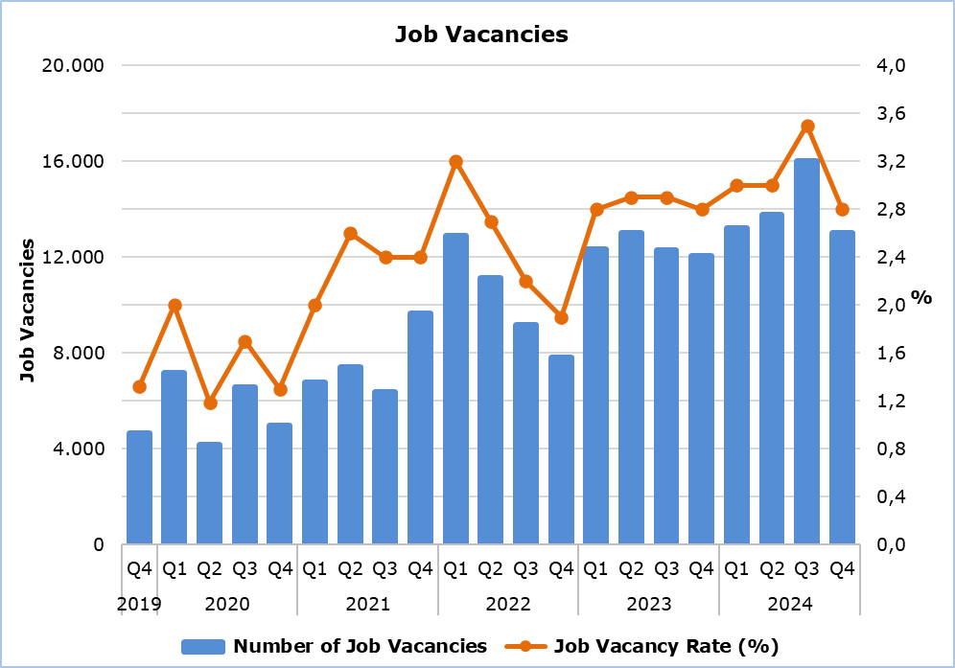

|  |  |  |  |  |  |  |  |
| --- | --- | --- | --- | --- | --- | --- | --- |
| **Table 1** | | | | | | | |
| **Nace Rev.2** | **Economic Activity** | **Number of Job Vacancies** | | |  | **% Change** | |
| **Q4**  **2023** | **Q3**  **2024** | **Q4**  **2024** |  | **Q4 2024/ Q3 2024** | **Q4 2024/2023** |
| B | Mining and Quarrying | 3 | 7 | 3 |  | -57,1 | 0,0 |
| C | Manufacturing | 624 | 1.470 | 1.026 |  | -30,2 | 64,4 |
| D | Electricity, Gas, Steam and Air Conditioning Supply | 4 | 151 | 2 |  | -98,7 | -50,0 |
| E | Water Supply, Sewerage, Waste Management and Remediation Activities | 90 | 71 | 89 |  | 25,4 | -1,1 |
| F | Construction | 980 | 1.315 | 920 |  | -30,0 | -6,1 |
| G | Wholesale and Retail Trade, Repair of Motor Vehicles and Motorcycles | 2.659 | 2.849 | 2.479 |  | -13,0 | -6,8 |
| H | Transportation and Storage | 511 | 767 | 360 |  | -53,1 | -29,5 |
| I | Accommodation and Food Service Activities | 1.469 | 3.793 | 2.431 |  | -35,9 | 65,5 |
| J | Information and Communication | 483 | 724 | 750 |  | 3,6 | 55,3 |
| K | Financial and Insurance Activities | 413 | 509 | 635 |  | 24,8 | 53,8 |
| L | Real Estate Activities | 43 | 84 | 110 |  | 31,0 | 155,8 |
| M | Professional, Scientific and Technical Activities | 1.122 | 1.160 | 1.315 |  | 13,4 | 17,2 |
| N | Administrative and Support Service Activities | 970 | 690 | 517 |  | -25,1 | -46,7 |
| O | Public Administration and Defense, Compulsory Social Security | 695 | 172 | 618 |  | 259,3 | -11,1 |
| P | Education | 894 | 637 | 196 |  | -69,2 | -78,1 |
| Q | Human Health and Social Work Activities | 531 | 753 | 880 |  | 16,9 | 65,7 |
| R | Arts, Entertainment and Recreation | 57 | 639 | 458 |  | -28,3 | 703,5 |
| S | Other Service Activities | 490 | 219 | 208 |  | -5,0 | -57,6 |
|  | **Total** | **12.038** | **16.010** | **12.997** |  | **-18,8** | **8,0** |

|  |  |  |  |  |
| --- | --- | --- | --- | --- |
| **Table 2** | | | | |
| **Nace Rev.2** | **Economic Activity** | **Job Vacancy Rate**  **(%)** | | |
| **Q4 2023** | **Q3 2024** | **Q4 2024** |
| B | Mining and Quarrying | 0,5 | 1,3 | 0,6 |
| C | Manufacturing | 1,7 | 3,8 | 2,7 |
| D | Electricity, Gas, Steam and Air Conditioning Supply | 0,2 | 8,3 | 0,1 |
| E | Water Supply, Sewerage, Waste Management and Remediation Activities | 2,5 | 2,0 | 2,5 |
| F | Construction | 2,5 | 3,2 | 2,3 |
| G | Wholesale and Retail Trade, Repair of Motor Vehicles and Motorcycles | 3,5 | 3,6 | 3,1 |
| H | Transportation and Storage | 2,8 | 3,8 | 1,9 |
| I | Accommodation and Food Service Activities | 3,0 | 6,4 | 4,6 |
| J | Information and Communication | 2,9 | 3,6 | 3,7 |
| K | Financial and Insurance Activities | 1,9 | 2,2 | 2,8 |
| L | Real Estate Activities | 1,2 | 2,1 | 2,7 |
| M | Professional, Scientific and Technical Activities | 3,0 | 2,9 | 3,3 |
| N | Administrative and Support Service Activities | 5,2 | 3,5 | 2,7 |
| O | Public Administration and Defense, Compulsory Social Security | 2,2 | 0,5 | 1,8 |
| P | Education | 2,4 | 2,0 | 0,5 |
| Q | Human Health and Social Work Activities | 2,3 | 3,0 | 3,5 |
| R | Arts, Entertainment and Recreation | 0,7 | 6,2 | 4,7 |
| S | Other Service Activities | 3,9 | 1,8 | 1,7 |
|  | **Total** | **2,8** | **3,5** | **2,8** |

**METHODOLOGICAL INFORMATION**

**Definitions**

A **job vacancy** is a paid post that is newly created, unoccupied or about to become vacant, and for which the employer is taking active steps to find a suitable candidate from outside the enterprise concerned and intends to fill it either immediately or within a specific period of time.

The **job vacancy rate** is the number of job vacancies expressed as a percentage of the total number of occupied posts and job vacancies.

**Coverage**

The survey covers enterprises with 1 or more employees classified in all sectors of economic activities according to the Statistical Classification of Economic Activities NACE Rev. 2 of the European Union system, except Sectors A (Agriculture, Forestry and Fishing), T (Activities of Households as Employers; Undifferentiated Goods- and Services-Producing Activities of Households for own use) and U (Activities of Extraterritorial Organizations and Bodies).

**Collection of Data**

The data collection is carried out by telephone interviews every quarter.

***For more information:***

CYSTAT Portal, subtheme [Labour Market](https://www.cystat.gov.cy/en/SubthemeStatistics?s=43)

[CYSTAT-DB](https://cystatdb.cystat.gov.cy/pxweb/en/8.CYSTAT-DB/8.CYSTAT-DB__Labour%20Market__) (Online Database)

[Predefined Tables](https://www.cystat.gov.cy/en/KeyFiguresList?s=43) (Excel)

[Methodological Information](https://www.cystat.gov.cy/en/MethodologicalDetails?m=2260)

**The data included in the Predefined Tables in Excel format are available up to 4th Quarter 2021. Data from the 1st Quarter 2022 onwards are available only in the CYSTAT-DB Online Database.**

*Contact*

Maria Kkoushi: Tel: +357-22602235, Email: [mkkoushi@cystat.mof.gov.cy](mailto:mkkoushi@cystat.mof.gov.cy)