16 March, 2026

PRESS RELEASE

JOB VACANCIES: 4th QUARTER 2025

Job Vacancy Rate 2,8%

The number of job vacancies in the 4th quarter of 2025 reached 13.538, recording an increase of 541 vacancies (4,2%) compared to the same quarter of the previous year where the number was 12.997. Compared to the 3rd quarter of 2025 the number of job vacancies decreased by 1.035 (-7,1%). (Table 1)
The job vacancy rate in the 4th quarter of 2025 was 2,8%, while the job vacancy rate in the previous quarter and the 4th quarter of 2024 was 3,0% and 2,8% respectively. The largest job vacancy rates in the 4th quarter of 2025 were observed in the Sectors of Administrative and Support Service Activities (3,9%), Wholesale and Retail Trade, Repair of Motor Vehicles and Motorcycles (3,8%) and Mining and Quarrying (3,6%). (Table 2)

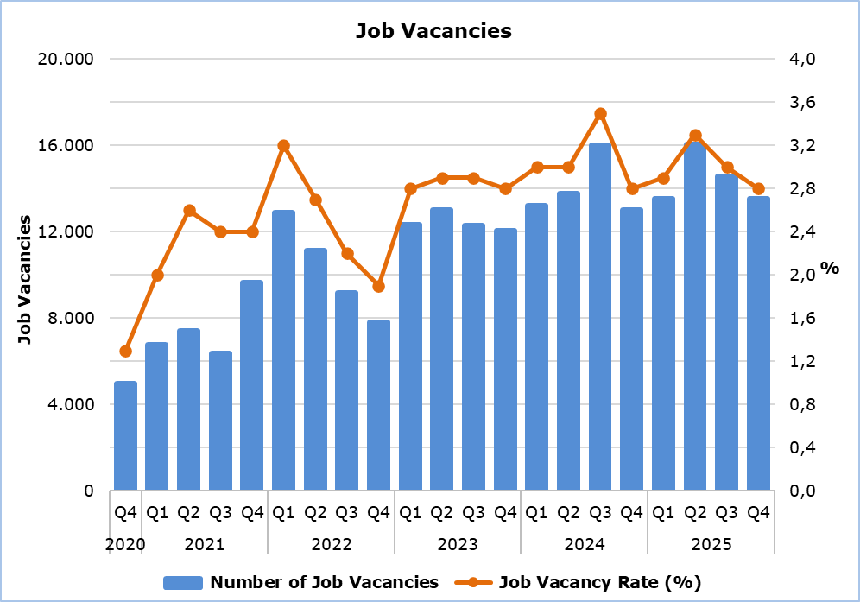

Table 1
Nace Rev.2 | Economic Activity | Number of Job Vacancies |  |  |  | % Change
Nace Rev.2 | Economic Activity | Q4  2024 | Q3  2025 | Q4  2025 |  | Q4 2025/ Q3 2025 | Q4 2025/2024
B | Mining and Quarrying | 3 | 37 | 22 |  | -40,5 | 633,3
C | Manufacturing | 1.026 | 1.146 | 946 |  | -17,5 | -7,8
D | Electricity, Gas, Steam and Air Conditioning Supply | 2 | 59 | 11 |  | -81,4 | 450,0
E | Water Supply, Sewerage, Waste Management and Remediation Activities | 89 | 155 | 82 |  | -47,1 | -7,9
F | Construction | 920 | 1.383 | 1.117 |  | -19,2 | 21,4
G | Wholesale and Retail Trade, Repair of Motor Vehicles and Motorcycles | 2.479 | 3.358 | 3.076 |  | -8,4 | 24,1
H | Transportation and Storage | 360 | 643 | 408 |  | -36,5 | 13,3
I | Accommodation and Food Service Activities | 2.431 | 2.519 | 1.825 |  | -27,6 | -24,9
J | Information and Communication | 750 | 816 | 818 |  | 0,2 | 9,1
K | Financial and Insurance Activities | 635 | 365 | 387 |  | 6,0 | -39,1
L | Real Estate Activities | 110 | 77 | 134 |  | 74,0 | 21,8
M | Professional, Scientific and Technical Activities | 1.315 | 1.080 | 1.371 |  | 26,9 | 4,3
N | Administrative and Support Service Activities | 517 | 779 | 870 |  | 11,7 | 68,3
O | Public Administration and Defense, Compulsory Social Security | 618 | 368 | 683 |  | 85,6 | 10,5
P | Education | 196 | 527 | 625 |  | 18,6 | 218,9
Q | Human Health and Social Work Activities | 880 | 513 | 609 |  | 18,7 | -30,8
R | Arts, Entertainment and Recreation | 458 | 405 | 341 |  | -15,8 | -25,5
S | Other Service Activities | 208 | 343 | 213 |  | -37,9 | 2,4
 | Total | 12.997 | 14.573 | 13.538 |  | -7,1 | 4,2

Table 2
Nace Rev.2 | Economic Activity | Job Vacancy Rate  (%)
Nace Rev.2 | Economic Activity | Q4 2024 | Q3 2025 | Q4 2025
B | Mining and Quarrying | 0,6 | 5,9 | 3,6
C | Manufacturing | 2,7 | 2,9 | 2,4
D | Electricity, Gas, Steam and Air Conditioning Supply | 0,1 | 3,2 | 0,6
E | Water Supply, Sewerage, Waste Management and Remediation Activities | 2,5 | 3,6 | 1,9
F | Construction | 2,3 | 3,2 | 2,6
G | Wholesale and Retail Trade, Repair of Motor Vehicles and Motorcycles | 3,1 | 4,1 | 3,8
H | Transportation and Storage | 1,9 | 2,8 | 1,8
I | Accommodation and Food Service Activities | 4,6 | 4,1 | 3,2
J | Information and Communication | 3,7 | 3,0 | 2,8
K | Financial and Insurance Activities | 2,8 | 1,5 | 1,6
L | Real Estate Activities | 2,7 | 1,7 | 3,0
M | Professional, Scientific and Technical Activities | 3,3 | 2,5 | 3,1
N | Administrative and Support Service Activities | 2,7 | 3,5 | 3,9
O | Public Administration and Defense, Compulsory Social Security | 1,8 | 1,1 | 2,0
P | Education | 0,5 | 1,6 | 1,7
Q | Human Health and Social Work Activities | 3,5 | 2,0 | 2,4
R | Arts, Entertainment and Recreation | 4,7 | 3,7 | 3,3
S | Other Service Activities | 1,7 | 2,7 | 1,7
 | Total | 2,8 | 3,0 | 2,8

METHODOLOGICAL INFORMATION

Definitions

A job vacancy is a paid post that is newly created, unoccupied or about to become vacant, and for which the employer is taking active steps to find a suitable candidate from outside the enterprise concerned and intends to fill it either immediately or within a specific period of time.

The job vacancy rate is the number of job vacancies expressed as a percentage of the total number of occupied posts and job vacancies.

Coverage

The survey covers enterprises with 1 or more employees classified in all sectors of economic activities according to the Statistical Classification of Economic Activities NACE Rev. 2 of the European Union system, except Sectors A (Agriculture, Forestry and Fishing), T (Activities of Households as Employers; Undifferentiated Goods- and Services-Producing Activities of Households for own use) and U (Activities of Extraterritorial Organizations and Bodies).

Collection of Data

The data collection is carried out by telephone interviews every quarter.

For more information:
CYSTAT Portal, subtheme Labour Market
CYSTAT-DB (Online Database)
Methodological Information

Contact
Maria Kkoushi: Tel.: +357-22602235, Email: mkkoushi@cystat.mof.gov.cy

