15 September, 2025

**PRESS RELEASE**

###### LABOUR COST INDEX: 2nd QUARTER 2025

**Annual Change 4,1%**

On the basis of provisional data, it is estimated that in the 2nd quarter of 2025 hourly labour costs (total cost) increased by 4,1%, compared with the same quarter of the previous year.

The two main components of labour costs, wages and salaries per hour worked and non-wage costs per hour worked increased by 4,2% and 4,1% respectively, compared with the same quarter of the previous year.

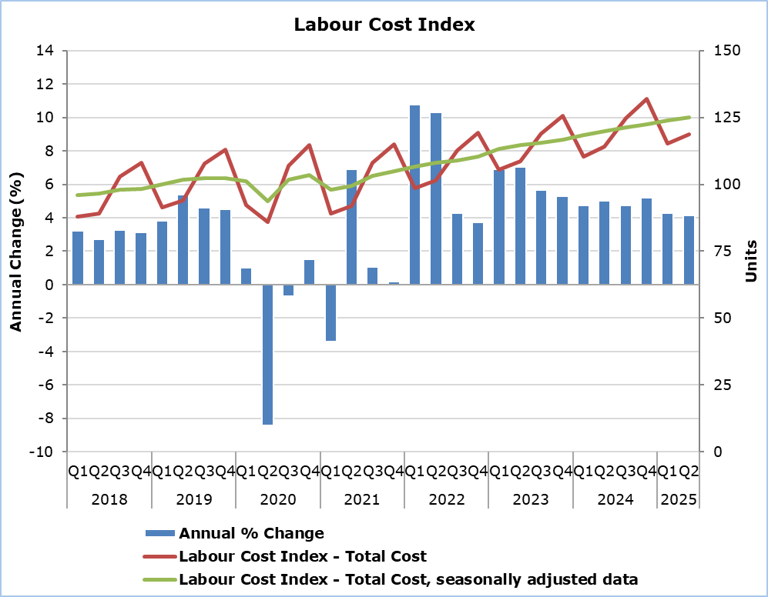

Note: From the 1st quarter of 2024 onwards, data are provisional.

The hourly labour cost (total cost), seasonally adjusted, increased by 1,0% compared to the previous quarter. The hourly labour cost that refers to wages and salaries, seasonally adjusted, also increased by 1.0% compared to the previous quarter, as did the hourly non-wage cost, seasonally adjusted.

|  |  |  |  |  |  |  |  |  |  |  |
| --- | --- | --- | --- | --- | --- | --- | --- | --- | --- | --- |
| **Table** |  | |  | |  | |  | |  | |
|  | | **Index (2020=100)** | | | |  | | **Percentage Change (%)** | | | |
| Unadjusted | | Seasonally adjusted | |  | | To the same quarter of the previous year | | To the previous quarter (seasonally adjusted Index) | |
| **Total Labour Cost** | | | |  | |  | |  | |  | |
| 2nd Quarter 2025 | | 118,73 | | 125,06 | |  | | 4,1 | | 1,0 | |
| 1st Quarter 2025 | | 115,20 | | 123,82 | |  | | 4,3 | | 1,0 | |
| 2nd Quarter 2024 | | 114,01 | | 119,95 | |  | | 5,0 | | 1,3 | |
|  | |  | |  | |  | |  | |  | |
| **Wages and Salaries** | | | |  | |  | |  | |  | |
| 2nd Quarter 2025 | | 119,02 | | 124,85 | |  | | 4,2 | | 1,0 | |
| 1st Quarter 2025 | | 115,45 | | 123,63 | |  | | 4,3 | | 1,0 | |
| 2nd Quarter 2024 | | 114,28 | | 119,77 | |  | | 4,6 | | 1,2 | |
|  | |  | |  | |  | |  | |  | |
| **Non-wage cost** | | | |  | |  | |  | |  | |
| 2nd Quarter 2025 | | 117,50 | | 125,94 | |  | | 4,1 | | 1,0 | |
| 1st Quarter 2025 | | 114,19 | | 124,63 | |  | | 4,3 | | 1,2 | |
| 2nd Quarter 2024 | | 112,87 | | 120,72 | |  | | 6,6 | | 1,4 | |

Note: Due to rounding reasons, the calculation of the change may differ from the percentage change presented in the table.

**METHODOLOGICAL INFORMATION**

**Index Identity**

The Labour Cost Index is one of the principal European economic indicators produced by all the countries of the European Union on the basis of the Commission Regulation (EC) No 1216/2003 implementing Regulation (EC) No 430/2003 of the European Parliament and of the Council concerning the Labour Cost Index. The indicator is used as an indication of the inflationary pressure that may result from developments in the labour market.

**Data Coverage**

The Index covers all economic activities except Section A: Agriculture, forestry and fishing, Section T: Activities of households as employers and Section U: Activities of extraterritorial organisations and bodies.

All employees recorded at the Social Insurance Services’ Records are covered. Excluded are those employees who report a gross salary that is less than 50% of the minimum salary as determined in the decree issued by the Ministry of Labour, Welfare and Social Insurance. Excluded also, are salaries in excess of €20,000 per month.

**Definitions**

The Labour Cost Index captures changes in the hourly labour costs borne by enterprises for employing labour.

The Labour Cost Index is compiled as a 'chain-linked Laspeyres cost-index' using a common index reference period (2020 = 100). The Index is presented both in non-seasonally adjusted and in seasonally adjusted form.

Besides the total labour cost, two additional indices are presented, breaking down each component of total labour cost:

(a) 'Wages and Salaries', that refer to gross wages and salaries, and

(b) 'Non-wage cost', that refers to employers' social contributions and taxes net of subsidies connected to employment.

Administrative sources and other available data are used to compile the Index. Specifically:

1. data from the Social Insurance Services

2. data from the Treasury of the Republic of Cyprus

3. hours worked as published by the Statistical Service (National Accounts data)

4. the latest available results of the Labour Cost Survey.

In addition to changes in «wages and salaries» and the «non-wage costs», the Labour Cost Index (total cost) reflects also the changes in hours worked. Please note that, weights (total labour costs) are used to calculate the change, which refer to the previous year.

**Base Year**

Data with base year 2020 are available quarterly from the first quarter of 2000.

Data with base year 2016 are available quarterly from the first quarter of 2000 to the fourth quarter of 2022.

**Data Revision**

The data are revised when new data used to calculate the index are available (labour cost, hours worked, assumptions).

Seasonally adjusted data may differ in each publication as when new observations are added, the parameters of the model change. The model is revised on an annual basis.

***For more information:***

CYSTAT Portal, subtheme [Labour Cost and Earnings](https://www.cystat.gov.cy/en/SubthemeStatistics?id=42)

[CYSTAT-DB](https://cystatdb.cystat.gov.cy/pxweb/en/8.CYSTAT-DB/8.CYSTAT-DB__Labour%20Cost%20and%20Earnings__) (Online Database)

[Methodological Information](https://www.cystat.gov.cy/en/MethodologicalDetails?m=2226)

*Contact*

Phani Lagou: Tel: +35722602115, Email: [plagou@cystat.mof.gov.cy](mailto:plagou@cystat.mof.gov.cy)