26 February, 2026

PRESS RELEASE

LABOUR FORCE SURVEY (LFS): 4th QUARTER 2025

Unemployment 4,0%

According to the results of the Labour Force Survey, the labour force in the 4th quarter of 2025 amounted to 531.062 persons or 65,2% of the population (males 70,3%, females 60,4%) in comparison to 518.053 persons (64,3%) in the corresponding quarter of 2024 (Table 1).

The number of employed persons was 509.773 and the employment rate 62,6% (males 67,6%, females 57,9%) in comparison to 494.600 persons (61,4%) in the corresponding quarter of 2024.

The number of unemployed persons amounted to 21.289 and the unemployment rate to 4,0% of the labour force (males 3,8%, females 4,2%) in comparison to 23.454 persons (4,5%) in the corresponding quarter of 2024.

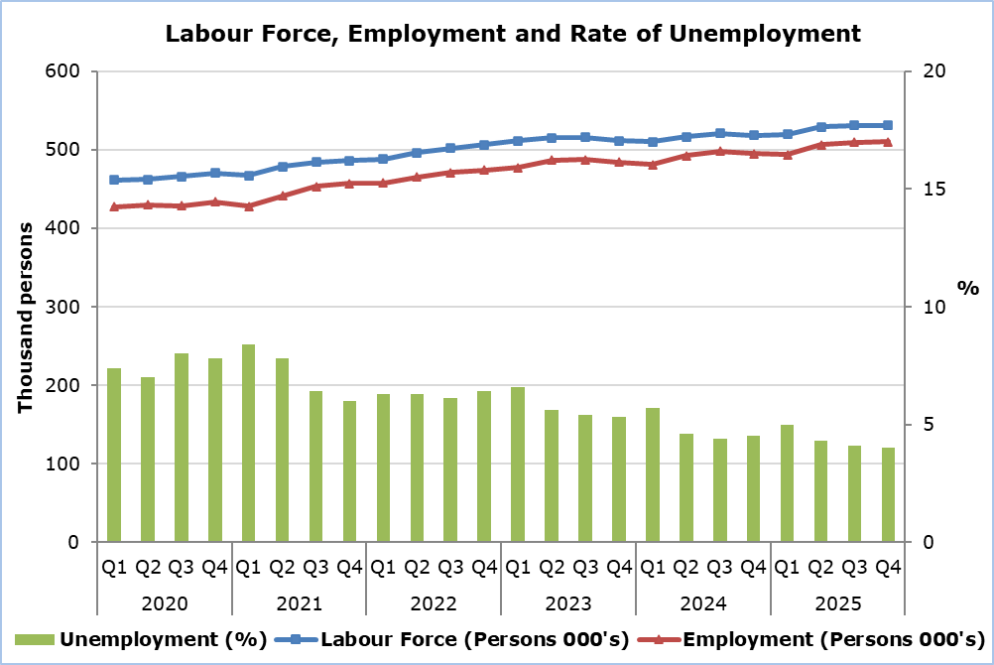

Employment (Table 2)

For the age group 20-64, the employment rate was 81,7%. The rate for males was 86,2% and for females 77,4%. In the corresponding quarter of 2024, the rate was 80,2% (males 86,2%, females 74,5%). For the age group 55-64 the employment rate was 71,7% in comparison to 69,9% in the corresponding quarter of 2024.

According to the distribution of employment by sector, the biggest percentage of employed persons was in Services (81,3%), followed by Manufacturing (16,5%) and Agriculture (2,2%). For the 4th quarter of 2024, the corresponding percentages were: Services 81,2%, Manufacturing 16,5% and Agriculture 2,3%.

The share of part-time employment to total employment was 8,6% or 43.703 persons (males 6,9%, females 10,4%). The corresponding rate for the 4th quarter of 2024 was 8,8% (males 6,4%, females 11,6%).

90,2% or 460.003 of the total employed persons were employees, of which 14,8% (68.244 persons) had a temporary job. In the corresponding quarter of 2024 employees accounted for 90,4% of total employment of which 13,6% had a temporary job.

Unemployment (Table 3)

For young persons aged 15-24 years old, the unemployment rate was 14,7% of the labour force of the same age group (males 14,8%, females 14,7%) in comparison to 9,6% (males 9,2%, females 10,2%) in the corresponding quarter of last year.

As far as the duration of unemployment is concerned, 66,6% of the total unemployed persons searched for a job for a period of less than 6 months, 15,1% for a period of 6-11 months, whereas a percentage of 18,3% were long-term unemployed. The corresponding rates for the 4th quarter of 2024 were 57,9%, 16,7% and 25,4%.

Table 1
 | Number |  | Percentage (%)
 | Q4 2025 | Q4 2024 | Q4 2025 | Q4 2024
Labour Force
Total | 531.062 | 518.053 | 65,2 | 64,3
Males | 278.455 | 274.567 | 70,3 | 70,0
Females | 252.606 | 243.487 | 60,4 | 58,9
Employment
Total | 509.773 | 494.600 | 62,6 | 61,4
Males | 267.899 | 262.962 | 67,6 | 67,1
Females | 241.874 | 231.638 | 57,9 | 56,0
Unemployment
Total | 21.289 | 23.454 | 4,0 | 4,5
Males | 10.557 | 11.605 | 3,8 | 4,2
Females | 10.732 | 11.849 | 4,2 | 4,9

Table 2
Employment | Number |  |  |  |  |  | Percentage (%)
Employment | Q4 2025 |  |  | Q4 2024 |  |  | Q4 2025 |  |  | Q4 2024
 | Total | M | F | Total | M | F | Total | M | F | Total | M | F
Age
15+ | 509.773 | 267.899 | 241.874 | 494.600 | 262.962 | 231.638 | 62,6 | 67,6 | 57,9 | 61,4 | 67,1 | 56,0
20–64 | 486.030 | 251.224 | 234.806 | 472.199 | 247.481 | 224.718 | 81,7 | 86,2 | 77,4 | 80,2 | 86,2 | 74,5
55–64 | 86.035 | 45.984 | 40.051 | 82.030 | 45.691 | 36.339 | 71,7 | 81,0 | 63,4 | 69,9 | 80,9 | 59,7
Sector
Agriculture | 11.308 | 8.676 | 2.632 | 11.165 | 8.965 | 2.200 | 2,2 | 3,3 | 1,1 | 2,3 | 3,4 | 0,9
Industry | 83.975 | 69.220 | 14.755 | 81.728 | 67.420 | 14.308 | 16,5 | 25,8 | 6,1 | 16,5 | 25,6 | 6,2
Services | 414.490 | 190.003 | 224.487 | 401.706 | 186.577 | 215.129 | 81,3 | 70,9 | 92,8 | 81,2 | 71,0 | 92,9
Full-time | 466.070 | 249.463 | 216.607 | 450.956 | 246.124 | 204.831 | 91,4 | 93,1 | 89,6 | 91,2 | 93,6 | 88,4
Part-time | 43.703 | 18.436 | 25.267 | 43.644 | 16.838 | 26.806 | 8,6 | 6,9 | 10,4 | 8,8 | 6,4 | 11,6
Prof. Status
Self-employed | 49.770 | 29.700 | 20.070 | 47.373 | 29.422 | 17.951 | 9,8 | 11,1 | 8,3 | 9,6 | 11,2 | 7,7
Employees
Total | 460.003 | 238.199 | 221.804 | 447.227 | 233.540 | 213.687 | 90,2 | 88,9 | 91,7 | 90,4 | 88,8 | 92,3
Permanent | 391.759 | 213.922 | 177.837 | 386.471 | 213.240 | 173.231 | 85,2 | 89,8 | 80,2 | 86,4 | 91,3 | 81,1
Temporary | 68.244 | 24.277 | 43.968 | 60.756 | 20.300 | 40.456 | 14,8 | 10,2 | 19,8 | 13,6 | 8,7 | 18,9

Table 3
Unemployment |  | Number |  |  |  |  |  | Percentage (%)
 |  | Q4 2025 |  |  | Q4 2024 |  |  | Q4 2025 |  |  | Q4 2024
 |  | Total | M | F | Total | M | F | Total | M | F | Total | M | F
Age
15+ | 21.289 |  | 10.557 | 10.732 | 23.454 | 11.605 | 11.849 | 4,0 | 3,8 | 4,2 | 4,5 | 4,2 | 4,9
15–24 | 4.448 |  | 2.174 | 2.274 | 2.754 | 1.415 | 1.339 | 14,7 | 14,8 | 14,7 | 9,6 | 9,2 | 10,2
25–64 | 16.465 |  | 8.007 | 8.458 | 20.349 | 10.118 | 10.231 | 3,4 | 3,2 | 3,6 | 4,3 | 4,1 | 4,6
Duration
< 6 months | 14.174 |  | 6.982 | 7.191 | 13.589 | 5.628 | 7.961 | 66,6 | 66,1 | 67,0 | 57,9 | 48,5 | 67,2
6–11 months | 3.207 |  | 1.494 | 1.712 | 3.913 | 2.551 | 1.361 | 15,1 | 14,2 | 16,0 | 16,7 | 22,0 | 11,5
12+ months | 3.908 |  | 2.080 | 1.828 | 5.952 | 3.426 | 2.526 | 18,3 | 19,7 | 17,0 | 25,4 | 29,5 | 21,3
M: Males F: Females
Note: The figures may not add up to the total due to rounding.

METHODOLOGICAL INFORMATION

Survey Identity

The Labour Force Survey (LFS) is conducted in all European Union Member States every quarter in accordance with Regulation (EU) 2019/1700 of the European Parliament and of the Council, which entered into force on 1.1.2021. Until 2020, the LFS was conducted in accordance with Regulation 577/98 of the Council of the European Union. In Cyprus the survey was carried out in 1999 for the first time and until 2003 it was conducted in the second quarter of every year. As from the second quarter of 2004 onwards, the LFS is conducted every quarter, on a continuous basis.

The main objective of the LFS is to distribute the population aged 15 years and over into three main categories, regarding their labour status, the employed, the unemployed and the persons outside the labour force (inactive). In addition, the survey collects data related to the main job, the occupation, the working hours, the highest level of education, the search of a job, as well as other useful information that is used in policy formulation on labour matters and for pursuing and evaluating programmes that are applied both by the Government and by the European Union.

Coverage and Collection of Data

The LFS covers a sample of 3.800 households in all districts of Cyprus, which are allocated according to the number of households that reside in urban and rural areas.

For comparability of the results, in all Member States, the survey covers the population of private households only. It does not cover persons residing in collective households (i.e. institutions, homes for the aged, hospitals, monasteries etc.), conscripts on compulsory military service as well as students who study abroad and Cypriots who work abroad.

The collection of the data from the Statistical Service is done with personal interviews and the use of portable computers as well as with telephone interviews.

Methodological Changes

With the adoption of the new European Regulation on Social Statistics (2019/1700), the LFS is conducted with significant changes in the design and implementation of the questionnaire, so that it is fully harmonized with this new regulation. The most important changes in the context of the adoption of the new regulation are:

Employed - up to 2020  (persons 15 years and over) | Employed - as from 2021 onwards  (persons 15 - 89 years old)
(a) Persons who during the reference week worked for at least 1 hour for pay or profit. Unpaid family workers are also included. | (a) Persons who during the reference week worked for at least 1 hour for pay or profit. Unpaid family workers are also included.
(b) Persons who had a job from which they were temporarily absent during the reference week: | (b) Persons who had a job from which they were temporarily absent during the reference week:
- due to sick leave or maternity or paternity leave,  - due to other reasons with duration of absence 3 months or less,  - due to other reasons with duration of absence longer than 3 months and receiving at least 50% of their salary. | - due to holidays or leave, working time arrangements, sick leave, maternity or paternity leave or job related training,  - due to other reasons with duration of absence 3 months or less,  - seasonal workers who continue to perform regular duties for their job during the off-season.

The above changes in the regulations have not affected the comparability of the results of the LFS, from 2021 onwards. A special study conducted to check the above changes in the regulations shows that the implementation of the new regulation from 2021 onwards had no impact on the results of the LFS.

It is noted that, the coronavirus pandemic (COVID-19) had affected both employment and unemployment, as the measures taken by the government for the restrain of the pandemic had affected businesses of various economic activities, (e.g. total or partial suspension of their operation). As a result, persons employed in these businesses did not work for a significant period of time (more than 3 months) and therefore were not considered as employed. Additionally, persons who were not employed were not actively seeking for work (since there were no jobs) although they were available to work within 2 weeks following the reference week and hence were not considered as unemployed.

Revision of Data

The data for the years 2023 and 2024 have been estimated based on updated revisions of the population in respective years.

Definitions

Labour Force / Economically Active Population – The total number of the employed and unemployed persons aged 15 years and over.

Employed - Persons aged 15 – 89 years old who during the reference week worked for at least one hour, as well as persons who had a job but were temporarily absent from work.

Unemployed – Persons aged 15 – 74 years old who comply to the following standards:

• Neither worked nor had a job from which they were temporarily absent during the reference week.

• They had actively sought for work, i.e. had taken specific steps during the previous 4 weeks to find work or found a job which will start within a period of at most 3 months.

• They were available to start work within the 2 weeks following the reference week.

Long-term unemployed – Persons aged 15 – 74 years old who searched for work for a period of 12 months or more.

Inactive – Persons aged 15 years and over who are neither employed nor unemployed.

Labour Force participation rate – The number of persons in the Labour Force for any group expressed as a percentage of the total population in the same group.

Employment rate - The number of employed persons for any group expressed as a percentage of the total population in the same group.

Unemployment rate – The number of unemployed persons of any group expressed as a percentage of the labour force in the same group.

Employment Estimation LFS Vs National Accounts
National Accounts employment estimates differ from the results of other statistics and surveys, especially from those obtained from the LFS. In particular, there are differences due to both integration of sources and conceptual reasons.
The differences are presented in the file: Differences in employment estimates

For more information:
CYSTAT Portal, subtheme Labour Market
CYSTAT-DB (Online Database)
Methodological Information

Contact
Maria Hadjiprokopi: Τel: +35722602146, Email: mhadjiprokopi@cystat.mof.gov.cy
Christophoros Michaelides: Tel: +35722602154, Email: cmichaelides@cystat.mof.gov.cy

