15 December, 2022

PRESS RELEASE

GENERATION AND TREATMENT OF MUNICIPAL SOLID WASTE, 2021

Increase of 5% in the Generation of Municipal Waste in 2021

The Statistical Service estimates that the total amount of municipal solid waste generated in Cyprus in 2021 stood at 570 thousand tonnes compared to 543 thousand tonnes in 2020, recording an increase of 5%.

From the total amount of 455 thousand tonnes treated in 2021, 77,8% was disposed in landfills, 17,6% was used for recycling, 3,1% was used for energy recovery purposes and 1,5% was composted.

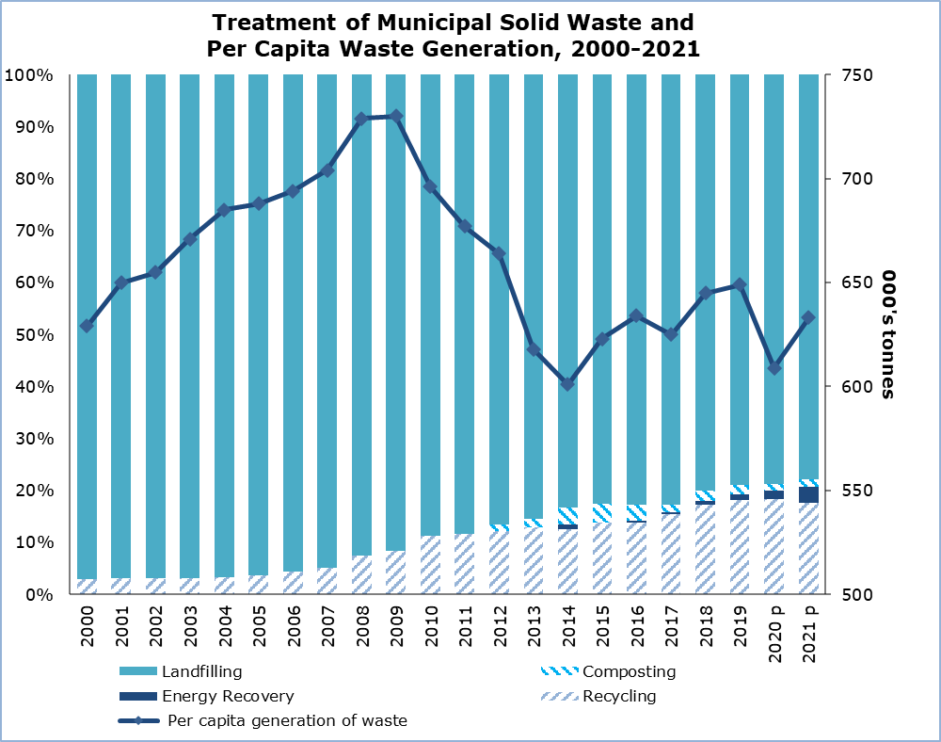

The average municipal waste generation per inhabitant in the European Union in 2020 (data for 2021 are not yet available) was 517 kg. In Cyprus, municipal waste generation per capita reached 609 kg, which is the 7th highest among EU member states. Austria had the highest municipal waste generation per capita (834 kg), followed by Denmark (814 kg), Luxembourg (790 kg), Belgium (746 kg), Malta (643 kg), Germany (628 kg) and Cyprus (609 kg).

Table
Indicator | Unit | 2010 | 2015 | 2017 | 2018 | 2019 | 2020 ^{p} | 2021 ^{p}
Waste Generated | 000’s tonnes | 576,31 | 525,24 | 537,49 | 562,10 | 571,07 | 542,84 | 570,00
Per Capita Generation | kg/person | 696 | 623 | 625 | 645 | 649 | 609 | 633
Waste Treated | 000’s tonnes | 560,76 | 496,69 | 511,33 | 490,61 | 480,13 | 462,18 | 455,49
Landfilling | " | 497,86 | 409,99 | 423,16 | 392,86 | 379,39 | 364,14 | 354,30
Recycling | " | 62,90 | 68,81 | 78,93 | 84,47 | 87,03 | 84,43 | 80,39
Composting | " | 0,00 | 17,89 | 7,56 | 9,30 | 8,08 | 5,77 | 6,87
Energy  Recovery | " | 0,00 | 0,00 | 1,68 | 3,98 | 5,63 | 7,83 | 13,93
^{p} = provisional data

METHODOLOGICAL INFORMATION

Definitions

Municipal Waste: is waste collected by or on behalf of municipalities. It includes household waste and similar waste as well as waste originating from commerce, trade, small businesses, office buildings and institutions (schools, hospitals, government buildings). It also includes: bulky waste and yard waste, leaves, grass clippings, street sweepings, the content of litter containers, and market cleansing waste, if managed as waste. Municipal waste is collected from door-to-door through traditional collection (mixed household waste) and fractions collected separately for recovery operations (mainly for recycling purposes, through door-to-door collection and/or through voluntary deposits). It also includes waste similar in nature and composition which: 1) is collected directly by the private sector (business or private non-profit institutions), not on behalf of municipalities (mainly separate collection for recovery purposes) and 2) originates from rural areas not served by a regular waste service, even if they are disposed by the generator. It excludes waste from municipal sewage network and treatment and municipal construction and demolition waste.

Recycling: is defined as any reprocessing of material in a production process that diverts it from the waste stream, except reuse as fuel. Both reprocessing as the same type of product and for different purposes is included. Direct recycling within industrial plants at the place of generation is excluded.

Composting: is defined as a biological process that submits biodegradable waste to anaerobic or aerobic decomposition and that results in a product used on land or for the production of growing media or substrates.

Incineration: refers to the thermal treatment of waste in an incineration plant in order to reduce the volume and the hazardousness of the waste and to obtain a still product that can be disposed of.

Energy recovery: refers to the incineration and co-incineration of waste in power stations and industrial facilities such as cement kilns so that the resulting energy can be used to generate heat or electricity.

Landfill (disposal site): is defined as deposit of waste into or onto land, including specially engineered landfills, and temporary storage of over one year on permanent sites. The definition covers both landfills in internal sites (i.e. where the generator of waste is carrying out its own waste disposal at the place of generation) and external sites.

For more information:
CYSTAT Portal, subtheme Environment
CYSTAT-DB (Online Database)
Predefined Tables (Excel)
Methodological Information

Contact
Marilena Kythreotou: Tel.: +357 22602137, Email: mkythreotou@cystat.mof.gov.cy

