21 February, 2024

**PRESS RELEASE**

###### GENERATION AND TREATMENT OF MUNICIPAL SOLID WASTE, 2022

**Increase of 5% in the Generation of Municipal Waste in 2022**

The Statistical Service estimates that the total amount of municipal solid waste generated in Cyprus in 2022 stood at 615 thousand tonnes compared to 585 thousand tonnes in 2021, recording an increase of 5%.

From the total amount of 469 thousand tonnes treated in 2022, 77,5% was disposed in landfills, 17,2% was used for recycling, 3,1% was used for energy recovery purposes and 2,2% was composted.

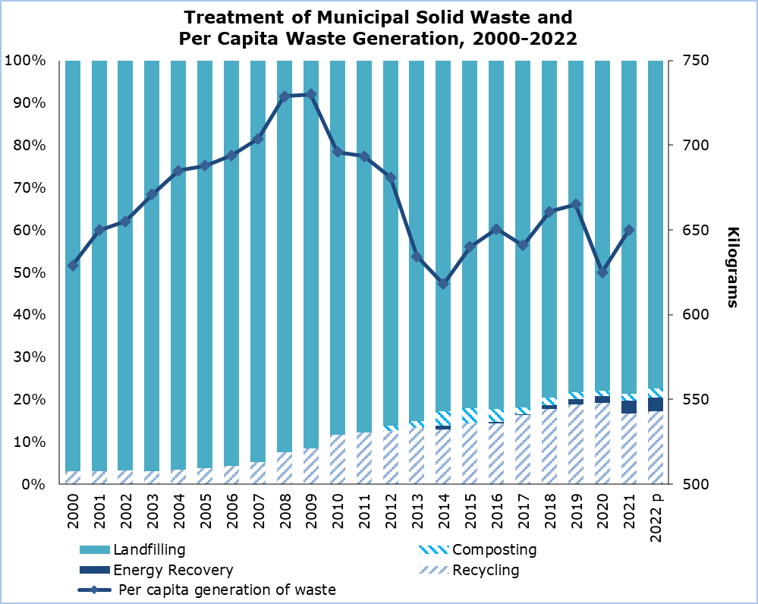

The average municipal waste generation per inhabitant in the European Union in 2022 was 513 kg. In Cyprus, municipal waste generation per capita reached 673 kg, which ranked the 5th highest among EU member states in 2022. Austria had the highest municipal waste generation per capita (835 kg, 2021 data), followed by Denmark (787 kg), Luxembourg (721 kg), Belgium (677 kg), and Cyprus (673 kg).

|  |  |  |  |  |  |  |  |  |
| --- | --- | --- | --- | --- | --- | --- | --- | --- |
| **Table** |  |  |  |  |  |  |  |  |
| **Indicator** | **Unit** | **2010** | **2015** | **2018** | **2019** | **2020** | **2021** | **2022 p** |
| **Waste Generated** | **000’s tonnes** | **589,77** | **539,75** | **575,63** | **585,73** | **557,73** | **585,24** | **614,62** |
| **Per Capita Generation** | **kg/person** | **713** | **640** | **661** | **665** | **625** | **650** | **673** |
| **Waste Treated** | **000’s tonnes** | **563,39** | **499,71** | **494,01** | **484,52** | **467,36** | **450,13** | **468,99** |
| Landfilling | " | 497,86 | 409,99 | 392,86 | 379,39 | 364,14 | 354,30 | 363,34 |
| Recycling | " | 65,53 | 71,83 | 87,87 | 91,42 | 89,61 | 75,03 | 80,82 |
| Composting | " | 0,00 | 17,89 | 9,30 | 8,08 | 5,77 | 6,87 | 10,14 |
| Energy   Recovery | " | 0,00 | 0,00 | 3,98 | 5,63 | 7,83 | 13,93 | 14,69 |
|  |

p = provisional data

**METHODOLOGICAL INFORMATION**

**Definitions**

**Municipal Waste:** is waste collected by or on behalf of municipalities. It includes household waste and similar waste as well as waste originating from commerce, trade, small businesses, office buildings and institutions (schools, hospitals, government buildings). It also includes: bulky waste and yard waste, leaves, grass clippings, street sweepings, the content of litter containers, and market cleansing waste, if managed as waste. Municipal waste is collected from door-to-door through traditional collection (mixed household waste) and fractions collected separately for recovery operations (mainly for recycling purposes, through door-to-door collection and/or through voluntary deposits). It also includes waste similar in nature and composition which: 1) is collected directly by the private sector (business or private non-profit institutions), not on behalf of municipalities (mainly separate collection for recovery purposes) and 2) originates from rural areas not served by a regular waste service, even if they are disposed by the generator. It excludes waste from municipal sewage network and treatment and municipal construction and demolition waste.

**Recycling:** is defined as any reprocessing of material in a production process that diverts it from the waste stream, except reuse as fuel. Both reprocessing as the same type of product and for different purposes is included. Direct recycling within industrial plants at the place of generation is excluded.

**Composting:** is defined as a biological process that submits biodegradable waste to anaerobic or aerobic decomposition and that results in a product used on land or for the production of growing media or substrates.

**Incineration:** refers to the thermal treatment of waste in an incineration plant in order to reduce the volume and the hazardousness of the waste and to obtain a still product that can be disposed of.

**Energy recovery:** refers to the incineration and co-incineration of waste in power stations and industrial facilities such as cement kilns so that the resulting energy can be used to generate heat or electricity.

**Landfilling:** is defined as the deposit of waste into or onto land, including specially engineered landfills and temporary storage of over one year on permanent sites. It covers both landfills in internal sites (i.e. where the generator of waste is carrying out its own waste disposal at the place of generation) and external sites.

***For more information:***

CYSTAT Portal, subtheme [Environment](https://www.cystat.gov.cy/en/SubthemeStatistics?s=35)

[CYSTAT-DB](https://cystatdb.cystat.gov.cy/pxweb/en/8.CYSTAT-DB/8.CYSTAT-DB__Environment__) (Online Database)

[Predefined Tables](https://www.cystat.gov.cy/en/KeyFiguresList?s=35) (Excel)

[Methodological Information](https://www.cystat.gov.cy/en/MethodologicalDetails?m=2118)

*Contact*

Marilena Kythreotou: Tel.: +357 22602137, Email: [mkythreotou@cystat.mof.gov.cy](mailto:mkythreotou@cystat.mof.gov.cy)