16 July 2026

PRESS RELEASE

GENERATION AND TREATMENT OF MUNICIPAL SOLID WASTE: 2024

Increase of 5,6% in the Generation of Municipal Waste

The Statistical Service estimates that the total amount of municipal solid waste generated in Cyprus in 2024 stood at 669 thousand tonnes compared to 633 thousand tonnes in 2023, recording an increase of 5,6%.

From the total amount of 566 thousand tonnes of waste treated in 2024, 78,5% was disposed in landfills, 14,2% was used for recycling, 2,9% was used for energy recovery purposes and 4,4% was composted.

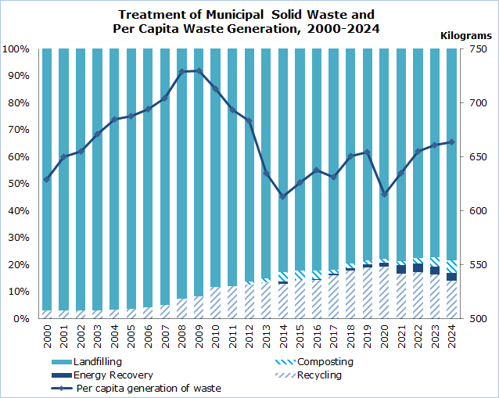

The average generation of municipal waste per inhabitant in the European Union in 2024 was 517 kg. In Cyprus, municipal waste generation per capita reached 664 kg, which ranked the 4th highest among EU member states. Denmark had the highest municipal waste generation per capita (755 kg), followed by Belgium (699 kg), Luxembourg (681kg), Cyprus (664 kg), Germany (628 kg) and Malta (621 kg).

Table
Indicator | Unit |  | 2010 | 2015 | 2020 | 2021 | 2022 | 2023 | 2024^{p}
Waste Generated |  | 000’s tonnes | 589,77 | 539,75 | 557,73 | 585,24 | 614,62 | 633,29 | 669,06
Per Capita Generation in Cyprus |  | kg/person | 713 | 626 | 615 | 635 | 655 | 661 | 664
Per Capita Generation in the EU |  | kg/person | 503 | 494 | 520 | 533 | 513 | 511 | 517
Waste Treatment |  | 000’s tonnes | 563,39 | 499,71 | 467,35 | 450,13 | 468,99 | 504,23 | 566,07
Landfilling |  | " | 497,86 | 409,99 | 364,14 | 354,30 | 363,34 | 388,83 | 444,26
Recycling |  | " | 65,53 | 71,83 | 89,61 | 75,03 | 80,82 | 82,34 | 80,26
Composting |  | " | 0,00 | 17,89 | 5,77 | 6,87 | 10,14 | 17,42 | 25,38
Energy Recovery |  | " | 0,00 | 0,00 | 7,83 | 13,93 | 14,69 | 15,65 | 16,16
^{p}: provisional data

METHODOLOGICAL INFORMATION

Definitions

Municipal Waste: is waste collected by or on behalf of municipalities. It includes household waste and similar waste as well as waste originating from commerce, trade, small businesses, office buildings and institutions (schools, hospitals, government buildings). It also includes: bulky waste and yard waste, leaves, grass clippings, street sweepings, the content of litter containers, and market cleansing waste, if managed as waste. Municipal waste is collected from door-to-door through traditional collection (mixed household waste) and fractions collected separately for recovery operations (mainly for recycling purposes, through door-to-door collection and/or through voluntary deposits). It also includes waste similar in nature and composition which: 1) is collected directly by the private sector (business or private non-profit institutions), not on behalf of municipalities (mainly separate collection for recovery purposes) and 2) originates from rural areas not served by a regular waste service, even if they are disposed by the generator. It excludes waste from municipal sewage network and treatment and municipal construction and demolition waste.

Recycling: is defined as any reprocessing of material in a production process that diverts it from the waste stream, except reuse as fuel. Both reprocessing as the same type of product and for different purposes is included. Direct recycling within industrial plants at the place of generation is excluded.

Composting: is defined as a biological process that submits biodegradable waste to anaerobic or aerobic decomposition and that results in a product used on land or for the production of growing media or substrates.

Incineration: refers to the thermal treatment of waste in an incineration plant in order to reduce the volume and the hazardousness of the waste and to obtain a still product that can be disposed of.

Energy recovery: refers to the incineration and co-incineration of waste in power stations and industrial facilities such as cement kilns so that the resulting energy can be used to generate heat or electricity.

Landfilling: is defined as the deposit of waste into or onto land, including specially engineered landfills and temporary storage of over one year on permanent sites. It covers both landfills in internal sites (i.e. where the generator of waste is carrying out its own waste disposal at the place of generation) and external sites.

For more information:
CYSTAT Portal, subtheme Environment
CYSTAT-DB (Online Database)
Predefined Tables (Excel)
Methodological Information

Contact
Marilena Kythreotou: Tel.: +357 22602137, Email: mkythreotou@cystat.mof.gov.cy

