18 October, 2024

PRESS RELEASE

ANNUAL NATIONAL ACCOUNTS: MAJOR REVISION FOR THE YEARS 1995-2022 AND REVISED ESTIMATE FOR THE YEAR 2023

Growth Rate 2,6%

The growth rate of the economy in 2023 is positive and is estimated at 2,6% in real terms (volume measures). At current prices, the percentage change in Gross Domestic Product (GDP) amounts to 6,5%.

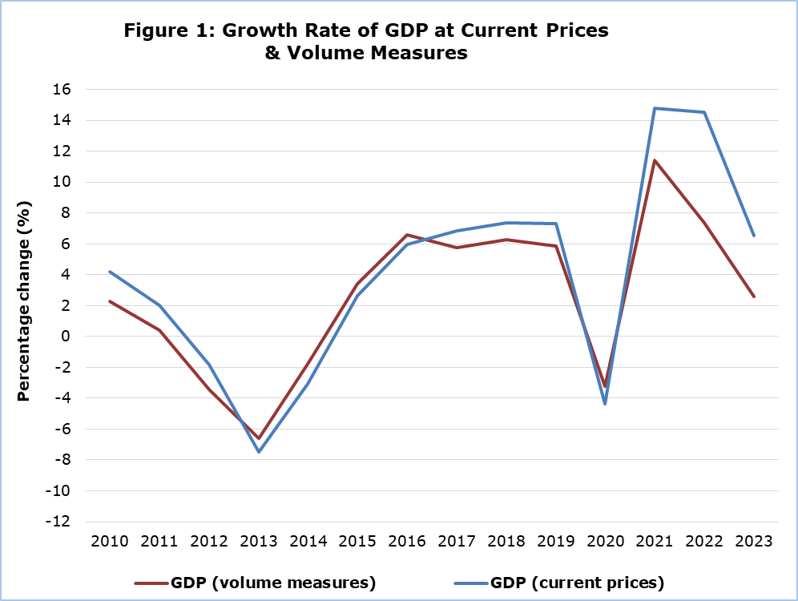

Regarding the production approach for the estimation of GDP, in real terms, the positive growth rate is mainly attributed to the sectors: ”Information and communication”, "Hotels and Restaurants", “Transportation and storage", “Construction” and “Wholesale and retail trade; repair of motor vehicles and motorcycles” (Table 1).

Table 1: Gross Domestic Product (GDP) - Production Approach
NACE Rev.2 | GDP at Current Prices |  |  | GDP at Volume Measures
NACE Rev.2 | Distribution of Gross Value Added  (%) | Euro  (million) | Change  (%) | Euro  (million) | Change  (%)
NACE Rev.2 | 2023 | 2023 | 2023/2022 | 2023 | 2023/2022
Gross Domestic Product (GDP) | 100,0 | 31.340,0 | 6,5 | 26.964,4 | 2,6
A | 1,3 | 369,5 | 6,8 | 291,5 | 0,9
B | 0,2 | 52,5 | 22,2 | 44,8 | 9,9
C | 4,9 | 1.362,5 | 7,5 | 1.082,0 | 2,4
D | 1,0 | 286,8 | 9,7 | 100,3 | 6,6
E | 0,7 | 193,8 | 7,2 | 166,1 | 3,3
F | 5,0 | 1.393,3 | 8,7 | 1.336,2 | 2,9
G | 12,0 | 3.312,1 | -5,4 | 2.944,2 | 1,3
H | 5,4 | 1.487,1 | 3,5 | 1.334,6 | 4,2
I | 6,3 | 1.742,0 | 18,7 | 1.345,8 | 13,1
J | 11,2 | 3.089,9 | 10,5 | 3.207,6 | 7,9
K | 10,1 | 2.790,2 | 13,9 | 1.838,5 | -1,1
L | 10,2 | 2.833,2 | 6,2 | 2.584,7 | 0,8
M | 7,3 | 2.025,3 | -0,1 | 1.766,4 | -3,0
N | 2,6 | 719,1 | 8,5 | 673,1 | 5,3
O | 8,4 | 2.322,7 | 9,9 | 1.920,5 | 1,6
P | 5,5 | 1.530,8 | 2,6 | 1.467,4 | 0,7
Q | 4,3 | 1.177,6 | 3,7 | 1.139,6 | 2,3
R | 1,5 | 405,7 | 5,9 | 384,0 | 2,3
S | 1,4 | 374,2 | 7,1 | 352,5 | 3,9
T | 0,8 | 210,8 | 1,6 | 189,6 | 1,6
Taxes less Subsidies | - | 3.660,8 | 9,4 | 3.238,9 | 2,9
Α: Agriculture, forestry and fishing
B: Mining and quarrying
C: Manufacturing
D: Electricity, gas, steam and air conditioning supply
E: Sewerage, waste management and remediation activities
F: Construction
G: Wholesale and retail trade; repair of motor vehicles and motorcycles
H: Transportation and storage
I: Accommodation and food service activities
J: Information and communication
K: Financial and insurance activities
L: Real estate activities
M: Professional, scientific and technical activities
N: Administrative and support service activities
O: Public administration and defense
P: Education
Q: Human health and social work activities
R: Arts, entertainment and recreation
S: Repair of household goods and other services
T: Activities of households as employers

Table 2: Gross Domestic Product (GDP) - Expenditure Approach
Type of Expenditure | GDP at Current Prices |  | GDP at Volume Measures
Type of Expenditure | Euro  (million) | Change  (%) | Euro  (million) | Change  (%)
Type of Expenditure | 2023 | 2023/2022 | 2023 | 2023/2022
Gross domestic product (GDP) | 31.340,0 | 6,5 | 26.964,4 | 2,6
Government final consumption | 5.816,2 | 10,6 | 4.850,9 | 2,2
Private final consumption | 18.702,7 | 9,8 | 16.713,3 | 6,0
Gross capital formation | 6.429,1 | 4,0 | 5.494,7 | 1,8
Exports of goods and services | 30.405,7 | 1,1 | 26.902,7 | 0,1
Less: Imports of goods and services | 30.013,7 | 3,1 | 27.188,0 | 1,7

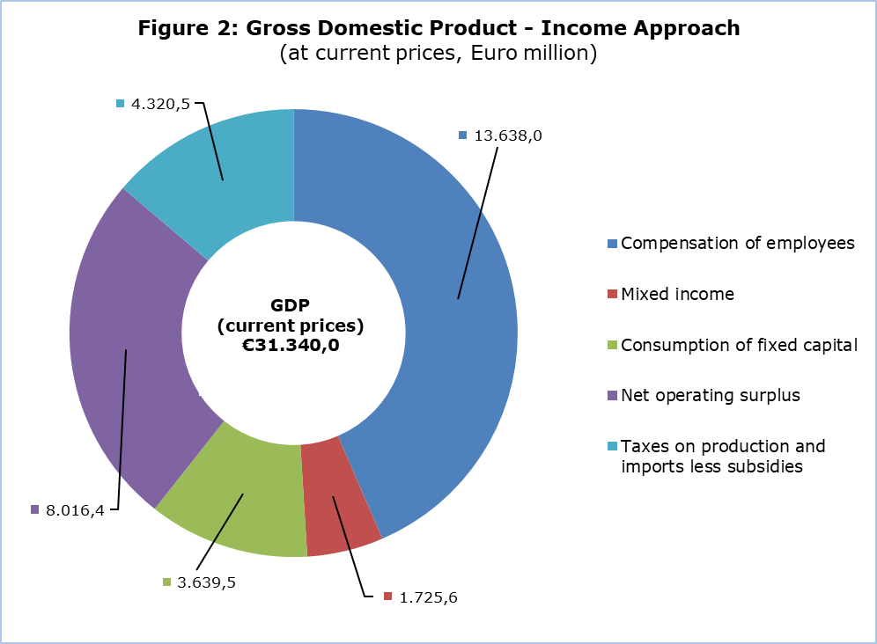
GDP (current prices)
€31.340,0

METHODOLOGICAL INFORMATION

Scope

The scope of major revision of National Accounts for the period 2018-2022 is due to the changes in sources & methods and routine revisions. The main changes in sources & methods, for the period 2018-2022, are related to the work on action points from the scheduled verification cycle for the compilation of GDP/GNI, including the incorporation of population and housing census 2021 and Household Budget Survey 2023, and the changes in Government Finance Statistics. Routine revisions for the years 2021 and 2022 are mainly due to updated information received from Balance of Payments statistics and the normal substitution of preliminary estimates with final source data from annual economic surveys and administrative sources for 2022.

The GDP estimate for 2023, nine months after the end of the reference year, is to provide a better estimate of the growth of Cyprus economy, while providing information on the main variables of the production, expenditure and income approach.

Compilation and Methodology

The GDP level in Cyprus is determined from the production and expenditure approaches, while the income approach is considered a residual item as concerns the operating surplus.

Annual National Accounts (ANA) are produced at current, volume measures and previous-year-prices, published and transmitted to Eurostat at two and nine months after the end of the reference year.

ANA are compiled in accordance with the European System of Accounts (ESA 2010) as defined in Regulation (EU) No 549/2013 of the European Parliament and of the Council of 21 May 2013.

Production Approach
The estimation of GDP is based mainly on the results of the annual economic surveys (SBS) and the quarterly Short-Term Statistics (STS) of the Statistical Service of Cyprus, administrative sources, Government Finance Statistics and any data adjustments according to the European System of Accounts 2010 (ESA 2010).

Expenditure Approach
The calculation of GDP is based on the statistics of the Private and Government Consumption, the Gross Fixed Capital Formation, the Changes in Inventories, the acquisitions less disposals of valuables and the external balance of goods and services (Exports minus Imports).

Income Approach
The calculation of GDP is the sum of income components for the total economy and it is comprised of the compensation of employees, taxes on production & imports less subsidies and gross operating surplus including mixed income.

Source of Data

In order to produce ANA estimates, the following datasets are used as input to the system of calculation:
- short-term economic indicators by activity,
- administrative data,
- annual business surveys,
- General Government Statistics,
- Private and Public Consumption,
- Gross Fixed Capital Formation,
- change in stocks,
- external balance of goods and services,
- price indices.

For more information:
CYSTAT Portal, subtheme National Accounts
CYSTAT-DB (Online Database)
Predefined Tables (Excel)
Methodological Information

Contact
Demetris Ioannou: Τel: +35722605128, Email: dioannou@cystat.mof.gov.cy

