4 March, 2025

**PRESS RELEASE - REVISED**

ANNUAL NATIONAL ACCOUNTS: **FIRST ESTIMATE FOR THE YEAR 2024**

**Growth Rate 3,4%**

The growth rate of the economy in 2024 is positive and is estimated at 3,4% in real terms (volume measures). At current prices, the percentage change in Gross Domestic Product (GDP) amounts to 6,6%.

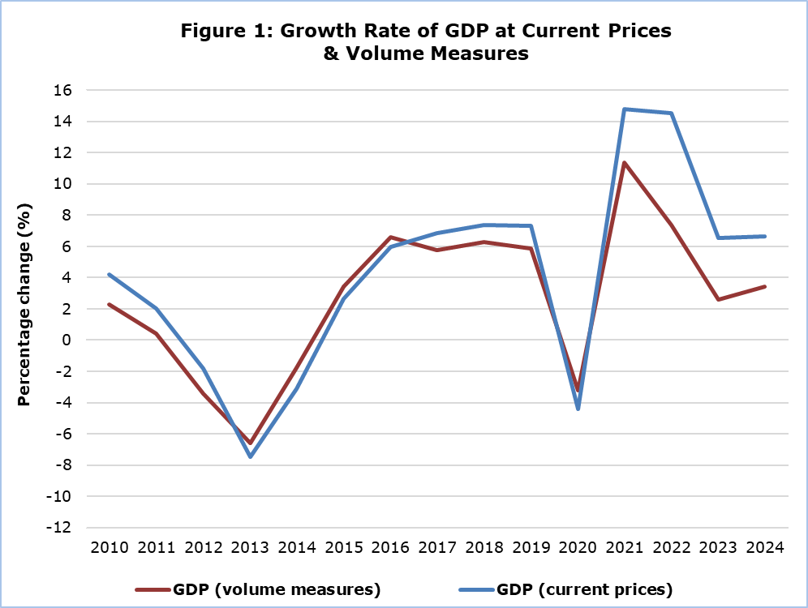

Regarding the production approach for the estimation of GDP in real terms, the positive growth rate is mainly attributed to the sectors: "Hotels and Restaurants", “Information and communication”, “Construction” and “Wholesale and retail trade; repair of motor vehicles and motorcycles”, (Table 1).

|  |  |  |  |  |  |
| --- | --- | --- | --- | --- | --- |
| **Table 1: Gross Domestic Product (GDP) - Production Approach** | | | | | |
| **NACE Rev.2** | **GDP at Current Market Prices** | | | **GDP at Volume Measures** | |
| Distribution of Gross Value Added  (%) | Euro  (million) | Change  (%) | Euro  (million) | Change  (%) |
| **2024** | **2024** | **2024/2023** | **2024** | **2024/2023** |
| **Gross Domestic Product (GDP)** | **100,0** | **33.414,4** | **6,6** | **27.889,3** | **3,4** |
| **A** | 1,3 | 396,2 | 7,2 | 294,8 | 1,1 |
| **B** | 0,2 | 58,3 | 11,1 | 49,3 | 10,0 |
| **C** | 4,8 | 1.401,6 | 2,9 | 1.112,1 | 2,8 |
| **D** | 1,0 | 287,0 | 0,1 | 108,0 | 7,7 |
| **E** | 0,7 | 206,3 | 6,5 | 175,8 | 5,8 |
| **F** | 5,1 | 1.511,2 | 8,5 | 1.406,5 | 5,3 |
| **G** | 11,8 | 3.480,4 | 5,1 | 3.067,0 | 4,2 |
| **H** | 5,1 | 1.511,2 | 1,6 | 1.355,6 | 1,6 |
| **I** | 6,6 | 1.938,0 | 11,3 | 1.429,3 | 6,2 |
| **J** | 11,1 | 3.282,9 | 6,2 | 3.388,1 | 5,6 |
| **K** | 10,4 | 3.066,7 | 9,9 | 1.868,2 | 1,6 |
| **L** | 10,4 | 3.050,1 | 7,7 | 2.637,6 | 2,0 |
| **M** | 7,1 | 2.099,9 | 3,7 | 1.803,8 | 2,1 |
| **N** | 2,6 | 758,2 | 5,4 | 698,7 | 3,8 |
| **O** | 8,7 | 2.553,7 | 9,9 | 2.004,5 | 4,4 |
| **P** | 5,4 | 1.597,9 | 4,4 | 1.491,8 | 1,7 |
| **Q** | 4,1 | 1.214,2 | 3,1 | 1.162,3 | 2,0 |
| **R** | 1,5 | 438,3 | 8,1 | 407,1 | 6,0 |
| **S** | 1,3 | 389,1 | 4,0 | 360,7 | 2,3 |
| **T** | 0,7 | 210,6 | -0,1 | 189,4 | -0,1 |
| **Taxes less Subsidies** | - | 3.962,5 | 8,2 | 3.238,3 | 3,3 |
|  |  |  |  |  |  |

**Α:** Agriculture, forestry and fishing

**B:** Mining and quarrying

**C:** Manufacturing

**D:** Electricity, gas, steam and air conditioning supply

**E:** Sewerage, waste management and remediation activities

**F:** Construction

**G:** Wholesale and retail trade; repair of motor vehicles and motorcycles

**H:** Transportation and storage

**I:** Accommodation and food service activities

**J:** Information and communication

**K:** Financial and insurance activities

**L:** Real estate activities

**M:** Professional, scientific and technical activities

**N:** Administrative and support service activities

**O:** Public administration and defense

**P:** Education

**Q:** Human health and social work activities

**R:** Arts, entertainment and recreation

**S:** Repair of household goods and other services

**T:** Activities of households as employers

|  |  |  |  |  |
| --- | --- | --- | --- | --- |
| **Table 2: Gross Domestic Product (GDP) - Expenditure Approach** | | | | |
| **Type of Expenditure** | **GDP at Current Prices** | | **GDP at Volume Measures** | |
| Euro  (million) | Change  (%) | Euro  (million) | Change  (%) |
| **2024** | **2024/2023** | **2024** | **2024/2023** |
| **Gross domestic product (GDP)** | **33.414,4** | **6,6** | **27.889,3** | **3,4** |
| Government final consumption | 6.260,6 | 7,6 | 4.972,6 | 2,5 |
| Private final consumption | 19.766,8 | 5,7 | 17.343,4 | 3,8 |
| Gross capital formation | 6.423,4 | -0,1 | 5.177,9 | -5,8 |
| Exports of goods and services | 32.497,3 | 6,9 | 28.406,5 | 5,6 |
| Less: Imports of goods and services | 31.533,7 | 5,1 | 28.188,6 | 3,7 |
|  |  |  |  |  |

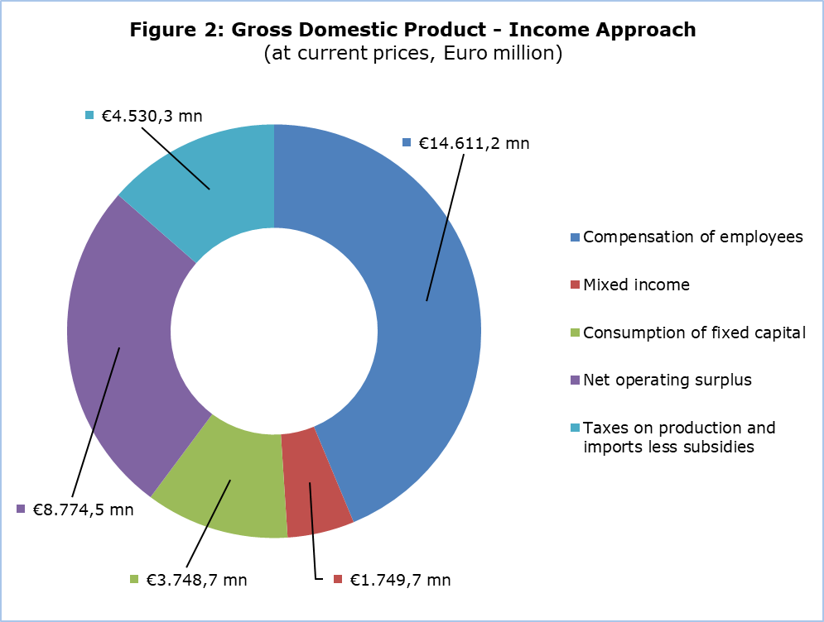

**GDP (current prices)**

**€33.414,4 mn**

**GDP (current prices)**

**€33.414,4**

**METHODOLOGICAL INFORMATION**

**Scope**

The GDP estimate for 2024, two months after the end of the reference year, is to provide the first estimate of the growth of Cyprus economy, while providing information on the main variables of the production, expenditure and income approach.

**Compilation and Methodology**

The GDP level in Cyprus is determined from the production and expenditure approaches, while the income approach is considered a residual item as concerns the operating surplus.

Annual National Accounts (ANA) are produced at current prices, volume measures and previous-year-prices, published and transmitted to Eurostat at two and nine months after the end of the reference year.

ANA are compiled in accordance with the European System of Accounts (ESA 2010) as defined in Regulation (EU) No 549/2013 of the European Parliament and of the Council of 21 May 2013.

***Production Approach***

The estimation of GDP is based mainly on the results of the annual economic surveys (SBS) and the quarterly Short-Term Statistics (STS) of the Statistical Service of Cyprus, administrative sources, Government Finance Statistics and any data adjustments according to the European System of Accounts 2010 (ESA 2010).

***Expenditure Approach***

The calculation of GDP is based on the statistics of the Private and Government Consumption, the Gross Fixed Capital Formation, the Changes in Inventories, the acquisitions less disposals of valuables and the external balance of goods and services (Exports minus Imports).

***Income Approach***

The calculation of GDP is the sum of income components for the total economy and it is comprised of the compensation of employees, taxes on production & imports less subsidies and gross operating surplus including mixed income.

**Source of Data**

In order to produce ANA estimates, the following datasets are used as input to the system of calculation:

- short-term economic indicators by activity,

- administrative data,

- annual business surveys,

- General Government Statistics,

- Private and Public Consumption,

- Gross Fixed Capital Formation,

- change in stocks,

- external balance of goods and services,

- price indices.

***For more information:***

CYSTAT Portal, subtheme [National Accounts](https://www.cystat.gov.cy/en/SubthemeStatistics?s=45)

[CYSTAT-DB](https://cystatdb.cystat.gov.cy/pxweb/en/8.CYSTAT-DB/8.CYSTAT-DB__National%20Accounts__) (Online Database)

[Predefined Tables](https://www.cystat.gov.cy/en/KeyFiguresList?s=45) (Excel)

[Methodological Information](https://www.cystat.gov.cy/en/MethodologicalDisplay?s=45)

*Contact*

Demetris Ioannou: Τel: +35722605128, Email: [dioannou@cystat.mof.gov.cy](mailto:dioannou@cystat.mof.gov.cy)

5 March, 2025

**CORRIGENDUM**

Data related to Compensation of employees and Net operating surplus, in the press release, have been corrected due to a technical issue occurred during data processing. Specifically, Compensation of employees reached €14.611,2 mn instead of €13.888,9 mn and the Net operating surplus reached €8.774,5 mn instead of €9.496,8 mn.