20 April, 2026

PRESS RELEASE

DATA UPDATE OF ANNUAL NATIONAL ACCOUNTS

Growth Rate 2025 at 3,8% (in real terms)

Annual National Accounts data, at current prices for the year 2025, have been updated due to changes in Government Finance Statistics (GFS) and Balance of Payments Statistics (BOP). The changes in data in real terms are due to the incorporation of the balanced Supply and Use Tables 2022.

The growth rate of the economy in 2025 remains positive at 3,8% in real terms. At current prices, the percentage change in Gross Domestic Product (GDP) amounts to 4,9%.

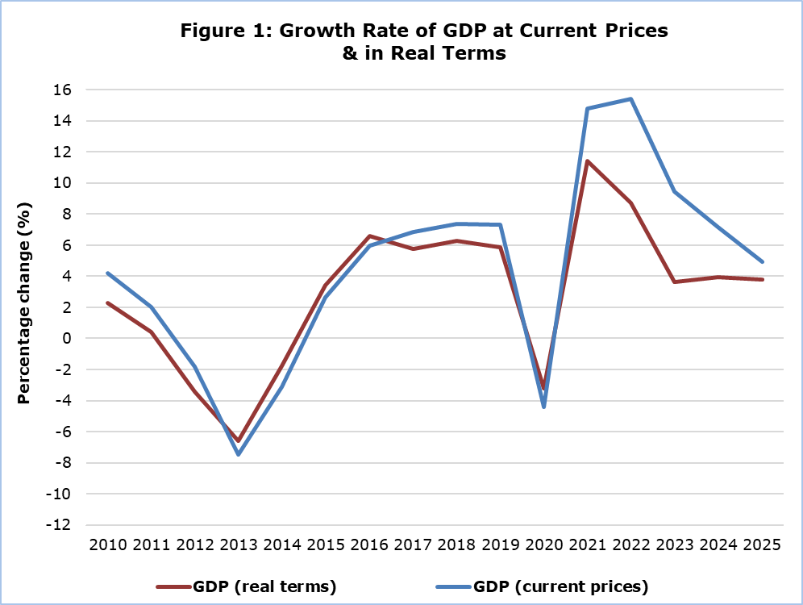

Regarding the production approach for the estimation of GDP in real terms, the positive growth rate is mainly attributed to the sectors: “Information and communication”, "Hotels and Restaurants", and “Wholesale and retail trade; repair of motor vehicles and motorcycles” and “Construction” (Table 1).

Table 1: Gross Domestic Product (GDP) - Production Approach
Economic Activity  (NACE Rev.2) | GDP at Current Prices |  |  | GDP in Real Terms  (base year 2019)
Economic Activity  (NACE Rev.2) | Distribution of Gross Value Added  (%) | Euro  (million) | Change  (%) | Euro  (million) | Change  (%)
Economic Activity  (NACE Rev.2) | 2025 | 2025 | 2025/2024 | 2025 | 2025/2024
Gross Domestic Product  (GDP) | 100,0 | 36.483,5 | 4,9 | 30.661,3 | 3,8
A | 1,3 | 406,9 | 1,3 | 334,9 | 0,8
B | 0,2 | 58,5 | 15,4 | 43,0 | 7,3
C | 4,9 | 1.602,3 | 3,4 | 1.318,6 | 2,8
D | 1,0 | 340,4 | -2,5 | 239,5 | 2,5
E | 0,6 | 198,8 | 3,1 | 188,4 | 2,8
F | 5,7 | 1.867,0 | 7,9 | 1.457,3 | 4,5
G | 11,6 | 3.786,4 | 5,7 | 2.904,3 | 7,4
H | 4,9 | 1.593,0 | 2,9 | 1.439,0 | 3,0
I | 7,0 | 2.278,4 | 12,0 | 1.932,9 | 7,1
J | 12,5 | 4.049,6 | 12,9 | 3.580,0 | 8,0
K | 9,2 | 3.004,8 | -2,5 | 2.459,3 | 2,0
L | 10,2 | 3.319,8 | 6,3 | 2.714,4 | 2,3
M | 6,7 | 2.188,4 | 1,7 | 1.935,8 | 1,6
N | 2,6 | 830,6 | 3,3 | 743,1 | 3,2
O | 8,5 | 2.774,9 | 5,2 | 2.049,5 | 0,6
P | 5,6 | 1.809,2 | 4,8 | 1.571,9 | 1,3
Q | 4,1 | 1.322,3 | 3,0 | 1.188,0 | 1,6
R | 1,4 | 440,4 | 5,7 | 384,3 | 3,2
S | 1,3 | 414,2 | 5,5 | 365,3 | 3,2
T | 0,7 | 224,3 | 0,4 | 219,5 | 0,4
Taxes less Subsidies | - | 3.973,6 | 1,7 | 3.740,5 | 3,8
Economic activities
Α: Agriculture, forestry and fishing
B: Mining and quarrying
C: Manufacturing
D: Electricity, gas, steam and air conditioning supply
E: Sewerage, waste management and remediation activities
F: Construction
G: Wholesale and retail trade; repair of motor vehicles and motorcycles
H: Transportation and storage
I: Accommodation and food service activities
J: Information and communication
K: Financial and insurance activities
L: Real estate activities
M: Professional, scientific and technical activities
N: Administrative and support service activities
O: Public administration and defense
P: Education
Q: Human health and social work activities
R: Arts, entertainment and recreation
S: Repair of household goods and other services
T: Activities of households as employers

Table 2: Gross Domestic Product (GDP) - Expenditure Approach
Type of Expenditure | GDP at Current Prices |  | GDP in Real Terms  (base year 2019)
Type of Expenditure | Euro  (million) | Change  (%) | Euro  (million) | Change  (%)
Type of Expenditure | 2025 | 2025/2024 | 2025 | 2025/2024
Gross domestic product (GDP) | 36.483,5 | 4,9 | 30.661,3 | 3,8
Government final consumption | 6.744,0 | 5,4 | 5.099,9 | 2,0
Private final consumption | 20.651,1 | 3,7 | 18.108,0 | 3,3
Gross capital formation | 7.026,6 | -2,3 | 5.779,3 | -4,6
Exports of goods and services | 35.598,4 | 5,5 | 31.985,6 | 5,0
Less: Imports of goods and services | 33.536,5 | 3,3 | 30.213,2 | 2,5

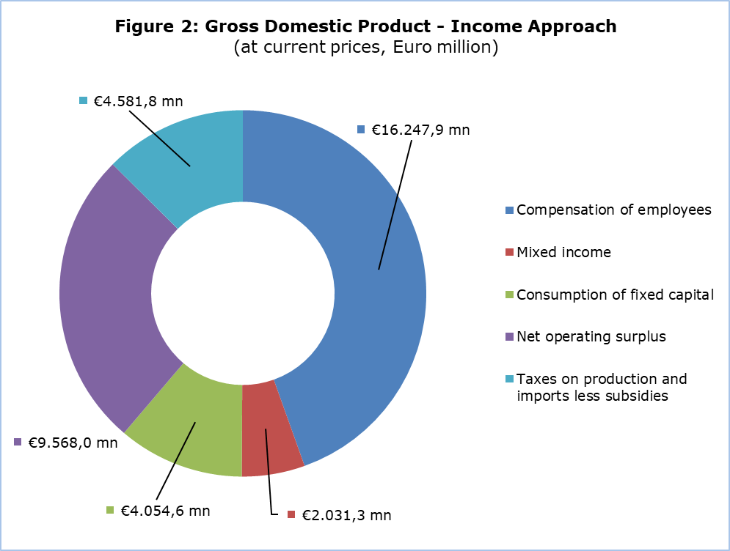
GDP (current prices)
€36.483,5 mn

METHODOLOGICAL INFORMATION

Scope

The update of National Accounts, 110 days after the reference year, is to incorporate revised data of Balance of Payments (BOP), Government Finance Statistics (GFS) and Supply and Use Tables (SUT) providing at the same time information on the main variables of the production, expenditure and income approach.

Compilation and Methodology

The GDP level in Cyprus is determined from the production and expenditure approaches, while the income approach is considered a residual item as concerns the operating surplus.

Annual and Quarterly National Accounts are produced at current prices, real terms (base year 2019) and previous-year-prices, published and transmitted to Eurostat.

Annual National Accounts and Quarterly National Accounts are compiled in accordance with the European System of Accounts (ESA 2010) as defined in Regulation (EU) No 549/2013 of the European Parliament and of the Council of 21 May 2013.

Production Approach
The estimation of GDP is based mainly on the results of the annual economic surveys (SBS) and the quarterly Short-Term Statistics (STS) of the Statistical Service of Cyprus, administrative sources, Government Finance Statistics and any data adjustments according to the European System of Accounts 2010 (ESA 2010).

Expenditure Approach
The calculation of GDP is based on the statistics of the Private and Government Consumption, the Gross Fixed Capital Formation, the Changes in Inventories, the acquisitions less disposals of valuables and the external balance of goods and services (Exports minus Imports).

Income Approach
The calculation of GDP is the sum of income components for the total economy and it is comprised of the compensation of employees, taxes on production & imports less subsidies and gross operating surplus including mixed income.

Source of Data

In order to produce ANA and QNA estimates, the following datasets are used as input to the system of calculation:
- short-term economic indicators by activity,
- administrative data,
- annual business surveys,
- General Government Statistics,
- Private and Public Consumption,
- Gross Fixed Capital Formation,
- change in stocks,
- external balance of goods and services,
- price indices.

For more information:
CYSTAT Portal, subtheme National Accounts
CYSTAT-DB (Online Database)
Predefined Tables (Excel)
Methodological Information

Contact
Demetris Ioannou: Τel: +35722605128, Email: dioannou@cystat.mof.gov.cy

