1 September, 2025

**PRESS RELEASE**

QUARTERLY NATIONAL ACCOUNTS: **2nd QUARTER 2025**

**Growth Rate 3,3% (seasonally adjusted)**

The GDP growth ratein real terms (seasonally adjusted), during the second quarter of 2025 is positive and it is estimated at 3,3% over the corresponding quarter of 2024.

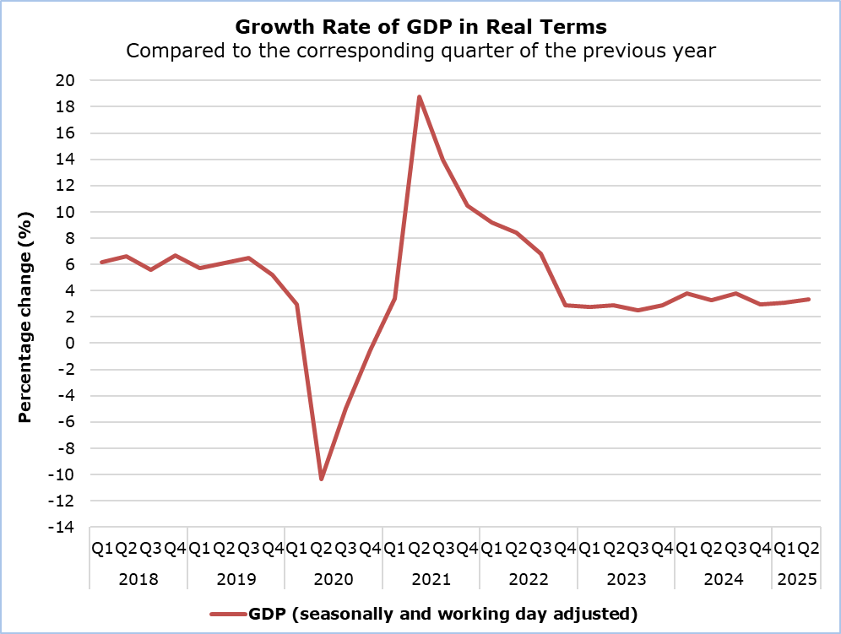

Regarding the production approach for the estimation of GDP, the positive growth rate is mainly attributed to the sectors: "Wholesale and Retail Trade, Repair of Motor Vehicles", "Information and Communication", "Hotels and Restaurants". (Table 1)

|  |  |  |  |
| --- | --- | --- | --- |
| **Table 1** |  |  |  |
| **Economic Activity (NACE Rev.2)** | **GDP in Real Terms Seasonally and Working Day Adjusted** | | |
| Euro (million) | Change (%) | |
| **Q2**  **2025** | **Q2**  **2025/24** | **Q2 2025/**  **Q1 2025** |
| **Gross Domestic Product (GDP)** | **7.384,3** | **3,3** | **0,5** |
| **A** | 80,6 | 0,6 | 0,6 |
| **B - E** | 409,1 | 3,1 | 0,3 |
| **C** | 294,1 | 1,7 | -0,4 |
| **F** | 323,2 | 1,7 | 0,1 |
| **G - I** | 1.565,4 | 6,0 | 1,6 |
| **J** | 841,7 | 6,2 | 1,8 |
| **K** | 601,3 | 0,2 | -1,7 |
| **L** | 650,1 | 2,1 | 0,5 |
| **M & N** | 646,9 | 3,1 | 0,8 |
| **O - Q** | 1.150,8 | 1,5 | 0,4 |
| **R - U** | 242,1 | 3,2 | 0,1 |
|  |  |  |  |

**Economic Activities:**

**Α:** Agriculture, forestry and fishing

**B - E:** Mining and quarrying; manufacturing; electricity, gas, steam and air conditioning supply; water supply; sewerage, waste management and remediation activities

**C:** Manufacturing

**F:** Construction

**G - I:** Wholesale and retail trade; repair of motor vehicles and motorcycles; transportation and storage; accommodation and food service activities

**J:** Information and communication

**K:** Financial and insurance activities

**L:** Real estate activities

**M & N:** Professional, scientific and technical activities; administrative and support service activities

**O - Q:** Public administration and defence; compulsory social security; education; human health and social work activities

**R - U:** Arts, entertainment and recreation, repair of household goods and other services

|  |  |  |  |
| --- | --- | --- | --- |
| **Table 2** |  |  |  |
| **Type of Expenditure** | **GDP in Real Terms Seasonally and Working Day Adjusted** | | |
| Euro (million) | Change (%) | |
| **Q2**  **2025** | **Q2**  **2025/24** | **Q2 2025/**  **Q1 2025** |
| **Gross Domestic Product (GDP)** | **7.384,3** | **3,3** | **0,5** |
| **Final Consumption Expenditure** | **5.840,9** | **5,0** | **2,4** |
| *Of which:*  Households and NPISH | 4.507,6 | 2,8 | 1,1 |
| General Government | 1.330,4 | 12,1 | 6,3 |
| **Gross Fixed Capital Formation (GFCF)** | **1.653,6** | **17,7** | **12,5** |
| GFCF excluding ships & aircrafts | 1.567,1 | 16,0 | 6,6 |
| **Imports of Goods and Services** | **7.702,0** | **6,8** | **7,4** |
| **Exports of Goods and Services** | **8.007,2** | **5,5** | **2,2** |
|  |  |  |  |

**NPISH**: Non-Profit Institutions Serving Households

**METHODOLOGICAL INFORMATION**

**Scope**

The scope of the GDP estimate two months after the end of the reference quarter is to provide a better estimate of the growth of Cyprus economy, while providing information on the main variables of the production and expenditure approach.

**Compilation and Methodology**

QNA are generally constructed using an indirect approach, which is based on short-term indicators providing information on the evolution of the phenomena under study. Furthermore, Chow-Lin’s approach technique is used for temporal disaggregation.

The GDP level in Cyprus is determined from the production and expenditure approaches, while the income approach is considered a residual item.

QNA are produced at current, in real terms and previous-year-prices, published and transmitted to Eurostat at t+2 months. The flash estimate is obtained by running the same estimation procedure as the one applied for the t+2 months calculation however, with less input information available. It is calculated in real terms at t+45 days, published and transmitted to Eurostat as well.

QNA are compiled in accordance with the European System of Accounts (ESA 2010) as defined in Regulation (EU) No 549/2013 of the European Parliament and of the Council of 21 May 2013.

**Source of Data**

In order to produce QNA estimates, the following data are used as input to the system of calculation:

- short-term economic indicators by activity,

- administrative data,

- quarterly employment data,

- price indices.

***For more information:***

CYSTAT Portal, subtheme [National Accounts](https://www.cystat.gov.cy/en/SubthemeStatistics?s=45)

[CYSTAT-DB](https://cystatdb.cystat.gov.cy/pxweb/en/8.CYSTAT-DB/8.CYSTAT-DB__National%20Accounts__) (Online Database)

[Methodological Information](https://www.cystat.gov.cy/en/MethodologicalDisplay?s=45)

*Contact*

Constantinou Maria: Τel: +35722602226, Email: [mconstantinou@cystat.mof.gov.cy](mailto:mconstantinou@cystat.mof.gov.cy)