1 December, 2023

**PRESS RELEASE**

QUARTERLY NATIONAL ACCOUNTS: **3rd QUARTER 2023**

**Growth Rate 2,5%**

The GDP growth rate in real terms during the third quarter of 2023 is positive and it is estimated at 2,5% over the corresponding quarter of 2022. Based on seasonally and working day adjusted data, GDP growth rate in real terms is estimated at 2,2%.

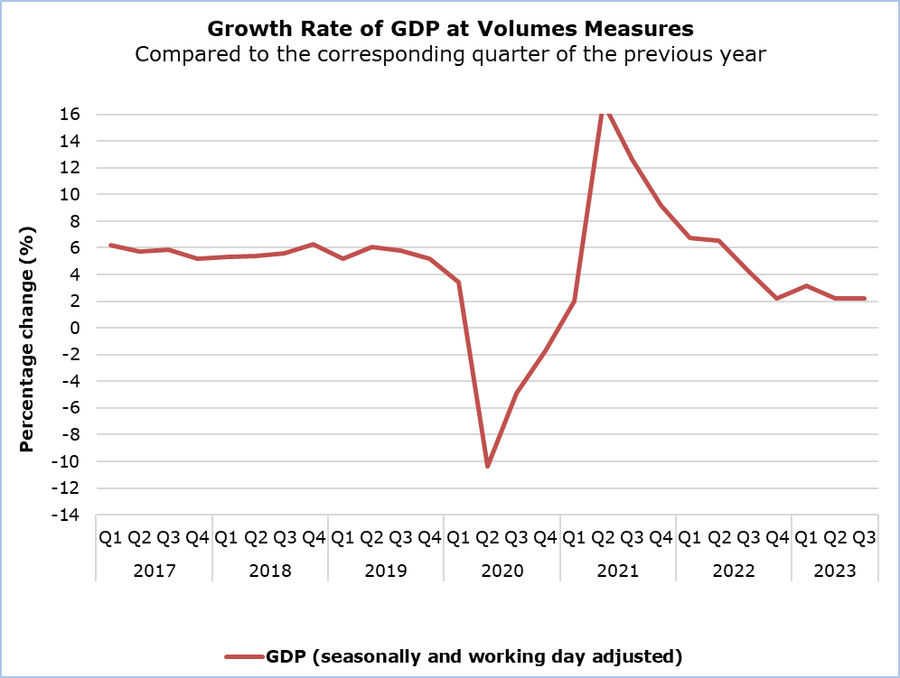

Regarding the production approach for the estimation of GDP, the positive growth rate is mainly attributed to the sectors: "Hotels and Restaurants", "Transport and Storage", "Construction", "Information and Communication", "Wholesale and Retail Trade, Repair of Motor Vehicles", "Arts, Entertainment and Recreation", "Other Service Activities" and "Financial Activities". (Table 1)

|  |  |  |  |
| --- | --- | --- | --- |
| **Table 1** |  |  |  |
| **Economic Activity (NACE Rev.2)** | **GDP in Volume Terms Seasonally and Working Day Adjusted** | | |
| Euro (million) | Change (%) | |
| **Q3**  **2023** | **Q3**  **2023/22** | **Q3 2023/**  **Q2 2023** |
| **Gross Domestic Product (GDP)** | **6.447,9** | **2,2** | **1,1** |
| **A** | 93,6 | 0,8 | 0,1 |
| **B - E** | 389,3 | 3,5 | 0,7 |
| **C** | 312,6 | 2,2 | 0,2 |
| **F** | 351,1 | 2,7 | 0,9 |
| **G - I** | 1.366,0 | 5,0 | 2,1 |
| **J** | 655,6 | 4,6 | 1,4 |
| **K** | 442,0 | -2,8 | -1,1 |
| **L** | 510,1 | 0,8 | 0,2 |
| **M & N** | 614,0 | -0,1 | 5,4 |
| **O - Q** | 1.088,4 | 1,4 | 0,4 |
| **R - U** | 205,8 | 2,6 | 0,6 |
|  |  |  |  |

**Economic Activities:**

**Α:** Agriculture, forestry and fishing

**B - E:** Mining and quarrying; manufacturing; electricity, gas, steam and air conditioning supply; water supply; sewerage, waste management and remediation activities

**C:** Manufacturing

**F:** Construction

**G - I:** Wholesale and retail trade; repair of motor vehicles and motorcycles; transportation and storage; accommodation and food service activities

**J:** Information and communication

**K:** Financial and insurance activities

**L:** Real estate activities

**M & N:** Professional, scientific and technical activities; administrative and support service activities

**O - Q:** Public administration and defence; compulsory social security; education; human health and social work activities

**R - U:** Arts, entertainment and recreation, repair of household goods and other services

|  |  |  |  |
| --- | --- | --- | --- |
| **Table 2** |  |  |  |
| **Type of Expenditure** | **GDP in Volume Terms Seasonally and Working Day Adjusted** | | |
| Euro (million) | Change (%) | |
| **Q3**  **2023** | **Q3**  **2023/22** | **Q3 2023/**  **Q2 2023** |
| **Gross Domestic Product (GDP)** | **6447,9** | **2,2** | **1,1** |
| **Final Consumption Expenditure** | **5257,1** | **4,2** | **2,1** |
| *Of which:*  Households and NPISH | 4065,3 | 5,1 | 3,3 |
| General Government | 1191,8 | 1,3 | -1,6 |
| **Gross Fixed Capital Formation (GFCF)** | **1307,5** | **8,5** | **11,7** |
| GFCF excluding ships & aircrafts | 1213,7 | -1,5 | -0,5 |
| **Imports of Goods and Services** | **6415,9** | **6,4** | **10,3** |
| **Exports of Goods and Services** | **6045,6** | **0,1** | **2,5** |
|  |  |  |  |

**NPISH**: Non-Profit Institutions Serving Households

**METHODOLOGICAL INFORMATION**

**Scope**

The scope of the GDP estimate two months after the end of the reference quarter is to provide a better estimate of the growth of Cyprus economy, while providing information on the main variables of the production and expenditure approach.

**Compilation and Methodology**

QNA are generally constructed using an indirect approach, which is based on short-term indicators providing information on the evolution of the phenomena under study. Furthermore, Chow-Lin’s approach technique is used for temporal disaggregation.

The GDP level in Cyprus is determined from the production and expenditure approaches, while the income approach is considered a residual item.

QNA are produced at current, volume and previous-year-prices, published and transmitted to Eurostat at t+2 months. The flash estimate is obtained by running the same estimation procedure as the one applied for the t+2 months calculation however, with less input information available. It is calculated in volume terms at t+45 days, published and transmitted to Eurostat as well.

QNA are compiled in accordance with the European System of Accounts (ESA 2010) as defined in Regulation (EU) No 549/2013 of the European Parliament and of the Council of 21 May 2013.

**Source of Data**

In order to produce QNA estimates, the following data are used as input to the system of calculation:

- short-term economic indicators by activity,

- administrative data,

- quarterly employment data,

- price indices.

***For more information:***

CYSTAT Portal, subtheme [National Accounts](https://www.cystat.gov.cy/en/SubthemeStatistics?s=45)

[CYSTAT-DB](https://cystatdb.cystat.gov.cy/pxweb/en/8.CYSTAT-DB/8.CYSTAT-DB__National%20Accounts__) (Online Database)

[Predefined Tables](https://www.cystat.gov.cy/en/KeyFiguresList?s=45) (Excel)

[Methodological Information](https://www.cystat.gov.cy/en/MethodologicalDisplay?s=45)

**The Predefined Tables, available in Excel format, include data up to the fourth quarter of 2022. Data from the first quarter of 2023 onwards will be available only in the CYSTAT-DB Online Database.**

*Contact*

Constantinou Maria: Τel: +35722602226, Email: [mconstantinou@cystat.mof.gov.cy](mailto:mconstantinou@cystat.mof.gov.cy)