20 April, 2026

PRESS RELEASE

DATA UPDATE OF QUARTERLY NATIONAL ACCOUNTS

Growth Rate Q4 2025 at 4,5% (seasonally adjusted)

Quarterly National Accounts data at current prices for the year 2025 have been updated due to changes in Government Finance Statistics (GFS) and Balance of Payments Statistics (BOP). The changes in data in real terms are due to the incorporation of the balanced Supply and Use Tables 2022.
Τhe GDP growth rate in real terms (seasonally adjusted), during the fourth quarter of 2025 remains positive at 4,5% over the corresponding quarter of 2024.

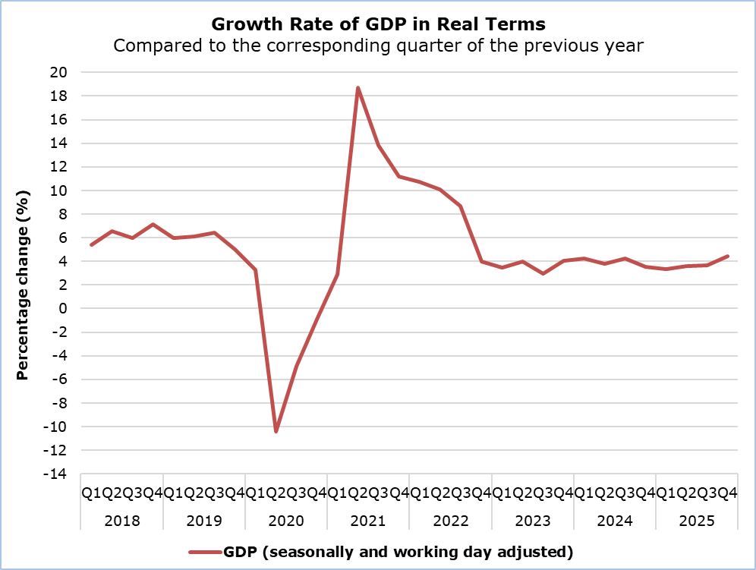

Regarding the production approach for the estimation of GDP, the positive growth rate is mainly attributed to the sectors: "Wholesale and Retail Trade, Repair of Motor Vehicles", "Information and Communication", "Hotels and Restaurants", “Construction”. (Table 1)

Table 1
Economic Activity (NACE Rev.2) | GDP in Real Terms Seasonally and Working Day Adjusted
Economic Activity (NACE Rev.2) | Euro (million) | Change (%)
Economic Activity (NACE Rev.2) | Q4  2025 | Q4  2025/24 | Q4 2025/  Q3 2025
Gross Domestic Product (GDP) | 7.795,3 | 4,5 | 1,4
A | 84,3 | 1,1 | 0,5
B - E | 459,1 | 4,3 | 1,7
C | 335,4 | 4,7 | 1,5
F | 377,7 | 9,4 | 3,4
G - I | 1.589,2 | 7,2 | 2,0
J | 923,8 | 8,0 | 2,1
K | 617,8 | 2,8 | 0,6
L | 685,9 | 2,6 | 1,0
M & N | 675,2 | 2,4 | 0,7
O - Q | 1.206,5 | 1,1 | 0,1
R - U | 243,6 | 1,1 | 0,5
Economic Activities:
Α: Agriculture, forestry and fishing
B - E: Mining and quarrying; manufacturing; electricity, gas, steam and air conditioning supply; water supply; sewerage, waste management and remediation activities
C: Manufacturing
F: Construction
G - I: Wholesale and retail trade; repair of motor vehicles and motorcycles; transportation and storage; accommodation and food service activities
J: Information and communication
K: Financial and insurance activities
L: Real estate activities
M & N: Professional, scientific and technical activities; administrative and support service activities
O - Q: Public administration and defence; compulsory social security; education; human health and social work activities
R - U: Arts, entertainment and recreation, repair of household goods and other services

Table 2
Type of Expenditure | GDP in Real Terms Seasonally and Working Day Adjusted
Type of Expenditure | Euro (million) | Change (%)
Type of Expenditure | Q4  2025 | Q4  2025/24 | Q4 2025/  Q3 2025
Gross Domestic Product (GDP) | 7.795,3 | 4,5 | 1,4
Final Consumption Expenditure | 5.865,5 | 3,6 | -0,1
Of which:  Households and NPISH | 4.571,0 | 3,4 | -0,5
General Government | 1.298,3 | 4,4 | 1,1
Gross Fixed Capital Formation (GFCF) | 1.570,3 | -15,2 | 13,9
GFCF excluding ships & aircrafts | 1.485,3 | 1,6 | -1,3
Imports of Goods and Services | 7.603,4 | -4,2 | -0,3
Exports of Goods and Services | 7.980,8 | 2,9 | -1,5
NPISH: Non-Profit Institutions Serving Households

METHODOLOGICAL INFORMATION

Scope

The scope of the GDP estimate 110 days after the end of the reference quarter, is to incorporate any changes from sources in order to update appropriately QNA data.

Compilation and Methodology

QNA are generally constructed using an indirect approach, which is based on short-term indicators providing information on the evolution of the phenomena under study. Furthermore, Chow-Lin’s approach technique is used for temporal disaggregation.

The GDP level in Cyprus is determined from the production and expenditure approaches, while the income approach is considered a residual item.

QNA are produced at current, in real terms and previous-year-prices, published and transmitted to Eurostat at t+2 months. The flash estimate is obtained by running the same estimation procedure as the one applied for the t+2 months calculation however, with less input information available. It is calculated in real terms at t+45 days, published and transmitted to Eurostat as well.

QNA are compiled in accordance with the European System of Accounts (ESA 2010) as defined in Regulation (EU) No 549/2013 of the European Parliament and of the Council of 21 May 2013.

Source of Data

In order to produce QNA estimates, the following data are used as input to the system of calculation:
- short-term economic indicators by activity,
- administrative data,
- quarterly employment data,
- price indices.

For more information:
CYSTAT Portal, subtheme National Accounts
CYSTAT-DB (Online Database)
Methodological Information

Contact
Constantinou Maria: Τel: +35722602226, Email: mconstantinou@cystat.mof.gov.cy

