4 November, 2024

**PRESS RELEASE**

ANNUAL NON-FINANCIAL SECTOR ACCOUNTS: **2023**

**Annual Increase of 4,9% to the Disposable Income of Households and Non-Profit Institutions Serving Households**

Based on the preliminary estimates of the main aggregates of the National Accounts by institutional sector for the year 2023, the gross disposable income for the total economy amounted to €27.981,9 mn, the gross saving amounted to €3.463,0 mn and the net borrowing (-) amounted to €2.998,7 mn. (Table)

The disposable income of households and non-profit institutions serving households (NPISH) increased by 4,9% compared to 2022, from €19.743,7 mn to €20.713,2 mn, while their final consumption expenditure, increased by 9,8% in 2023 compared to 2022, from €17.030,2 mn to €18.702,7 mn.

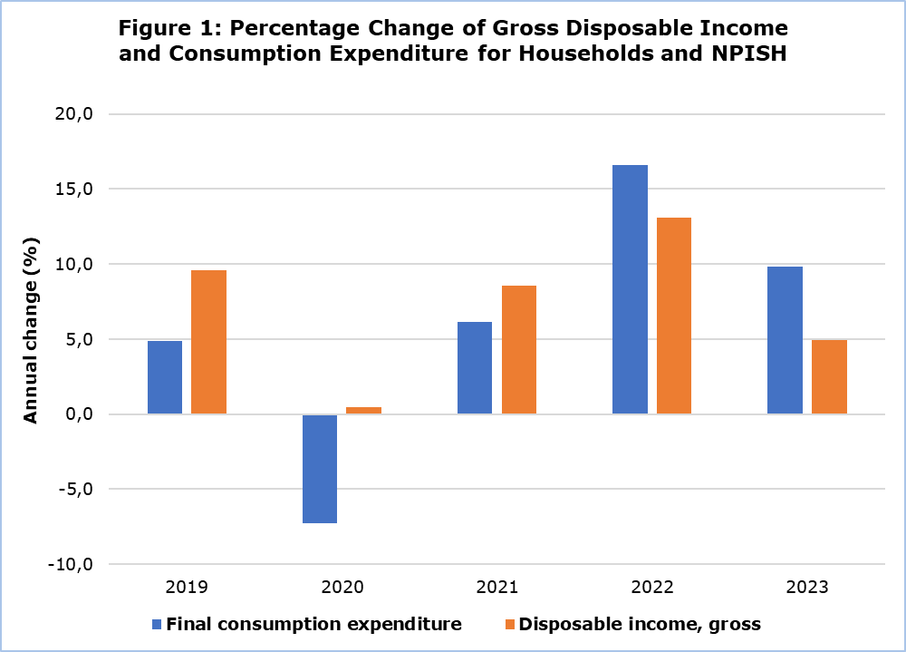

In addition, the savings ratio, which is calculated as the percentage of the gross saving to the gross disposable income of Households and NPISH, amounted to 9,9% compared to 12,1% in 2022.

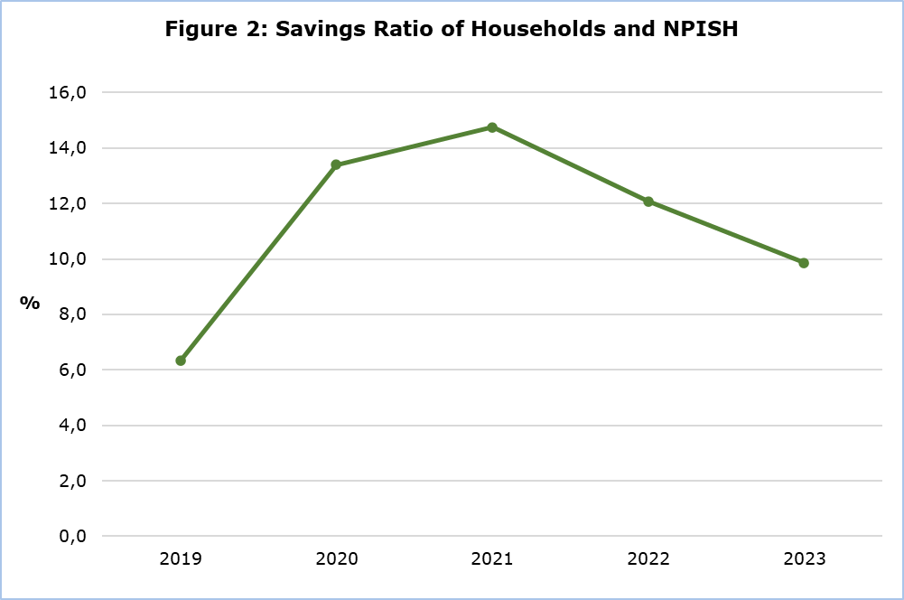

The investment ratio of the non-financial corporations, which is calculated as the percentage of investments to gross value added of the non-financial corporations’ sector, amounted to 19,8% compared to 17,7% in 2022.

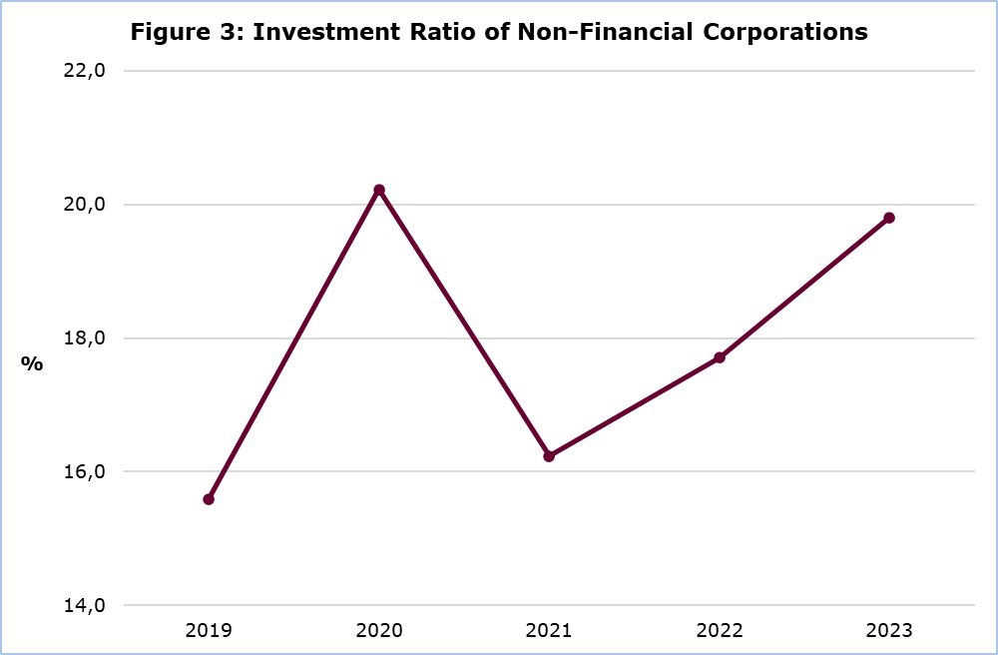

|  |  |  |  |  |  |  |  |
| --- | --- | --- | --- | --- | --- | --- | --- |
| **Table** |  |  |  |  |  |  |  |
| **Main Aggregates** | **Institutional Sectors 2023 (€mn.)** | | | | | | |
| **Total Economy** | **Non-Financial Corporations** | **Financial Corporations** | **General Government** | **Households and Non-Profit Institutions** | **Non- sectorized transactions** | **Rest of the World** |
| B1G | 31.340,0 | 13.002,9 | 2.790,2 | 4.371,8 | 7.514,2 | 3.660,8 | n.a. |
| D1 | 13.638,0 | 7.920,4 | 1.299,2 | 3.591,8 | 826,6 | n.a. | 73,9 |
| B2A3G | 13.381,3 | 4.540,7 | 1.469,2 | 780,0 | 6.591,3 | n.a. | n.a. |
| D4 | -2.819,1 | -2.547,1 | -861,5 | -270,8 | 860,3 | n.a. | 2.819,1 |
| B5G | 28.341,0 | 1.993,6 | 607,8 | 4.792,4 | 20.947,3 | n.a. | n.a. |
| D5 | -1,2 | -1.986,5 | -309,0 | 3.242,2 | -947,9 | n.a. | 1,2 |
| D6 | 0,2 | -139,0 | -437,5 | -2.928,4 | 3.505,1 | n.a. | -0,2 |
| D7 | -358,1 | -486,8 | -32,5 | -411,3 | 572,5 | n.a. | 358,1 |
| B6G | 27.981,9 | -618,7 | -171,1 | 8.058,6 | 20.713,2 | n.a. | n.a. |
| P3 | 24.518,9 | n.a. | n.a. | 5.816,2 | 18.702,7 | n.a. | n.a. |
| B8G | 3.463,0 | -618,7 | 206,3 | 1.831,4 | 2.044,0 | n.a. | n.a. |
| D9 | 85,1 | -31,1 | -0,8 | -206,4 | 323,4 | n.a. | -85,1 |
| P5 | 6.429,1 | 2.325,3 | 65,0 | 977,5 | 3.061,3 | n.a. | n.a. |
| P6 | n.a. | n.a. | n.a. | n.a. | n.a. | n.a. | 30.405,7 |
| P7 | n.a. | n.a. | n.a. | n.a. | n.a. | n.a. | 30.013,7 |
| B9 | -2.998,7 | -3.092,8 | 156,3 | 631,7 | -693,9 | n.a. | 2.998,7 |

n.a.: Not applicable

Non sectorized transactions: Taxes less Subsidies

**Main Aggregates:**

**B1G**: Gross domestic product

**D1**: Compensation of employees

**B2A3G**: Gross operating surplus and mixed income

**D4**: Property income

**B5G**: Gross national income

**D5**: Current taxes on income and wealth

**D6**: Social contributions and benefits

**D7**: Other current transfers

**B6G**: Gross disposable income

**P3**: Final consumption expenditure

**B8G**: Gross Saving

**D9**: Capital transfers

**P5**: Gross capital formation

**P6**: Exports of goods and services

**P7**: Imports of goods and services

**B9**: Net lending (+) / net borrowing (-)

**METHODOLOGICAL INFORMATION**

**Scope**

Information is provided for the complete sequence of non-financial accounts (transactions and balancing items) by institutional sector. It consists of the following accounts:

* Production account,
* Primary distribution of income account,
* Secondary distribution of income account,
* Use of income account,
* Capital account,
* Change in net worth due to saving and capital transfers account,
* Acquisition of non-financial assets account.

The institutional sectors consist of groups of institutional units with similar characteristics and some of these sectors are subdivided into further subsectors.

**Compilation and Methodology**

The annual non-financial accounts by institutional sector cover all the institutional sectors based on the European System of Accounts 2010 (ESA 2010).

Economic data by institutional sector and for the total economy are collected from:

* Government Finance Statistics Section of the Statistical Service for the General Government sector,
* National Accounts Division of the Statistical Service, for the macroeconomic figures that concern the whole economy,
* Central Bank of Cyprus for the Rest Of the World Sector (ROW), from Balance of Payments statistics,
* Demography, Social Statistics and Tourism Division of the Statistical Service,
* Cyprus Agricultural Payments Organization (CAPO),
* Business Register of the Statistical Service,
* Results of the annual economic surveys (Industry, Construction, Wholesale and Retail Trade, Services) of the Statistical Service.

**Source of Data**

The annual non-financial accounts by institutional sector cover all the institutional sectors of the economy.

***For more information:***

CYSTAT Portal, subtheme [National Accounts](https://www.cystat.gov.cy/en/SubthemeStatistics?s=45)

[CYSTAT-DB](https://cystatdb.cystat.gov.cy/pxweb/en/8.CYSTAT-DB/8.CYSTAT-DB__National%20Accounts__) (Online Database)

[Predefined Tables](https://www.cystat.gov.cy/en/KeyFiguresList?s=45) (Excel)

[Methodological Information](https://www.cystat.gov.cy/en/MethodologicalDetails?m=2086)

*Contact*

Michalis Pantziaras: Tel:+35722605127, Email: [mpantziaras@cystat.mof.gov.cy](mailto:mpantziaras@cystat.mof.gov.cy)