31 October, 2025

PRESS RELEASE

ANNUAL NON-FINANCIAL SECTOR ACCOUNTS: 2024

Annual Increase of 8,4% to the Disposable Income of Households and Non-Profit Institutions Serving Households (NPISH)

Based on the preliminary estimates of the main aggregates of the National Accounts by institutional sector for the year 2024, the gross disposable income for the total economy amounted to €30.655,2 mn, the gross saving amounted to €4.339,5 mn and the net borrowing (-) amounted to €3.063,8 mn. (Table)

The disposable income of Households and NPISH increased by 8,4% in 2024 compared to 2023, from €19.387,8 mn to €21.016,1 mn, while their final consumption expenditure, increased by 5,8% in 2024 compared to 2023, from €18.829,8 mn to €19.915,1 mn.

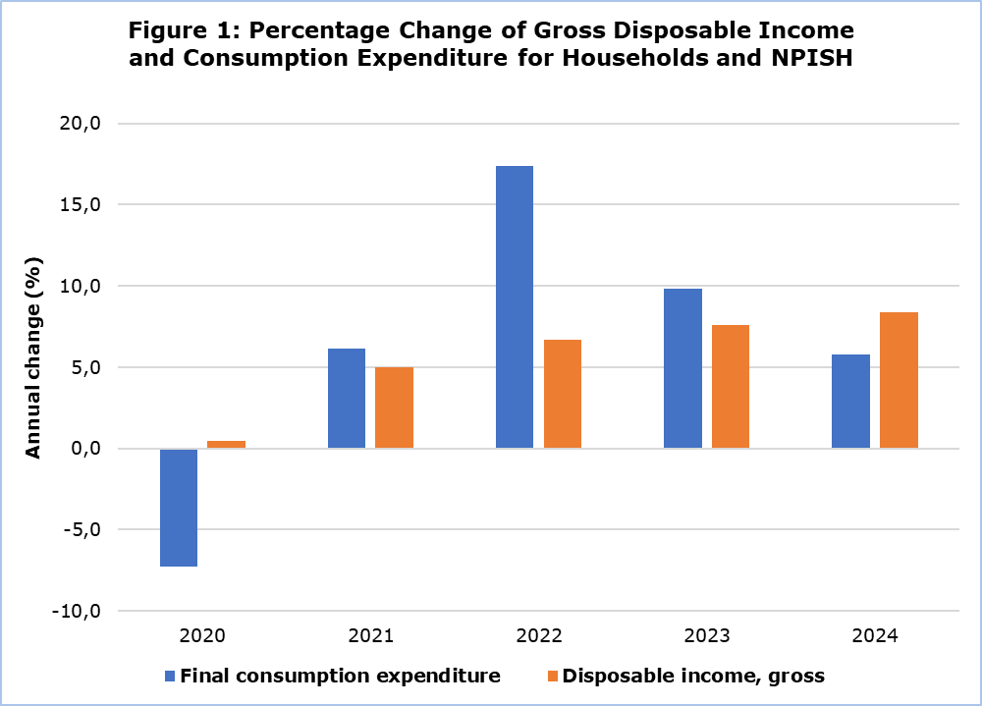

In addition, the savings ratio, which is calculated as the percentage of the gross saving to the gross disposable income of Households and NPISH, amounted to 5,6% in 2024 compared to 5,9% in 2023.

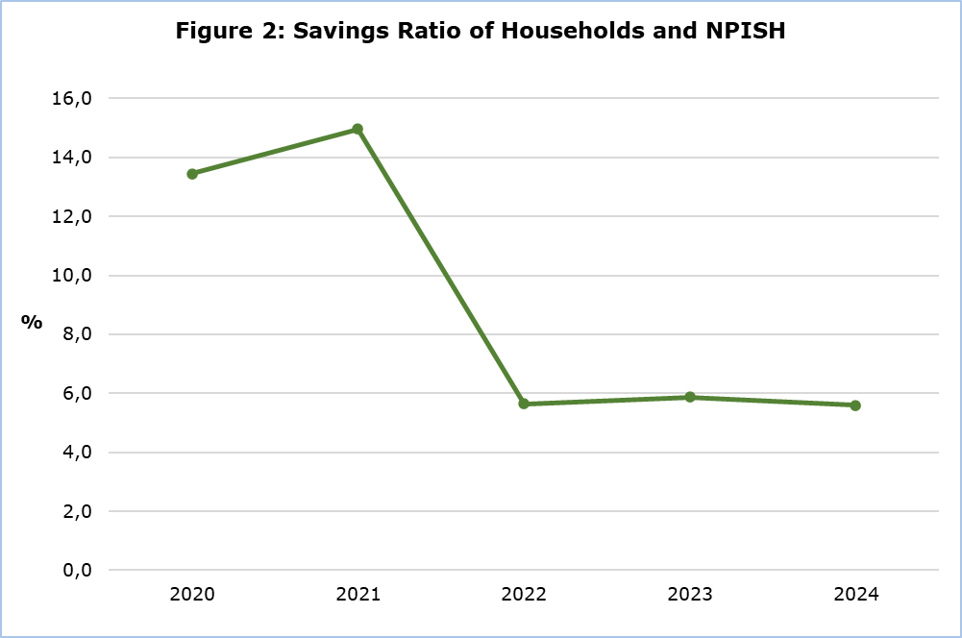

The investment ratio of the non-financial corporations, which is calculated as the percentage of investments to gross value added of the non-financial corporations’ sector, amounted to 16,0% in 2024 compared to 18,3% in 2023.

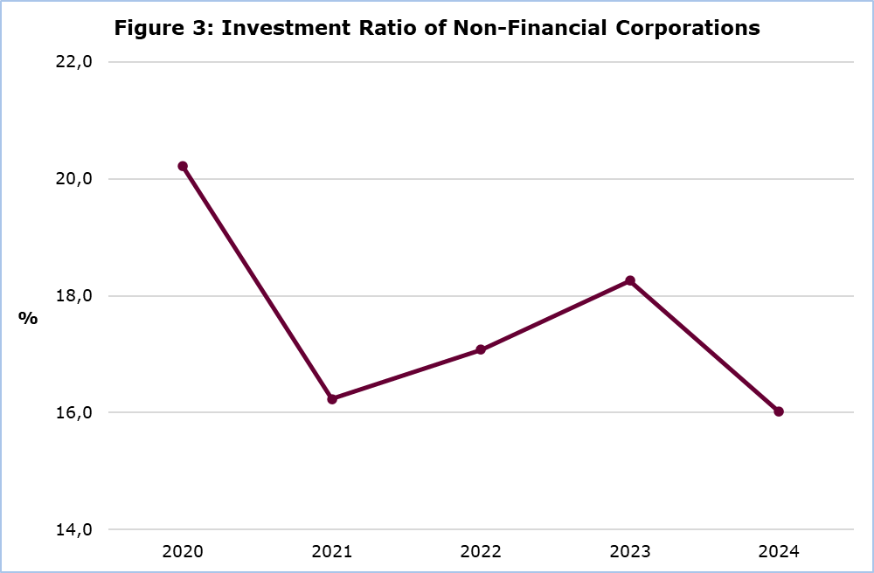
Table
Main Aggregates | Institutional Sectors 2024 (€mn.)
Main Aggregates | Total Economy | Non-Financial Corporations | Financial Corporations | General Government | Households and Non-Profit Institutions | Non- sectorized transactions | Rest of the World
B1G | 34.770,2 | 16.592,3 | 3.080,9 | 4.693,9 | 6.497,6 | 3.905,4 | n.a.
D1 | 15.319,9 | 8.976,5 | 1.536,6 | 3.877,9 | 928,9 | n.a. | 102,2
B2A3G | 14.933,4 | 7.117,0 | 1.522,7 | 816,0 | 5.477,6 | n.a. | n.a.
D4 | -3.555,7 | -3.886,6 | -612,9 | -311,8 | 1.255,7 | n.a. | 3.555,7
B5G | 31.016,6 | 3.230,5 | 909,8 | 5.015,9 | 21.860,5 | n.a. | n.a.
D5 | -0,8 | -2.315,4 | -378,8 | 3.776,0 | -1.082,5 | n.a. | 0,8
D6 | 2,5 | -180,7 | 12,9 | -3.343,2 | 3.513,5 | n.a. | -2,5
D7 | -363,1 | -364,8 | -43,6 | -359,7 | 405,0 | n.a. | 363,1
B6G | 30.655,2 | 369,5 | 500,3 | 8.769,4 | 21.016,1 | n.a. | n.a.
P3 | 26.315,8 | n.a. | n.a. | 6.400,7 | 19.915,1 | n.a. | n.a.
B8G | 4.339,5 | 369,5 | 487,4 | 2.308,0 | 1.174,6 | n.a. | n.a.
D9 | -19,8 | -61,6 | -8,5 | 123,4 | -73,1 | n.a. | 19,8
P5 | 7.189,6 | 2.664,4 | 366,7 | 966,1 | 3.192,4 | n.a. | n.a.
P6 | n.a. | n.a. | n.a. | n.a. | n.a. | n.a. | 33.734,1
P7 | n.a. | n.a. | n.a. | n.a. | n.a. | n.a. | 32.469,3
B9 | -3.063,8 | -2.550,4 | 137,8 | 1.439,7 | -2.090,9 | n.a. | 3.063,8
n.a.: Not applicable
Non sectorized transactions: Taxes less Subsidies
Main Aggregates:
B1G: Gross domestic product
D1: Compensation of employees
B2A3G: Gross operating surplus and mixed income
D4: Property income
B5G: Gross national income
D5: Current taxes on income and wealth
D6: Social contributions and benefits
D7: Other current transfers
B6G: Gross disposable income
P3: Final consumption expenditure
B8G: Gross Saving
D9: Capital transfers
P5: Gross capital formation
P6: Exports of goods and services
P7: Imports of goods and services
B9: Net lending (+) / net borrowing (-)

METHODOLOGICAL INFORMATION

Scope

Information is provided for the complete sequence of non-financial accounts (transactions and balancing items) by institutional sector. It consists of the following accounts:
- Production account,
- Primary distribution of income account,
- Secondary distribution of income account,
- Use of income account,
- Capital account,
- Change in net worth due to saving and capital transfers account,
- Acquisition of non-financial assets account.

The institutional sectors consist of groups of institutional units with similar characteristics and some of these sectors are subdivided into further subsectors.

Compilation and Methodology

The annual non-financial accounts by institutional sector cover all the institutional sectors based on the European System of Accounts 2010 (ESA 2010).
Economic data by institutional sector and for the total economy are collected from:
- Government Finance Statistics Section of the Statistical Service for the General Government sector,
- National Accounts Division of the Statistical Service, for the macroeconomic figures that concern the whole economy,
- Central Bank of Cyprus for the Rest of the World Sector (ROW), from Balance of Payments statistics,
- Demography, Social Statistics and Tourism Division of the Statistical Service,
- Cyprus Agricultural Payments Organization (CAPO),
- Business Register of the Statistical Service,
- Results of the annual economic surveys (Industry, Construction, Wholesale and Retail Trade, Services) of the Statistical Service.

Source of Data

The annual non-financial accounts by institutional sector cover all the institutional sectors of the economy.

For more information:
CYSTAT Portal, subtheme National Accounts
CYSTAT-DB (Online Database)
Predefined Tables (Excel)
Methodological Information

Contact
Michalis Pantziaras: Tel: +35722605127, Email: mpantziaras@cystat.mof.gov.cy

