18 September, 2025

**PRESS RELEASE**

PRICE INDEX OF CONSTRUCTION MATERIALS: **AUGUST 2025**

**Annual Change +1,17%**

The Price Index of Construction Materials for August 2025 reached 119,06 units (base year 2021=100), recording a negligible increase of 0,01% compared to the previous month.

Compared to the same month of the previous year, the index recorded an increase of 1,17%. By main commodity category, increases were recorded in mineral products (3,24%), minerals (3,20%) and products of wood, insulation materials, chemicals and plastics (0,73%), whereas decreases were observed in metallic products (-0,92%) and electromechanical products (-0,07%).

For the period January-August 2025, the index recorded an increase of 1,23% compared to the corresponding period of 2024.

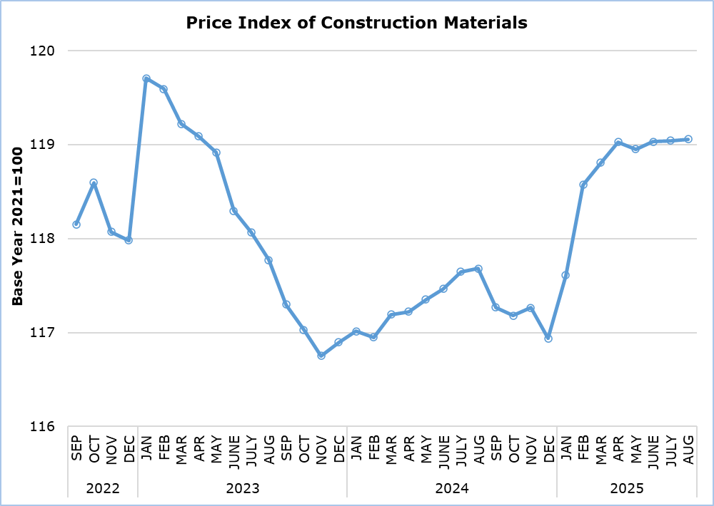

|  |  |  |  |  |  |
| --- | --- | --- | --- | --- | --- |
| **Table** | | | | | |
| **Code** | **Commodity Category** | **Index**  **August 2025**  **(2021=100)** | **Percentage Change**  **(%)** | | |
| **Aug 2025 /**  **July 2025** | **Aug 2025 /**  **Aug 2024** | **Jan-Aug 2025 /**  **Jan-Aug 2024** |
| **1** | **Minerals** | **135,47** | **-0,12** | **3,20** | **3,17** |
| 11 | Mineral aggregates | 137,85 | 0,88 | 9,48 | 7,11 |
| 12 | Cements | 137,71 | -0,81 | -2,15 | -0,69 |
| 13 | Stones | 130,20 | 0,00 | 6,36 | 5,94 |
| **2** | **Mineral products** | **126,23** | **-0,03** | **3,24** | **3,08** |
| 21 | Cement products | 126,39 | -0,04 | 3,71 | 3,34 |
| 22 | Ceramics | 125,70 | 0,00 | 1,66 | 2,21 |
| **3** | **Products of wood, insulation materials, chemicals and plastics** | **120,28** | **0,00** | **0,73** | **0,75** |
| 31 | Products of wood | 121,58 | 0,00 | 0,44 | 0,53 |
| 32 | Insulation materials | 117,32 | 0,00 | 2,75 | 2,00 |
| 33 | Chemical products | 112,84 | 0,00 | 0,48 | 0,81 |
| 34 | Plastic products | 124,29 | 0,00 | 0,79 | 0,74 |
| **4** | **Metallic products** | **106,69** | **0,13** | **-0,92** | **-0,84** |
| 41 | Iron and steel products | 102,03 | 0,19 | -2,02 | -2,08 |
| 42 | Products from aluminium and other metals | 117,24 | 0,00 | 1,31 | 1,72 |
| **5** | **Electromechanical products** | **115,17** | **0,06** | **-0,07** | **0,69** |
| 51 | Electrical fixtures | 132,26 | 0,14 | 1,85 | 4,39 |
| 52 | Heating and cooling equipment | 95,68 | 0,00 | -5,59 | -6,22 |
| 53 | Other electromechanical products | 115,97 | 0,00 | 2,67 | 2,49 |
|  | **General Index** | **119,06** | **0,01** | **1,17** | **1,23** |

**METHODOLOGICAL INFORMATION**

**Definitions**

The Price Index of Construction Materials shows the evolution of the cost of construction materials incurred by the contractor.

**Collection of Data**

Prices of materials used in construction are collected on a monthly basis based on a sample of products and suppliers. The reference date for the prices collected is the 15th each month. Prices are valued excluding VAT. The data collection is carried out by telephone or e-mail.

**Compilation Method**

The price indices are based on the year 2021, meaning that they show the evolution of the price of a certain material in relation to its average price in 2021. In the base year, the average of the price indices for the twelve months is 100. For example, a price index of 101,56 for a material in a certain month implies that the price has gone up by 1,56% in relation to its average price of 2021.

The aggregated price index of materials is a weighted average of the price indices of the various materials in the sample. The weights used reflect the share of each material to the total expenditure for construction materials incurred by the contractors and are derived from the value of imports and local production for that material in the base year (2021).

The index disseminated on the web Portal of the Statistical Service covers all types of construction works. It forms a component of the Construction Costs Index, which is transmitted to and published by the Statistical Office of the European Union (Eurostat) in accordance with the provisions of Regulation (EU) 2019/2152 on European business statistics. The Construction Costs Index is limited to new residential buildings, excluding residencies for communities.

***For more information:***

CYSTAT Portal, subtheme [Construction](https://www.cystat.gov.cy/en/SubthemeStatistics?s=31)

[CYSTAT-DB](https://cystatdb23px.cystat.gov.cy/pxweb/en/8.CYSTAT-DB/8.CYSTAT-DB__Construction__) (Online Database)

[Predefined Tables](https://www.cystat.gov.cy/en/KeyFiguresList?s=31) (Excel)

[Methodological Information](https://www.cystat.gov.cy/en/MethodologicalDetails?m=2308)

**Data for base year 2021=100 are available only in the CYSTAT-DB Online Database.**

*Contact*  
Evi Kalogirou Demetriou: Tel:+357 22 602168, Email: [ekalogirou@cystat.mof.gov.cy](mailto:ekalogirou@cystat.mof.gov.cy)

Dimitrios Pilavakis: Tel:+357 22 602153, Email: [dpilavakis@cystat.mof.gov.cy](mailto:dpilavakis@cystat.mof.gov.cy)