19 January, 2026

PRESS RELEASE

PRICE INDEX OF CONSTRUCTION MATERIALS: DECEMBER 2025

Annual Change +1,54%

The Price Index of Construction Materials for December 2025 reached 118,74 units (base year 2021=100), recording a marginal increase of 0,10% compared to the previous month.

Compared to the same month of the previous year, the index recorded an increase of 1,54%. By main commodity category, increases were observed in minerals (3,38%), mineral products (2,62%), electromechanical products (2,23%) and products of wood, insulation materials, chemicals and plastics (1,33%), whereas a decrease was recorded in metallic products (-0,54%).

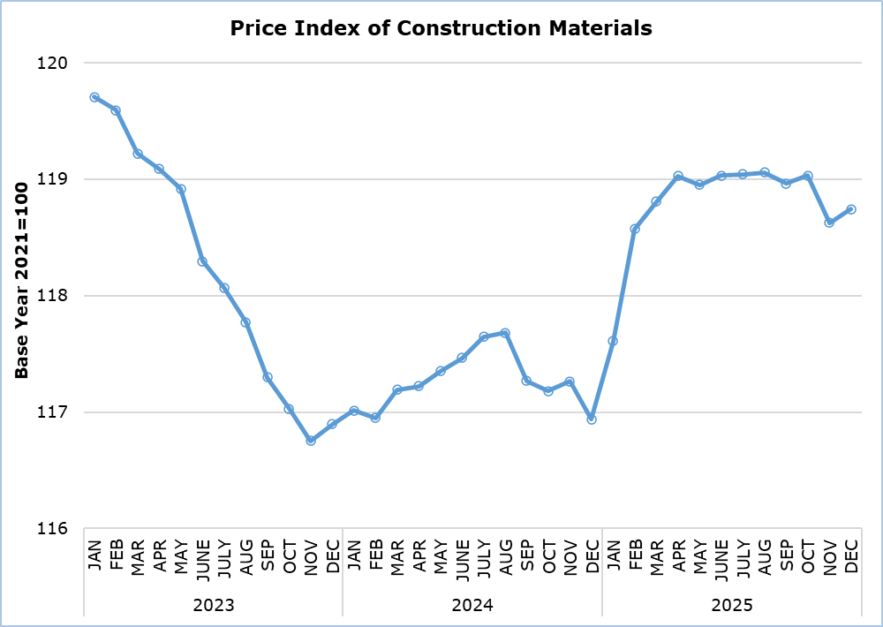

For the period January-December 2025, the index increased by 1,30% compared to the corresponding period of 2024.

The increase of the index in 2025 over the previous year is mainly due to the increase in the prices of the following materials: crushed sand (9,27%), marble (7,98%), crushed gravel (7,28%), iron rails (6,60%), wires and cables (6,19%), thermal insulation (5,25%) and ready-mix concrete (4,14%). On the other hand, many materials recorded a decrease in their prices compared to 2024. The most significant are: steel pipes (-7,61%), air conditioners (-6,27%), lamps (-4,90%), structural grid (-4,10%), building iron (-3,67%), concrete and mortar additives (-3,29%) and structural steel (-2,89%).

Table
Code | Commodity Category | Index  December 2025  (2021=100) | Percentage Change  (%)
Code | Commodity Category | Index  December 2025  (2021=100) | Dec 2025 /  Nov 2025 | Dec 2025 /  Dec 2024 | Jan-Dec 2025 /  Jan-Dec 2024
1 | Minerals | 135,87 | 0,00 | 3,38 | 3,34
11 | Mineral aggregates | 138,01 | 0,00 | 9,68 | 7,95
12 | Cements | 138,55 | 0,00 | -1,06 | -0,74
13 | Stones | 130,20 | 0,00 | 4,97 | 5,84
2 | Mineral products | 125,92 | 0,00 | 2,62 | 3,07
21 | Cement products | 126,36 | 0,00 | 3,53 | 3,46
22 | Ceramics | 124,44 | 0,00 | -0,40 | 1,77
3 | Products of wood, insulation materials, chemicals and plastics | 120,85 | 0,00 | 1,33 | 0,90
31 | Products of wood | 122,41 | 0,00 | 1,11 | 0,63
32 | Insulation materials | 117,46 | 0,00 | 2,56 | 2,35
33 | Chemical products | 112,84 | 0,00 | 1,50 | 1,06
34 | Plastic products | 124,47 | 0,00 | 1,25 | 0,96
4 | Metallic products | 105,36 | -0,14 | -0,54 | -0,81
41 | Iron and steel products | 100,13 | -0,34 | -1,96 | -1,96
42 | Products from aluminium and other metals | 117,22 | 0,24 | 2,33 | 1,55
5 | Electromechanical products | 115,02 | 1,30 | 2,23 | 0,66
51 | Electrical fixtures | 133,22 | 0,33 | 3,80 | 3,75
52 | Heating and cooling equipment | 93,93 | 4,44 | -0,44 | -5,61
53 | Other electromechanical products | 116,23 | 0,00 | 2,52 | 2,57
 | General Index | 118,74 | 0,10 | 1,54 | 1,30

METHODOLOGICAL INFORMATION

Definitions

The Price Index of Construction Materials shows the evolution of the cost of construction materials incurred by the contractor.

Collection of Data

Prices of materials used in construction are collected on a monthly basis based on a sample of products and suppliers. The reference date for the prices collected is the 15th each month. Prices are valued excluding VAT. The data collection is carried out by telephone or e-mail.

Compilation Method

The price indices are based on the year 2021, meaning that they show the evolution of the price of a certain material in relation to its average price in 2021. In the base year, the average of the price indices for the twelve months is 100. For example, a price index of 101,56 for a material in a certain month implies that the price has gone up by 1,56% in relation to its average price of 2021.

The aggregated price index of materials is a weighted average of the price indices of the various materials in the sample. The weights used reflect the share of each material to the total expenditure for construction materials incurred by the contractors and are derived from the value of imports and local production for that material in the base year (2021).

The index disseminated on the web Portal of the Statistical Service covers all types of construction works. It forms a component of the Construction Costs Index, which is transmitted to and published by the Statistical Office of the European Union (Eurostat) in accordance with the provisions of Regulation (EU) 2019/2152 on European business statistics. The Construction Costs Index is limited to new residential buildings, excluding residencies for communities.

For more information:
CYSTAT Portal, subtheme Construction
CYSTAT-DB (Online Database)
Predefined Tables (Excel)
Methodological Information

Data for base year 2021=100 are available only in the CYSTAT-DB Online Database.

Contact
Evi Kalogirou Demetriou: Tel.: +357-22602168, Email: ekalogirou@cystat.mof.gov.cy
Dimitrios Pilavakis: Tel.: +357-22602153, Email: dpilavakis@cystat.mof.gov.cy

