18 October, 2022

PRESS RELEASE

PRICE INDEX OF CONSTRUCTION MATERIALS: SEPTEMBER 2022

Annual Change +16,24%

The Price Index of Construction Materials for September 2022 reached 134,55 units (base year 2015=100), recording a marginal increase of 0,16% compared to the previous month.

Compared to the same month of the previous year, the index recorded an increase of 16,24%. By main commodity category, increases were recorded in metallic products (18,73%), minerals (16,95%), mineral products (15,51%), products of wood, insulation materials, chemicals and plastics (14,62%) and electromechanical products (12,23%).

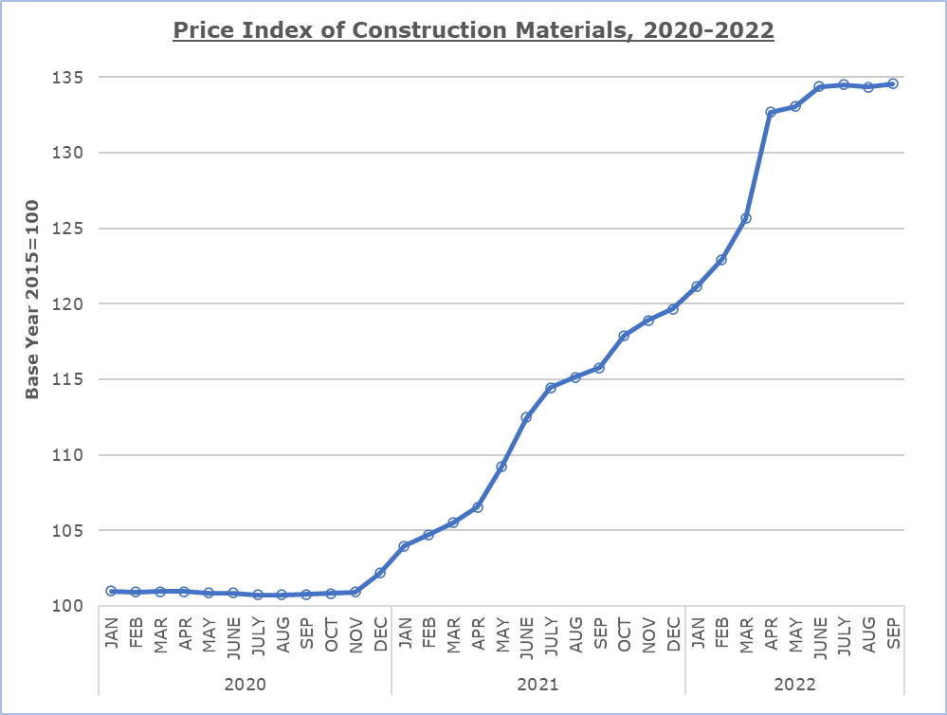

 | Table
Code |  | Commodity category |  | Index  September 2022  (2015=100) |  | Percentage Change  (%)
 |  |  |  |  |  | Sept 22 /  Aug 22 |  | Sept 22 /  Sept 21 |  | Jan-Sept 22 / Jan-Sept 21
 | 1 |  | Minerals |  | 118,24 |  | 0,99 |  | 16,95 |  | 11,22
 | 11 |  | Mineral aggregates |  | 117,83 |  | 1,56 |  | 19,15 |  | 10,47
 | 12 |  | Cements |  | 124,44 |  | -0,32 |  | 20,61 |  | 15,50
 | 13 |  | Stones |  | 111,05 |  | 2,34 |  | 10,68 |  | 6,51
 | 2 |  | Mineral products |  | 115,95 |  | 0,20 |  | 15,51 |  | 11,27
 | 21 |  | Cement products |  | 111,91 |  | -0,21 |  | 11,72 |  | 8,61
 | 22 |  | Ceramics |  | 128,86 |  | 1,35 |  | 27,52 |  | 19,68
 | 3 |  | Products of wood, insulation materials, chemicals and plastics |  | 132,99 |  | 1,38 |  | 14,62 |  | 18,94
 | 31 |  | Products of wood |  | 134,38 |  | 1,55 |  | 12,65 |  | 20,13
 | 32 |  | Insulation materials |  | 107,15 |  | 0,24 |  | 7,54 |  | 8,73
 | 33 |  | Chemical products |  | 118,55 |  | 1,95 |  | 5,67 |  | 9,72
 | 34 |  | Plastic products |  | 156,08 |  | 0,94 |  | 32,69 |  | 27,97
 | 4 |  | Metallic products |  | 161,37 |  | -1,31 |  | 18,73 |  | 27,52
 | 41 |  | Iron and steel products |  | 174,91 |  | -2,19 |  | 16,40 |  | 29,43
 | 42 |  | Products from aluminium and other metals |  | 143,84 |  | 0,10 |  | 22,57 |  | 24,46
 | 5 |  | Electromechanical products |  | 123,38 |  | 1,24 |  | 12,23 |  | 13,59
 | 51 |  | Electrical fixtures |  | 151,25 |  | 3,01 |  | 18,20 |  | 19,72
 | 52 |  | Heating and cooling equipment |  | 91,54 |  | 0,00 |  | 2,55 |  | 2,27
 | 53 |  | Other electromechanical products |  | 123,34 |  | 0,08 |  | 12,16 |  | 14,83
 |  |  | General Index |  | 134,55 |  | 0,16 |  | 16,24 |  | 18,78

METHODOLOGICAL INFORMATION

Definitions

The Price Index of Construction Materials shows the evolution of the cost of construction materials incurred by the contractor.

Collection of data

Prices of materials used in construction are collected on a monthly basis based on a sample of products and suppliers. The reference date for the prices collected is the 15th each month. Prices are valued excluding VAT. The data collection is carried out by telephone, fax or e-mail.

Compilation method

The price indices are based on the year 2015, meaning that they show the evolution of the price of a certain material in relation to its average price in 2015. In the base year, the average of the price indices for the twelve months is 100. For example, a price index of 101,57 for a material in a certain month implies that the price has gone up by 1,57% in relation to its average price of 2015.

The aggregated price index of materials is a weighted average of the price indices of the various materials in the sample. The weights used reflect the share of each material to the total expenditure for construction materials incurred by the contractors and are derived from the value of imports and local production for that material in the base year (2015).

The index disseminated on the web site of the Statistical Service covers all types of construction works. It forms a component of the Construction Costs Index, which is transmitted to and published by the Statistical Office of the European Union (Eurostat) in accordance to the provisions of Regulation (EU) 2019/2152 on European business statistics. The Construction Costs Index is limited to new residential buildings, excluding residencies for communities.

For more information:
CYSTAT Portal, subtheme Construction
Predefined Tables (Excel)

Contact
Evi Kalogirou Demetriou
Tel:+357 22 602168
Email: ekalogirou@cystat.mof.gov.cy

