15 July, 2021

PRESS RELEASE

RESEARCH AND DEVELOPMENT ACTIVITY IN CYPRUS IN 2019

On the basis of the results of the survey carried out by the Statistical Service for the collection of data on scientific research and experimental development, total R & D expenditure in Cyprus in 2019 is estimated at €164,4 million which corresponds to 0,74% of the Gross Domestic Product, compared to €133,1 million or 0,62% of the GDP in 2018.

FIGURE 1: R & D EXPENDITURE IN EUROPE AS % OF GDP, 2019

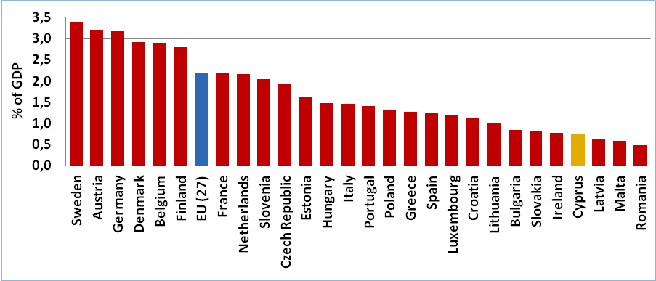

Despite the substantial increase of 23,5% observed in R&D expenditure in 2019 relative to 2018, the share of the GDP of Cyprus devoted to R&D activities continues to be low compared to other countries (Figure 1). For example, the share of R&D expenditure to the GDP of the Member States of the European Union stands at 2,20% on average (ranging from 0,50% in Romania, 0,57% in Malta and 0,64% in Latvia to 3,18% in Germany, 3,19% in Austria and 3,40% in Sweden).

It is worth noting that Cyprus exhibits one of the highest average annual growth rates in R&D expenditure, at 11% over the period 1998 – 2019.

FIGURE 2: PERCENTAGE DISTRIBUTION OF R & D EXPENDITURE BY SECTOR, 2008-2019

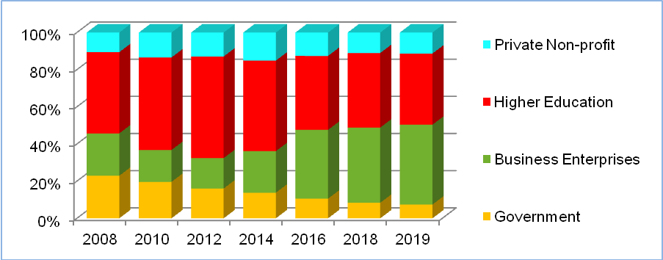

By sector of performance, the business enterprises accounted in 2019 for €70,7 million or 43,0% of total R & D expenditure, the higher education institutions for €63,0 million or 38,3%, the private non-profit institutions for €18,6 million or 11,3% and the government for €12,2 million or 7,4%, comparing with shares of 40,5%, 40,1%, 11,0% and 8,4% respectively in 2018 (Figure 2).

In the business enterprise sector, the information and communication branch constituted the principal source of R & D activity, with a total R & D expenditure of €40,7 million, while of importance was also the contribution of the manufacturing industry (and particularly the manufacturers of basic pharmaceutical products and preparations and of computer, electronic and optical products and electrical equipment) with €22,2 million.

About 22,4% of R & D activity in 2019 was financed from government funds (€36,8 million), as compared with €24,5 million or 18,4% in 2018, while €21,5 million was drawn from the budget of public universities and €37,5 million from sources from abroad (including European Union funds). An amount of €68,7 million or 41,8% of the total constituted the contribution of the private sector (Figure 3).

FIGURE 3: R & D EXPENDITURE BY SOURCE OF FUNDS, 2019

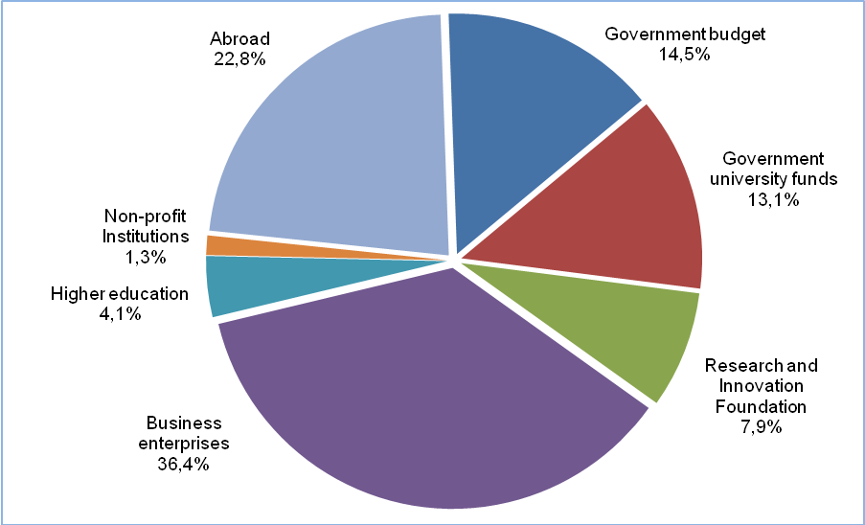

The biggest part of R & D expenditure was devoted to the natural sciences (€65,2 million), while engineering and technology absorbed €56,4 million, the social sciences €18,5 million, the medical sciences €10,6 million, the agricultural sciences €7,5 million and the humanities €6,2 million.

The number of persons engaged in R & D activities in 2019 stood at 4.082, compared to 3.754 in 2018. In full-time equivalent terms, this number is estimated at 2.121 persons, of which 827 or 39,0% were women. Of these persons, 33,1% were PhD degree holders.

METHODOLOGICAL INFORMATION

Coverage and Reference Period

Data cover all R&D activities in the Government controlled areas of Cyprus and refer to the calendar year.

Data Collection and Sources οf Data

A similar, with regard to its structure and content, questionnaire is used for all sectors of performance, with only minor differences in order to accommodate certain special features of each sector.

The survey can be considered as a census in terms of R&D expenditure and personnel.

Methodology

The data collection is carried out in accordance to the provisions of the Commission Implementing Regulation (EU) No 995/2012 laying down detailed rules for the implementation of Decision No 1608/2003/EC of the European Parliament and of the Council concerning the production and development of Community statistics on science and technology. It uses the definitions, concepts and methodology of the “Frascati Manual”, developed by the Organisation for Economic Co-operation and Development, which forms the proposed standard practice for surveys of R&D and is also used by the Statistical Office of the European Union (Eurostat).

Definitions

Scientific research and experimental development (R&D): comprise creative work undertaken on a systematic basis in order to increase the stock of knowledge, including knowledge of man, culture and society, and the use of this stock of knowledge to devise new applications.

R&D expenditure: comprises all expenditures (current and capital) performed within a statistical unit or sector of the economy, whatever the source of funds. Expenditures made outside the statistical unit or sector but in support of R&D are also included.

R&D personnel: comprise all persons employed directly on R&D, as well as those providing direct services such as R&D managers, administrators and clerical staff. R&D personnel can be distinguished into three categories: researchers, technicians and other supporting staff.

Full-time Equivalent (F.T.E.): expresses the total time devoted to research by a person during one year. One F.T.E. may be thought of as one person-year which corresponds to one person working full-time on R&D during one year.

Government sector: is composed of (a) all departments, services and other bodies which furnish but normally do not sell to the community those common services, other than higher education, which cannot otherwise be conveniently and economically provided and administer the state and the economic and social policy of the community, (b) non-profit institutions controlled and mainly financed by government. Public enterprises are included in the business enterprise sector.

Business enterprise sector: includes (a) all firms, organisations and institutions whose primary activity is the market production of goods or services (other than higher education) for sale to the general public, (b) the private non-profit institutions mainly serving them.

Higher education sector: is composed of all universities, colleges and other institutes of post-secondary education, whatever their source of finance or legal status. It also includes all research institutes, experimental stations and clinics operating under the direct control of or administered by or associated with higher education establishments.

Private non-profit sector: covers (a) non-market, private non-profit institutions serving households (i.e. the general public), (b) private individuals or households.

For more information:
Statistical Service (CYSTAT) Website, subtheme Research and Development

Contact
Georgios Dogoritis: Tel:+35722602170, Email: gdogoritis@cystat.mof.gov.cy

