13 May, 2024

**PRESS RELEASE**

REGISTRATION OF MOTOR VEHICLES: **JANUARY - APRIL 2024**

**Total Registrations +33,5%**

The Statistical Service announces the publication of the report entitled "Registration of Motor Vehicles" for the period January-April 2024.

In April 2024, the total registrations of motor vehicles numbered 4.762, recording an increase of 59,4% compared to 2.987 in April 2023. Passenger saloon cars registered a rise of 60,5% to 3.662, from 2.282 in April 2023.

The main developments during the period January-April 2024 compared to the corresponding period of 2023 are summarised as follows:

(a) The total registrations of motor vehicles increased by 33,5% to 17.589 in January-April 2024, from 13.180 in January-April 2023.

(b) Passenger saloon cars increased to 13.851 from 10.546 in January-April 2023, recording a rise of 31,3%. Of the total passenger saloon cars, 6.073 or 43,8% were new and 7.778 or 56,2% were used cars. Rental cars in particular recorded a fall of 18,5% to 1.399.

(c) The share of petrol powered passengers’ cars to the total of this category of vehicles decreased in January-April 2024 to 48,9% (from 60,1% in the corresponding period of the preceding year) and that of diesel powered cars to 10,0% in 2024 from 11,0% in 2023. On the other hand, the share of electric cars rose from 2,3% in 2023 to 3,6% in 2024 and of hybrid cars from 26,6% to 37,4%.

(d) Motor coaches and buses registered in January-April 2024 increased to 78, from 68 in the same period of 2023.

(e) Goods conveyance vehicles increased by 47,4% to 1.963 in January-April 2024, compared to 1.332 in January-April 2023. In particular, light goods vehicles increased by 48,5% to 1.550, heavy goods vehicles by 40,0% to 231, road tractors (units of trailers) by 91,9% to 71 and rental vehicles by 29,1% to 111.

(f) Mopeds < 50cc registered in January-April 2024 increased to 364 compared to 35 in the corresponding period of the previous year.

(g) Mechanised cycles > 50cc increased by 6,6% to 1.099 in January-April 2024, compared to 1.031 in the same period of 2023.

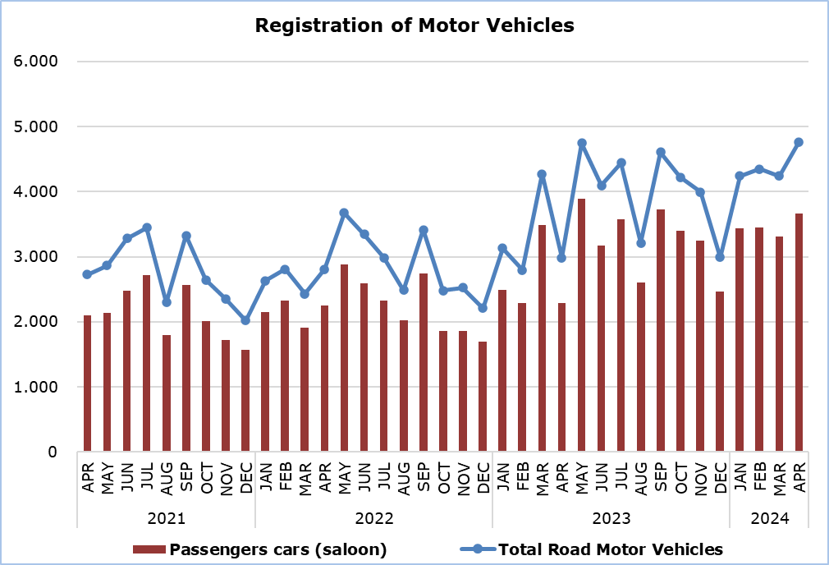

|  |  |  |  |  |  |  |  |
| --- | --- | --- | --- | --- | --- | --- | --- |
| **Table** |  |  |  |  |  |  |  |
| **Category of Road Motor Vehicles** | **Number of Registrations** | | | |  | **Percentage Change**  **(%)** | |
| **Apr**  **2024** | **Apr**  **2023** | **Jan-Apr**  **2024** | **Jan-Apr**  **2023** |  | **Apr**  **2024/2023** | **Jan-Apr**  **2024/2023** |
|
| Passengers’ cars (saloon) | 3.662 | 2.282 | 13.851 | 10.546 |  | 60,5 | 31,3 |
| Motor coaches and buses | 14 | 47 | 78 | 68 |  | -70,2 | 14,7 |
| Goods conveyance vehicles | 518 | 303 | 1.963 | 1.332 |  | 71,0 | 47,4 |
| Mopeds < 50cc | 124 | 7 | 364 | 35 |  | 1.671,4 | 940,0 |
| Mechanised cycles > 50cc | 372 | 309 | 1.099 | 1.031 |  | 20,4 | 6,6 |
| Tractors | 37 | 16 | 103 | 70 |  | 131,3 | 47,1 |
| Other vehicles | 35 | 23 | 131 | 98 |  | 52,2 | 33,7 |
| **Total** | **4.762** | **2.987** | **17.589** | **13.180** |  | **59,4** | **33,5** |
| New | 2.219 | 1.254 | 8.294 | 6.491 |  | 77,0 | 27,8 |
| Used | 2.543 | 1.733 | 9.295 | 6.689 |  | 46,7 | 39,0 |

**METHODOLOGICAL INFORMATION**

**Scope and Coverage**

Data for the Registration of Motor Vehicles are collected on a monthly basis. They include the newly registered motor vehicles, as recorded by the Department of Road Transport.

The registrations are presented by category, make, energy type, new or used, engine cubic capacity, country of manufacture and other vehicle characteristics, based on the information maintained by the Motor Vehicles Registration and Licensing Authority of the Department of Road Transport.

**Data Collection**

The collection of data is conducted by the Statistical Service, which receives the necessary data from the Department of Road Transport.

**Definitions**

“Road motor vehicle” means any road vehicle fitted with an engine whence it derives its sole means of propulsion, which is normally used for carrying persons or goods by road, namely:

* Passengers’ cars saloon, which include private cars, taxis, rental cars, learners’ cars and invalid carriages
* Motor coaches and buses, for private and public use
* Goods conveyance vehicles, which include heavy and light goods conveyance vehicles, rental vehicles and road tractors (units of trailers)
* Mopeds and mechanised cycles, which include autocycles, motor tricycles, motorcycles and rental motorcycles
* Tractors, for agriculture and non-agriculture use
* Other vehicles, which include road rollers, mobile motor cranes, heavy locomotives and other vehicles for specific type and use.

**Monthly Publication**

The report entitled "Registration of Motor Vehicles" is published on a monthly basis since 1982 and is available free of charge in electronic form on the portalof the Statistical Service.

***For more information:***

CYSTAT Portal, subtheme [Services](https://www.cystat.gov.cy/en/SubthemeStatistics?s=50)

[CYSTAT-DB](https://cystatdb.cystat.gov.cy/pxweb/en/8.CYSTAT-DB/8.CYSTAT-DB__Services__) (Online Database)

[Predefined Tables](https://www.cystat.gov.cy/en/KeyFiguresList?s=50) (Excel)

[Publications](https://www.cystat.gov.cy/en/PublicationList?s=50) (Excel, from Jan. 2024) (Pdf, until Dec. 2023)

**The Predefined Tables, available in Excel format, include data up to December 2022. Data from January 2023 onwards are available only in the CYSTAT-DB Online Database.**

*Contact*  
Andrie Milidoni: Tel.: 22602240, E-mail: amilidoni@cystat.mof.gov.cy