9 May, 2025

**PRESS RELEASE**

REGISTRATION OF MOTOR VEHICLES: **JANUARY - APRIL 2025**

**Total Registrations -8,3%**

The Statistical Service announces the publication of the report entitled "Registration of Motor Vehicles" for the period January-April 2025.

In April 2025, the total registrations of motor vehicles numbered 3.877, recording a decrease of 18,6% compared to 4.762 in April 2024. Passenger saloon cars registered a fall of 20,2% to 2.924, from 3.662 in April 2024.

The main developments during the period January-April 2025 compared to the corresponding period of 2024 are summarised as follows:

(a) The total registrations of motor vehicles decreased by 8,3% to 16.133 in January-April 2025, from 17.589 in January-April 2024.

(b) Passenger saloon cars decreased to 12.509 from 13.851 in January-April 2024, recording a fall of 9,7%. Of the total passenger saloon cars, 5.545 or 44,3% were new and 6.964 or 55,7% were used cars. Rental cars in particular recorded a rise of 10,9% to 1.551.

(c) The share of petrol powered passengers’ cars to the total of this category of vehicles decreased in January-April 2025 to 42,9% (from 48,9% in the corresponding period of the preceding year) and that of diesel powered cars to 9,0% in 2025 from 10,0% in 2024. On the other hand, the share of electric cars rose from 3,6% in 2024 to 4,8% in 2025 and of hybrid cars from 37,4% to 43,3%.

(d) Motor coaches and buses registered in January-April 2025 decreased to 44, from 78 in the same period of 2024.

(e) Goods conveyance vehicles decreased by 2,1% to 1.921 in January-April 2025, compared to 1.963 in January-April 2024. In particular, light goods vehicles increased by 1,3% to 1.570 and road tractors (units of trailers) by 2,8% to 73, while heavy goods vehicles decreased by 7,8% to 213 and rental vehicles by 41,4% to 65.

(f) Mopeds < 50cc registered in January-April 2025 decreased to 80 compared to 364 in the corresponding period of the previous year.

(g) Mechanised cycles > 50cc increased by 24,7% to 1.371 in January-April 2025, compared to 1.099 in the same period of 2024.

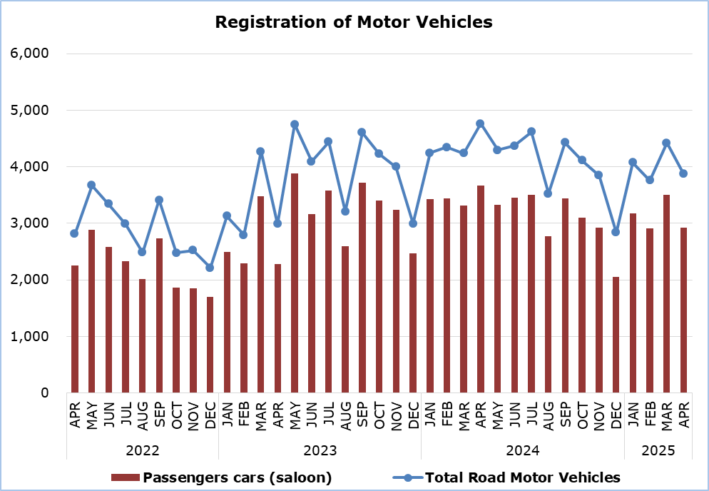

|  |  |  |  |  |  |  |  |
| --- | --- | --- | --- | --- | --- | --- | --- |
| **Table** |  |  |  |  |  |  |  |
| **Category of Road Motor Vehicles** | **Number of Registrations** | | | |  | **Percentage Change**  **(%)** | |
| **Apr**  **2025** | **Apr**  **2024** | **Jan-Apr 2025** | **Jan-Apr**  **2024** |  | **Apr**  **2025/2024** | **Jan-Apr**  **2025/2024** |
|
| Passengers’ cars (saloon) | 2.924 | 3.662 | 12.509 | 13.851 |  | -20,2 | -9,7 |
| Motor coaches and buses | 6 | 14 | 44 | 78 |  | -57,1 | -43,6 |
| Goods conveyance vehicles | 473 | 518 | 1.921 | 1.963 |  | -8,7 | -2,1 |
| Mopeds < 50cc | 20 | 124 | 80 | 364 |  | -83,9 | -78,0 |
| Mechanised cycles > 50cc | 398 | 372 | 1.371 | 1.099 |  | 7,0 | 24,7 |
| Tractors | 30 | 37 | 98 | 103 |  | -18,9 | -4,9 |
| Other vehicles | 26 | 35 | 110 | 131 |  | -25,7 | -16,0 |
| **Total** | **3.877** | **4.762** | **16.133** | **17.589** |  | **-18,6** | **-8,3** |
| New | 1.682 | 2.219 | 7.790 | 8.294 |  | -24,2 | -6,1 |
| Used | 2.195 | 2.543 | 8.343 | 9.295 |  | -13,7 | -10,2 |

**METHODOLOGICAL INFORMATION**

**Scope and Coverage**

Data for the Registration of Motor Vehicles are collected on a monthly basis. They include the newly registered motor vehicles, as recorded by the Department of Road Transport.

The registrations are presented by category, make, energy type, new or used, engine cubic capacity, country of manufacture and other vehicle characteristics, based on the information maintained by the Motor Vehicles Registration and Licensing Authority of the Department of Road Transport.

**Data Collection**

The collection of data is conducted by the Statistical Service, which receives the necessary data from the Department of Road Transport.

**Definitions**

“Road motor vehicle” means any road vehicle fitted with an engine whence it derives its sole means of propulsion, which is normally used for carrying persons or goods by road, namely:

* Passengers’ cars saloon, which include private cars, taxis, rental cars, learners’ cars and invalid carriages
* Motor coaches and buses, for private and public use
* Goods conveyance vehicles, which include heavy and light goods conveyance vehicles, rental vehicles and road tractors (units of trailers)
* Mopeds and mechanised cycles, which include autocycles, motor tricycles, motorcycles and rental motorcycles
* Tractors, for agriculture and non-agriculture use
* Other vehicles, which include road rollers, mobile motor cranes, heavy locomotives and other vehicles for specific type and use.

**Monthly Publication**

The report entitled "Registration of Motor Vehicles" is published on a monthly basis since 1982 and is available free of charge in electronic form on the portalof the Statistical Service.

***For more information:***

CYSTAT Portal, subtheme [Services](https://www.cystat.gov.cy/en/SubthemeStatistics?s=50)

[CYSTAT-DB](https://cystatdb.cystat.gov.cy/pxweb/en/8.CYSTAT-DB/8.CYSTAT-DB__Services__) (Online Database)

[Predefined Tables](https://www.cystat.gov.cy/en/KeyFiguresList?s=50) (Excel)

[Publications](https://www.cystat.gov.cy/en/PublicationList?s=50) (Excel, from Jan. 2024) (Pdf, until Dec. 2023)

**The Predefined Tables, available in Excel format, include data up to December 2022. Data from January 2023 onwards are available only in the CYSTAT-DB Online Database.**

*Contact*  
Andrie Milidoni: Tel.: 22602240, E-mail: amilidoni@cystat.mof.gov.cy