8 May, 2026

PRESS RELEASE

REGISTRATION OF MOTOR VEHICLES: JANUARY - APRIL 2026

Total Registrations +15,1%

The Statistical Service announces the publication of the report entitled "Registration of Motor Vehicles" for the period January-April 2026.

In April 2026, the total registrations of motor vehicles numbered 4.733, recording an increase of 22,1% compared to 3.877 in April 2025. Passenger saloon cars registered a rise of 24,2% to 3.632, from 2.924 in April 2025.

The main developments during the period January-April 2026 compared to the corresponding period of 2025 are summarised as follows:

(a) The total registrations of motor vehicles increased by 15,1% to 18.570 in January-April 2026, from 16.133 in January-April 2025.

(b) Passenger saloon cars increased to 14.259 from 12.509 in January-April 2025, recording a rise of 14,0%. Of the total passenger saloon cars, 4.800 or 33,7% were new and 9.459 or 66,3% were used cars. Rental cars in particular recorded a fall of 14,8% (from 1.551 to 1.321).

(c) The share of petrol powered passengers’ cars to the total of this category of vehicles decreased in January-April 2026 to 35,6% (from 42,9% in the corresponding period of the preceding year) and of diesel-powered cars to 8,5% in 2026 from 9,0% in 2025. On the other hand, the share of electric cars increased to 5,2% (from 4,8%) and the share of hybrid cars rose from 43,3% to 50,8%.

(d) Motor coaches and buses registered in January-April 2026 increased to 84, from 44 in the same period of 2025.

(e) Goods conveyance vehicles increased by 17,8% to 2.263 in January-April 2026, compared to 1.921 in January-April 2025. In particular, light goods vehicles increased by 13,4% to 1.781, road tractors (units of trailers) by 19,2% to 87, heavy goods vehicles by 34,7% to 287 and rental vehicles by 66,2% to 108.

(f) Mopeds < 50cc registered in January-April 2026 decreased to 43 compared to 80 in the corresponding period of the previous year.

(g) Mechanised cycles > 50cc increased by 21,5% to 1.666 in January-April 2026, compared to 1.371 in the same period of 2025.

In particular, rental vehicles increased by 66,2% to 108, , and.

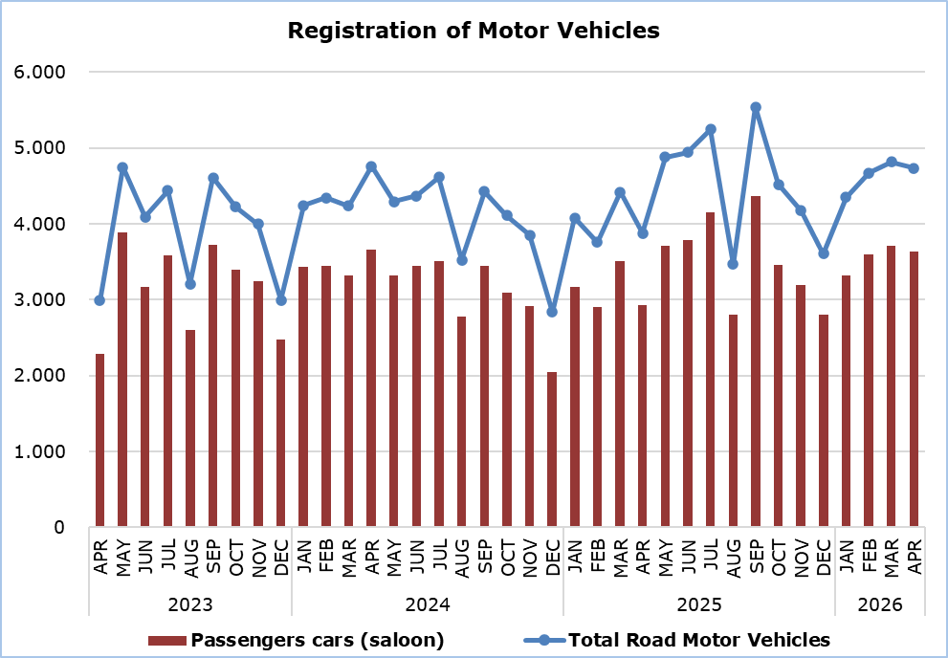

Table
Category of Road Motor Vehicles | Number of Registrations |  |  |  |  |  |  |  |  |  | Percentage Change  (%)
Category of Road Motor Vehicles | Apr  2026 |  | Apr  2025 |  | Jan-Apr  2026 |  | Jan-Apr  2025 |  |  |  | Apr  2026/2025 |  |  | Jan-Apr  2026/2025
Passengers’ cars (saloon) |  | 3.632 |  | 2.924 |  | 14.259 |  | 12.509 |  |  |  |  | 24,2 |  |  | 14,0
Motor coaches and buses |  | 20 |  | 6 |  | 84 |  | 44 |  |  |  | 233,3 |  |  | 90,9
Goods conveyance vehicles |  | 532 |  | 473 |  | 2.263 |  | 1.921 |  |  |  | 12,5 |  |  | 17,8
Mopeds < 50cc |  | 14 |  | 20 |  | 43 |  | 80 |  |  |  | -30,0 |  |  | -46,3
Mechanised cycles > 50cc |  | 475 |  | 398 |  | 1.666 |  | 1.371 |  |  |  | 19,3 |  |  | 21,5
Tractors |  | 31 |  | 30 |  | 108 |  | 98 |  |  |  | 3,3 |  |  | 10,2
Other vehicles |  | 29 |  | 26 |  | 147 |  | 110 |  |  |  | 11,5 |  |  | 33,6
Total |  | 4.733 |  | 3.877 |  | 18.570 |  | 16.133 |  |  |  | 22,1 |  |  | 15,1
New |  | 1.908 |  | 1.682 |  | 7.409 |  | 7.790 |  |  |  | 13,4 |  |  | -4,9
Used |  | 2.825 |  | 2.195 |  | 11.161 |  | 8.343 |  |  |  | 28,7 |  |  | 33,8

METHODOLOGICAL INFORMATION

Scope and Coverage

Data for the Registration of Motor Vehicles are collected on a monthly basis. They include the newly registered motor vehicles, as recorded by the Department of Road Transport.

The registrations are presented by category, make, energy type, new or used, engine cubic capacity, country of manufacture and other vehicle characteristics, based on the information maintained by the Motor Vehicles Registration and Licensing Authority of the Department of Road Transport.

Data Collection

The collection of data is conducted by the Statistical Service, which receives the necessary data from the Department of Road Transport.

Definitions

“Road motor vehicle” means any road vehicle fitted with an engine whence it derives its sole means of propulsion, which is normally used for carrying persons or goods by road, namely:
- Passengers’ cars saloon, which include private cars, taxis, rental cars, learners’ cars and invalid carriages
- Motor coaches and buses, for private and public use
- Goods conveyance vehicles, which include heavy and light goods conveyance vehicles, rental vehicles and road tractors (units of trailers)
- Mopeds and mechanised cycles, which include autocycles, motor tricycles, motorcycles and rental motorcycles
- Tractors, for agriculture and non-agriculture use
- Other vehicles, which include road rollers, mobile motor cranes, heavy locomotives and other vehicles for specific type and use.

Monthly Publication

The report entitled "Registration of Motor Vehicles" is published on a monthly basis since 1982 and is available free of charge in electronic form on the portal of the Statistical Service.

For more information:
CYSTAT Portal, subtheme Services
CYSTAT-DB (Online Database)
Predefined Tables (Excel)
Publications (Excel, from Jan. 2024) (Pdf, until Dec. 2023)

The Predefined Tables, available in Excel format, include data up to December 2022. Data from January 2023 onwards are available only in the CYSTAT-DB Online Database.

Contact
Andrie Milidoni: Tel.: 22602240, E-mail: amilidoni@cystat.mof.gov.cy

