9 January, 2024

**PRESS RELEASE**

REGISTRATION OF MOTOR VEHICLES: **JANUARY - DECEMBER 2023**

**Total Registrations +34,6%**

The Statistical Service announces the publication of the report entitled "Registration of Motor Vehicles" for the period January-December 2023.

In December 2023, the total registrations of motor vehicles numbered 2.994, recording an increase of 35,4% compared to 2.211 in December 2022. Passenger saloon cars registered a rise of 45,5% to 2.468, from 1.696 in December 2022.

The main developments during the period January-December 2023 compared to the corresponding period of 2022 are summarised as follows:

(a) The total registrations of motor vehicles increased by 34,6% to 45.494 in January-December 2023, from 33.795 in January-December 2022.

(b) Passenger saloon cars increased to 36.608 from 26.598 in January-December 2022, recording a rise of 37,6%. Of the total passenger saloon cars, 14.637 or 40,0% were new and 21.971 or 60,0% were used cars. Rental cars in particular recorded a rise of 36,0% to 5.577.

(c) Motor coaches and buses registered in 2023 increased to 329, from 85 in 2022.

(d) Goods conveyance vehicles increased by 12,3% to 4.374 in January-December 2023, compared to 3.895 in January-December 2022. In particular, light goods vehicles increased by 8,2% to 3.409, heavy goods vehicles by 40,9% to 534, road tractors (units of trailers) by 67,0% to 157 and rental vehicles by 1,1% to 274.

(e) Mopeds < 50cc registered in 2023 increased to 321 compared to 244 in the previous year.

(f) Mechanised cycles > 50cc increased by 27,9% to 3.324 in January-December 2023, compared to 2.598 in the same period of 2022.

(g) The main manufacturers of motor vehicles registered in Cyprus during 2023 were Japan (42,9%), Germany (13,9%), France (7,2%), the United Kingdom (5,3%) and South Korea (4,9%).

(h) The grand majority (55,0%) of motor vehicles registered in 2023 were petrol powered, while 18,0% were diesel powered, 2,9% electric and 24,1% hybrid vehicles. The corresponding proportions for 2022 were 58,3%, 21,2%, 2,2% and 18,3%.

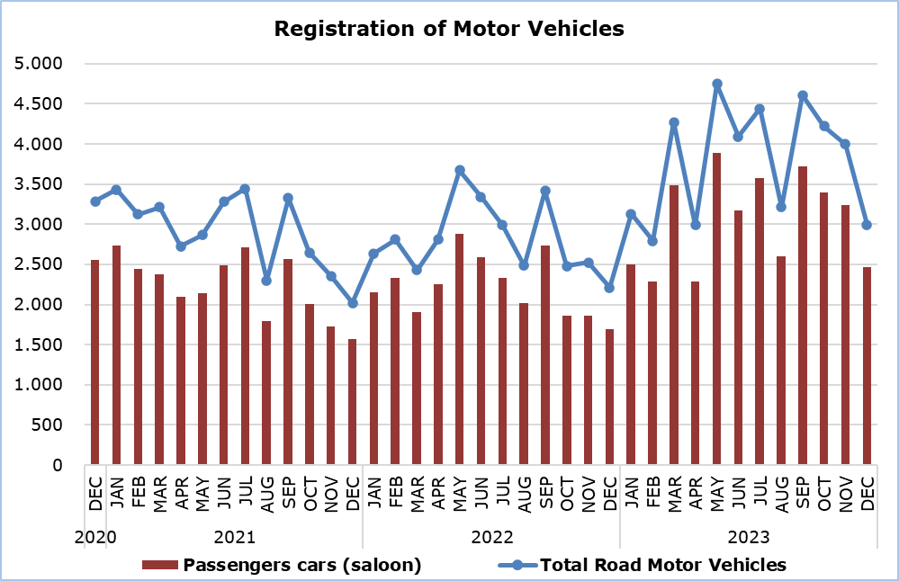

|  |  |  |  |  |  |  |  |
| --- | --- | --- | --- | --- | --- | --- | --- |
| **Table** |  |  |  |  |  |  |  |
| **Category of Road Motor Vehicles** | **Number of Registrations** | | | |  | **Percentage Change**  **(%)** | |
| **Dec**  **2023** | **Dec**  **2022** | **Jan-Dec**  **2023** | **Jan-Dec 2022** |  | **Dec**  **2023/2022** | **Jan-Dec 2023/2022** |
|
| Passengers’ cars | 2.468 | 1.696 | 36.608 | 26.598 |  | 45,5 | 37,6 |
| Motor coaches and buses | 23 | 1 | 329 | 85 |  | 2.200,0 | 287,1 |
| Goods conveyance vehicles | 274 | 331 | 4.374 | 3.895 |  | -17,2 | 12,3 |
| Mopeds < 50cc | 16 | 7 | 321 | 244 |  | 128,6 | 31,6 |
| Mechanised cycles > 50cc | 173 | 146 | 3.324 | 2.598 |  | 18,5 | 27,9 |
| Tractors | 20 | 10 | 223 | 164 |  | 100,0 | 36,0 |
| Other vehicles | 20 | 20 | 315 | 211 |  | 0,0 | 49,3 |
| **Total** | **2.994** | **2.211** | **45.494** | **33.795** |  | **35,4** | **34,6** |
| New | 1.030 | 1.026 | 20.506 | 16.446 |  | 0,4 | 24,7 |
| Used | 1.964 | 1.185 | 24.988 | 17.349 |  | 65,7 | 44,0 |

**METHODOLOGICAL INFORMATION**

**Scope and Coverage**

Data for the Registration of Motor Vehicles are collected on a monthly basis. They include the newly registered motor vehicles, as recorded by the Department of Road Transport.

The registrations are presented by category, make, energy type, new or used, engine cubic capacity, country of manufacture and other vehicle characteristics, based on the information maintained by the Motor Vehicles Registration and Licensing Authority of the Department of Road Transport.

**Data Collection**

The collection of data is conducted by the Statistical Service, which receives the necessary data from the Department of Road Transport.

**Definitions**

“Road motor vehicle” means any road vehicle fitted with an engine whence it derives its sole means of propulsion, which is normally used for carrying persons or goods by road, namely:

* Passengers’ cars saloon, which include private cars, taxis, rental cars, learners’ cars and invalid carriages
* Motor coaches and buses, for private and public use
* Goods conveyance vehicles, which include heavy and light goods conveyance vehicles, rental vehicles and road tractors (units of trailers)
* Mopeds and mechanised cycles, which include autocycles, motor tricycles, motorcycles and rental motorcycles
* Tractors, for agriculture and non-agriculture use
* Other vehicles, which include road rollers, mobile motor cranes, heavy locomotives and other vehicles for specific type and use.

**Monthly Publication**

The report entitled "Registration of Motor Vehicles" is published on a monthly basis since 1982 and is available free of charge in electronic form on the portalof the Statistical Service.

***For more information:***

CYSTAT Portal, subtheme [Services](https://www.cystat.gov.cy/en/SubthemeStatistics?s=50)

[CYSTAT-DB](https://cystatdb.cystat.gov.cy/pxweb/en/8.CYSTAT-DB/8.CYSTAT-DB__Services__) (Online Database)

[Predefined Tables](https://www.cystat.gov.cy/en/KeyFiguresList?s=50) (Excel)

[Publications](https://www.cystat.gov.cy/en/PublicationList?s=50) (Pdf)

**The Predefined Tables, available in Excel format, include data up to December 2022. Data from January 2023 onwards are available only in the CYSTAT-DB Online Database.**

*Contact*  
Andrie Milidoni: Tel.: 22602240, E-mail: amilidoni@cystat.mof.gov.cy