12 January, 2026

PRESS RELEASE

REGISTRATION OF MOTOR VEHICLES: JANUARY - DECEMBER 2025

Total Registrations +5,8%

The Statistical Service announces the publication of the report entitled "Registration of Motor Vehicles" for the period January-December 2025.

In December 2025, the total registrations of motor vehicles numbered 3.604, recording an increase of 27,1% compared to 2.836 in December 2024. Passenger saloon cars registered a rise of 36,6% to 2.801, from 2.050 in December 2024.

The main developments during the period January-December 2025 compared to the corresponding period of 2024 are summarised as follows:

(a) The total registrations of motor vehicles increased by 5,8% to 52.508 in January-December 2025, from 49.616 in January-December 2024.

(b) Passenger saloon cars increased to 40.778 from 38.410 in January-December 2024, recording a rise of 6,2%. Of the total passenger saloon cars, 14.633 or 35,9% were new and 26.145 or 64,1% were used cars. Rental cars in particular recorded a rise of 32,4% to 5.169.

(c) The share of petrol powered passengers’ cars to the total of this category of vehicles decreased in January-December 2025 to 42,0% (from 48,6% in the corresponding period of the preceding year) and that of diesel-powered cars to 8,9% in 2025 from 10,3% in 2024. On the other hand, the share of electric cars rose from 4,0% in 2024 to 4,7% in 2025 and of hybrid cars from 37,1% to 44,3%.

(d) Motor coaches and buses registered in January-December 2025 increased to 181, from 133 in the same period of 2024.

(e) Goods conveyance vehicles increased by 6,8% to 6.208 in January-December 2025, compared to 5.811 in January-December 2024. In particular, rental vehicles increased by 23,8% to 291, light goods vehicles by 6,9% to 4.959, road tractors (units of trailers) by 3,3% to 251 and heavy goods vehicles by 1,7% to 707.

(f) Mopeds < 50cc registered in January-December 2025 decreased to 213 compared to 690 in the corresponding period of the previous year.

(g) Mechanised cycles > 50cc increased by 14,5% to 4.467 in January-December 2025, compared to 3.903 in the same period of 2024.

(h) The main manufacturers of motor vehicles registered in Cyprus during 2025 were Japan (44,1%), Germany (13,0%), France (7,0%), the United Kingdom (6,0%) and South Korea (3,9%).

(i) The most popular colour among the motor vehicles registered in 2025 was white (34,4%), followed by grey (19,5%), black (15,6%), blue (8,8%) and silver (8,7%).

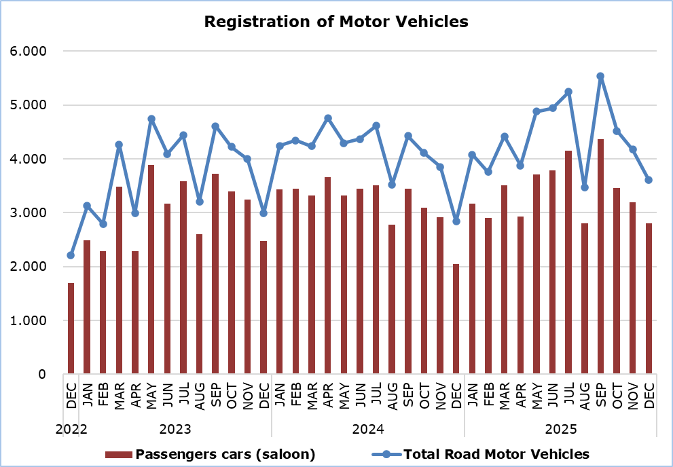

Table
Category of Road Motor Vehicles | Number of Registrations |  |  |  |  |  |  |  |  |  | Percentage Change  (%)
Category of Road Motor Vehicles | Dec  2025 |  | Dec  2024 |  | Jan-Dec  2025 |  | Jan-Dec  2024 |  |  |  | Dec  2025/2024 |  |  | Jan-Dec  2025/2024
Passengers’ cars (saloon) |  | 2.801 |  | 2.050 |  | 40.778 |  | 38.410 |  |  |  |  | 36,6 |  |  | 6,2
Motor coaches and buses |  | 9 |  | 6 |  | 181 |  | 133 |  |  |  | 50,0 |  |  | 36,1
Goods conveyance vehicles |  | 514 |  | 456 |  | 6.208 |  | 5.811 |  |  |  | 12,7 |  |  | 6,8
Mopeds < 50cc |  | 16 |  | 33 |  | 213 |  | 690 |  |  |  | -51,5 |  |  | -69,1
Mechanised cycles > 50cc |  | 203 |  | 246 |  | 4.467 |  | 3.903 |  |  |  | -17,5 |  |  | 14,5
Tractors |  | 8 |  | 24 |  | 295 |  | 303 |  |  |  | -66,7 |  |  | -2,6
Other vehicles |  | 53 |  | 21 |  | 366 |  | 366 |  |  |  | 152,4 |  |  | 0,0
Total |  | 3.604 |  | 2.836 |  | 52.508 |  | 49.616 |  |  |  | 27,1 |  |  | 5,8
New |  | 1.114 |  | 1.103 |  | 21.710 |  | 21.904 |  |  |  | 1,0 |  |  | -0,9
Used |  | 2.490 |  | 1.733 |  | 30.798 |  | 27.712 |  |  |  | 43,7 |  |  | 11,1

METHODOLOGICAL INFORMATION

Scope and Coverage

Data for the Registration of Motor Vehicles are collected on a monthly basis. They include the newly registered motor vehicles, as recorded by the Department of Road Transport.

The registrations are presented by category, make, energy type, new or used, engine cubic capacity, country of manufacture and other vehicle characteristics, based on the information maintained by the Motor Vehicles Registration and Licensing Authority of the Department of Road Transport.

Data Collection

The collection of data is conducted by the Statistical Service, which receives the necessary data from the Department of Road Transport.

Definitions

“Road motor vehicle” means any road vehicle fitted with an engine whence it derives its sole means of propulsion, which is normally used for carrying persons or goods by road, namely:
- Passengers’ cars saloon, which include private cars, taxis, rental cars, learners’ cars and invalid carriages
- Motor coaches and buses, for private and public use
- Goods conveyance vehicles, which include heavy and light goods conveyance vehicles, rental vehicles and road tractors (units of trailers)
- Mopeds and mechanised cycles, which include autocycles, motor tricycles, motorcycles and rental motorcycles
- Tractors, for agriculture and non-agriculture use
- Other vehicles, which include road rollers, mobile motor cranes, heavy locomotives and other vehicles for specific type and use.

Monthly Publication

The report entitled "Registration of Motor Vehicles" is published on a monthly basis since 1982 and is available free of charge in electronic form on the portal of the Statistical Service.

For more information:
CYSTAT Portal, subtheme Services
CYSTAT-DB (Online Database)
Predefined Tables (Excel)
Publications (Excel, from Jan. 2024) (Pdf, until Dec. 2023)

The Predefined Tables, available in Excel format, include data up to December 2022. Data from January 2023 onwards are available only in the CYSTAT-DB Online Database.

Contact
Andrie Milidoni: Tel.: 22602240, E-mail: amilidoni@cystat.mof.gov.cy

