6 February, 2026

PRESS RELEASE

REGISTRATION OF MOTOR VEHICLES: JANUARY 2026

Total Registrations +6,7%

The Statistical Service announces the publication of the report entitled "Registration of Motor Vehicles" for January 2026.

The main developments in January 2026 compared to the corresponding month of 2025 are summarised as follows:

(a) In January 2026, the total registrations of motor vehicles numbered 4.350 from 4.077 in January 2025, recording an increase of 6,7%.

(b) Passenger saloon cars increased to 3.317 from 3.173 in January 2025, recording a rise of 4,5%. Of the total passenger saloon cars, 1.294 or 39,0% were new and 2.023 or 61,0% were used cars. Rental cars in particular recorded a fall of 22,8% to 159.

(c) The share of petrol powered passengers’ cars to the total of this category of vehicles decreased in January 2026 to 35,8% from 42,5% in the corresponding month of the preceding year. On the other hand, the share of diesel powered cars increased to 8,4% in 2026 from 8,1% in 2025, of electric cars from 5,6% in 2025 to 6,9% in 2026 and of hybrid cars from 43,8% to 48,8%.

(d) Motor coaches and buses registered in January 2026 increased to 23, from 7 in the same month of 2025.

(e) Goods conveyance vehicles increased by 17,1% to 562 in January 2026, compared to 480 in January 2025. In particular, heavy goods vehicles increased by 43,8% to 69, road tractors (units of trailers) by 18,8% to 19 and light goods vehicles by 16,0% to 471, while rental vehicles decreased by 70,0% to 3.

(f) Mopeds < 50cc registered in January 2026 decreased to 6 compared to 22 in the same month of 2025.

(g) Mechanised cycles > 50cc increased by 13,5% to 387 in January 2026, compared to 341 in the corresponding month of 2025.

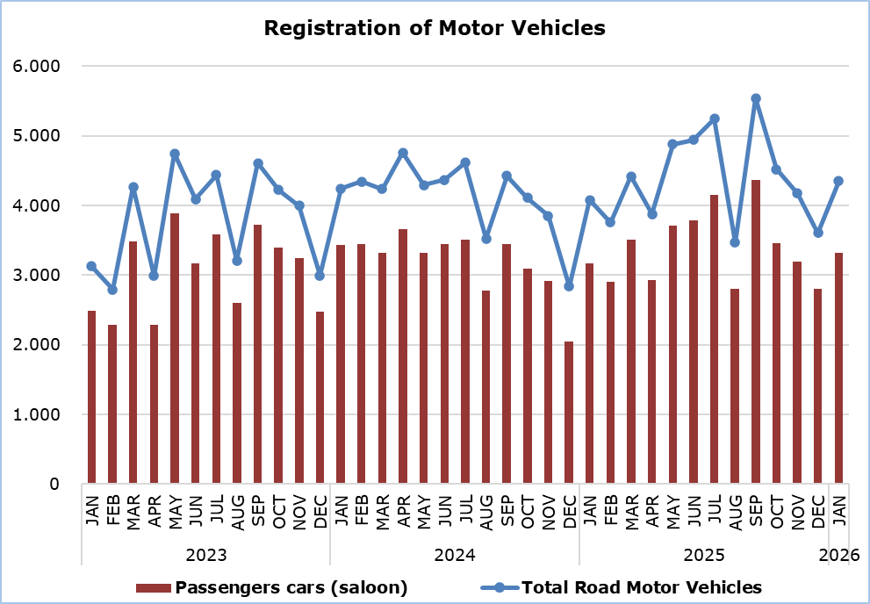

Table
Category of  Road Motor Vehicles | Number of Registrations |  |  |  |  |  | Percentage Change (%)
Category of  Road Motor Vehicles | Jan 2026 |  | Jan 2025 |  |  |  | Jan 2026/2025
Passengers’ cars (saloon) | 3.317 | 3.173 |  |  |  | 4,5
Motor coaches and buses | 23 | 7 |  |  |  | 228,6
Goods conveyance vehicles | 562 | 480 |  |  |  | 17,1
Mopeds < 50cc | 6 | 22 |  |  |  | -72,7
Mechanised cycles > 50cc | 387 | 341 |  |  |  | 13,5
Tractors | 21 | 23 |  |  |  | -8,7
Other vehicles | 34 | 31 |  |  |  | 9,7
Total | 4.350 | 4.077 |  |  |  | 6,7
New | 1.928 | 2.130 |  |  |  | -9,5
Used | 2.422 | 1.947 |  |  |  | 24,4

METHODOLOGICAL INFORMATION

Scope and Coverage

Data for the Registration of Motor Vehicles are collected on a monthly basis. They include the newly registered motor vehicles, as recorded by the Department of Road Transport.

The registrations are presented by category, make, energy type, new or used, engine cubic capacity, country of manufacture and other vehicle characteristics, based on the information maintained by the Motor Vehicles Registration and Licensing Authority of the Department of Road Transport.

Data Collection

The collection of data is conducted by the Statistical Service, which receives the necessary data from the Department of Road Transport.

Definitions

“Road motor vehicle” means any road vehicle fitted with an engine whence it derives its sole means of propulsion, which is normally used for carrying persons or goods by road, namely:
- Passengers’ cars saloon, which include private cars, taxis, rental cars, learners’ cars and invalid carriages
- Motor coaches and buses, for private and public use
- Goods conveyance vehicles, which include heavy and light goods conveyance vehicles, rental vehicles and road tractors (units of trailers)
- Mopeds and mechanised cycles, which include autocycles, motor tricycles, motorcycles and rental motorcycles
- Tractors, for agriculture and non-agriculture use
- Other vehicles, which include road rollers, mobile motor cranes, heavy locomotives and other vehicles for specific type and use.

Monthly Publication

The report entitled "Registration of Motor Vehicles" is published on a monthly basis since 1982 and is available free of charge in electronic form on the portal of the Statistical Service.

For more information:
CYSTAT Portal, subtheme Services
CYSTAT-DB (Online Database)
Predefined Tables (Excel)
Publications (Excel, from Jan. 2024) (Pdf, until Dec. 2023)

The Predefined Tables, available in Excel format, include data up to December 2022. Data from January 2023 onwards are available only in the CYSTAT-DB Online Database.

Contact
Andrie Milidoni: Tel.: 22602240, E-mail: amilidoni@cystat.mof.gov.cy

