8 August, 2025

**PRESS RELEASE**

REGISTRATION OF MOTOR VEHICLES: **JANUARY - JULY 2025**

**Total Registrations +1,1%**

The Statistical Service announces the publication of the report entitled "Registration of Motor Vehicles" for the period January-July 2025.

In July 2025, the total registrations of motor vehicles numbered 5.246, recording an increase of 13,7% compared to 4.614 in July 2024. Passenger saloon cars registered a rise of 18,6% to 4.154, from 3.503 in July 2024.

The main developments during the period January-July 2025 compared to the corresponding period of 2024 are summarised as follows:

(a) The total registrations of motor vehicles increased by 1,1% to 31.200 in January-July 2025, from 30.864 in January-July 2024.

(b) Passenger saloon cars increased to 24.158 from 24.126 in January-July 2024, recording a rise of 0,1%. Of the total passenger saloon cars, 9.660 or 40,0% were new and 14.498 or 60,0% were used cars. Rental cars in particular recorded a rise of 32,9% to 3.581.

(c) The share of petrol powered passengers’ cars to the total of this category of vehicles decreased in January-July 2025 to 43,3% (from 49,9% in the corresponding period of the preceding year) and that of diesel-powered cars to 8,5% in 2025 from 9,9% in 2024. On the other hand, the share of electric cars rose from 3,2% in 2024 to 4,8% in 2025 and of hybrid cars from 36,8% to 43,3%.

(d) Motor coaches and buses registered in January-July 2025 decreased to 89, from 99 in the same period of 2024.

(e) Goods conveyance vehicles increased by 2,4% to 3.608 in January-July 2025, compared to 3.523 in January-July 2024. In particular, light goods vehicles increased by 2,8% to 2.884, heavy goods vehicles by 2,7% to 423 and rental vehicles by 1,8% to 169, while road tractors (units of trailers) decreased by 5,7% to 169.

(f) Mopeds < 50cc registered in January-July 2025 decreased to 143 compared to 480 in the corresponding period of the previous year.

(g) Mechanised cycles > 50cc increased by 26,5% to 2.806 in January-July 2025, compared to 2.218 in the same period of 2024.

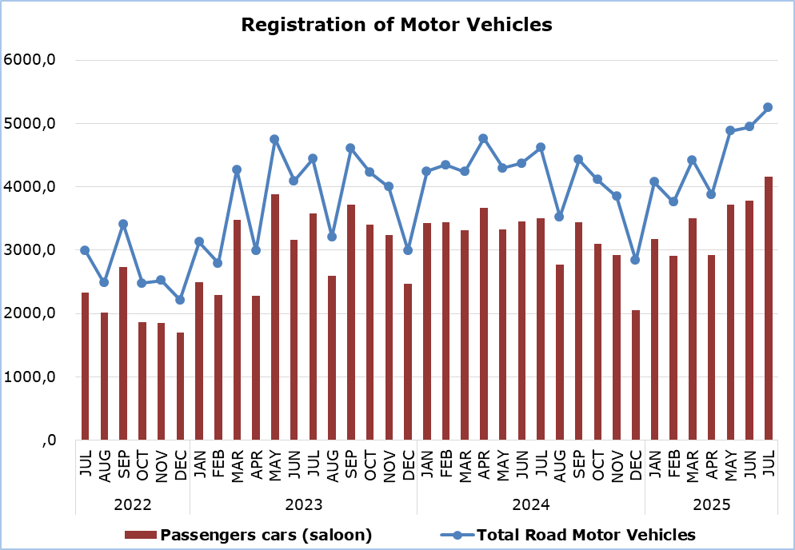

|  |  |  |  |  |  |  |  |
| --- | --- | --- | --- | --- | --- | --- | --- |
| **Table** |  |  |  |  |  |  |  |
| **Category of Road Motor Vehicles** | **Number of Registrations** | | | |  | **Percentage Change**  **(%)** | |
| **July**  **2025** | **July**  **2024** | **Jan-July**  **2025** | **Jan-July**  **2024** |  | **July**  **2025/2024** | **Jan-July**  **2025/2024** |
|
| Passengers’ cars (saloon) | 4.154 | 3.503 | 24.158 | 24.126 |  | 18,6 | 0,1 |
| Motor coaches and buses | 11 | 12 | 89 | 99 |  | -8,3 | -10,1 |
| Goods conveyance vehicles | 553 | 548 | 3.608 | 3.523 |  | 0,9 | 2,4 |
| Mopeds < 50cc | 31 | 81 | 143 | 480 |  | -61,7 | -70,2 |
| Mechanised cycles > 50cc | 442 | 418 | 2.806 | 2.218 |  | 5,7 | 26,5 |
| Tractors | 24 | 23 | 191 | 182 |  | 4,3 | 4,9 |
| Other vehicles | 31 | 29 | 205 | 236 |  | 6,9 | -13,1 |
| **Total** | **5.246** | **4.614** | **31.200** | **30.864** |  | **13,7** | **1,1** |
| New | 2.150 | 2.090 | 14.056 | 14.331 |  | 2,9 | -1,9 |
| Used | 3.096 | 2.524 | 17.144 | 16.533 |  | 22,7 | 3,7 |

**METHODOLOGICAL INFORMATION**

**Scope and Coverage**

Data for the Registration of Motor Vehicles are collected on a monthly basis. They include the newly registered motor vehicles, as recorded by the Department of Road Transport.

The registrations are presented by category, make, energy type, new or used, engine cubic capacity, country of manufacture and other vehicle characteristics, based on the information maintained by the Motor Vehicles Registration and Licensing Authority of the Department of Road Transport.

**Data Collection**

The collection of data is conducted by the Statistical Service, which receives the necessary data from the Department of Road Transport.

**Definitions**

“Road motor vehicle” means any road vehicle fitted with an engine whence it derives its sole means of propulsion, which is normally used for carrying persons or goods by road, namely:

* Passengers’ cars saloon, which include private cars, taxis, rental cars, learners’ cars and invalid carriages
* Motor coaches and buses, for private and public use
* Goods conveyance vehicles, which include heavy and light goods conveyance vehicles, rental vehicles and road tractors (units of trailers)
* Mopeds and mechanised cycles, which include autocycles, motor tricycles, motorcycles and rental motorcycles
* Tractors, for agriculture and non-agriculture use
* Other vehicles, which include road rollers, mobile motor cranes, heavy locomotives and other vehicles for specific type and use.

**Monthly Publication**

The report entitled "Registration of Motor Vehicles" is published on a monthly basis since 1982 and is available free of charge in electronic form on the portalof the Statistical Service.

***For more information:***

CYSTAT Portal, subtheme [Services](https://www.cystat.gov.cy/en/SubthemeStatistics?s=50)

[CYSTAT-DB](https://cystatdb.cystat.gov.cy/pxweb/en/8.CYSTAT-DB/8.CYSTAT-DB__Services__) (Online Database)

[Predefined Tables](https://www.cystat.gov.cy/en/KeyFiguresList?s=50) (Excel)

[Publications](https://www.cystat.gov.cy/en/PublicationList?s=50) (Excel, from Jan. 2024) (Pdf, until Dec. 2023)

**The Predefined Tables, available in Excel format, include data up to December 2022. Data from January 2023 onwards are available only in the CYSTAT-DB Online Database.**

*Contact*  
Andrie Milidoni: Tel.: 22602240, E-mail: amilidoni@cystat.mof.gov.cy