10 April, 2023

**PRESS RELEASE**

REGISTRATION OF MOTOR VEHICLES: **JANUARY - MARCH 2023**

**Total Registrations +29,5%**

The Statistical Service announces the publication of the report entitled "Registration of Motor Vehicles" for the period January-March 2023.

In March 2023, the total registrations of motor vehicles numbered 4.270, recording an increase of 75,6% compared to 2.431 in March 2022. Passenger saloon cars registered a rise of 83,0% to 3.484, from 1.904 in March 2022.

The main developments during the period January-March 2023 compared to the corresponding period of 2022 are summarised as follows:

(a) The total registrations of motor vehicles increased by 29,5% to 10.193 in January-March 2023, from 7.872 in January-March 2022.

(b) Passenger saloon cars increased to 8.264 from 6.382 in January-March 2022, recording a rise of 29,5%. Of the total passenger saloon cars, 4.009 or 48,5% were new and 4.255 or 51,5% were used cars. Rental cars in particular recorded a rise of 33,6% to 1.168.

(c) Motor coaches and buses registered in January-March 2023 decreased to 21, from 36 in the same period of 2022.

(d) Goods conveyance vehicles increased by 25,8% to 1.029 in January-March 2023, compared to 818 in January-March 2022. In particular, light goods vehicles increased by 23,3% to 793, heavy goods vehicles by 72,6% to 145 and road tractors (units of trailers) by 141,7% to 29, while rental vehicles decreased by 21,5% to 62.

(e) Mopeds < 50cc registered in January-March 2023 decreased to 28 compared to 73 in the corresponding period of the previous year.

(f) Mechanised cycles > 50cc increased by 50,4% to 722 in January-March 2023, compared to 480 in January-March 2022.

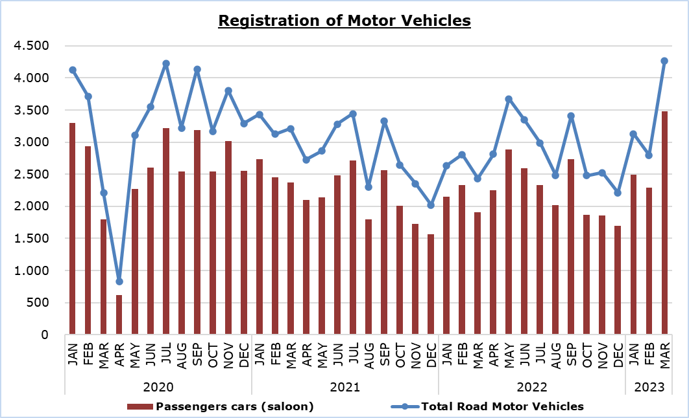

|  |  |  |  |  |  |  |  |
| --- | --- | --- | --- | --- | --- | --- | --- |
| **Table** |  |  |  |  |  |  |  |
| **Category of Road Motor Vehicles** | **Number of Registrations** | | | |  | **Percentage Change  (%)** | |
| **Mar**  **2023** | **Mar**  **2022** | **Jan-Mar 2023** | **Jan-Mar 2022** |  | **Mar  2023/2022** | **Jan-Mar 2023/2022** |
|  |
| Passengers’ cars | 3.484 | 1.904 | 8.264 | 6.382 |  | 83,0 | 29,5 |
| Motor coaches and buses | 6 | 27 | 21 | 36 |  | -77,8 | -41,7 |
| Goods conveyance vehicles | 419 | 279 | 1.029 | 818 |  | 50,2 | 25,8 |
| Mopeds < 50cc | 7 | 37 | 28 | 73 |  | -81,1 | -61,6 |
| Mechanised cycles > 50cc | 323 | 165 | 722 | 480 |  | 95,8 | 50,4 |
| Tractors | 14 | 8 | 54 | 42 |  | 75,0 | 28,6 |
| Other vehicles | 17 | 11 | 75 | 41 |  | 54,5 | 82,9 |
| **Total** | **4.270** | **2.431** | **10.193** | **7.872** |  | **75,6** | **29,5** |
| New | 2.245 | 1.229 | 5.237 | 4.116 |  | 82,7 | 27,2 |
| Used | 2.025 | 1.202 | 4.956 | 3.756 |  | 68,5 | 31,9 |

**METHODOLOGICAL INFORMATION**

**Scope and coverage**

Data for the Registration of Motor Vehicles are collected on a monthly basis. They include the newly registered motor vehicles, as recorded by the Department of Road Transport.

The registrations are presented by category, make, energy type, new or used, engine cubic capacity, country of manufacture and other vehicle characteristics, based on the information maintained by the Motor Vehicles Registration and Licensing Authority of the Department of Road Transport.

**Data collection**

The collection of data is conducted by the Statistical Service, which receives the necessary data from the Department of Road Transport.

**Definitions**

“Road motor vehicle” means any road vehicle fitted with an engine whence it derives its sole means of propulsion, which is normally used for carrying persons or goods by road, namely:

* Passengers’ cars saloon, which include private cars, taxis, rental cars, learners’ cars and invalid carriages
* Motor coaches and buses, for private and public use
* Goods conveyance vehicles, which include heavy and light goods conveyance vehicles, rental vehicles and road tractors (units of trailers)
* Mopeds and mechanised cycles, which include autocycles, motor tricycles, motorcycles and rental motorcycles
* Tractors, for agriculture and non-agriculture use
* Other vehicles, which include road rollers, mobile motor cranes, heavy locomotives and other vehicles for specific type and use.

**Monthly Publication**

The report entitled "Registration of Motor Vehicles" is published on a monthly basis since 1982 and is available free of charge in electronic form on the portalof the Statistical Service.

***For more information:***

CYSTAT Portal, subtheme [Services](https://www.cystat.gov.cy/en/SubthemeStatistics?s=50)

[CYSTAT-DB](https://cystatdb.cystat.gov.cy/pxweb/en/8.CYSTAT-DB/8.CYSTAT-DB__Services__) (Online Database)

[Predefined Tables](https://www.cystat.gov.cy/en/KeyFiguresList?s=50) (Excel)

[Publications](https://www.cystat.gov.cy/en/PublicationList?s=50) (Pdf)

**The Predefined Tables, available in Excel format, include data up to December 2022. Data from January 2023 onwards are available only in the CYSTAT-DB Online Database.**

*Contact*  
Andrie Milidoni: Tel.: 22602240, E-mail: amilidoni@cystat.mof.gov.cy