8 December, 2025

PRESS RELEASE

REGISTRATION OF MOTOR VEHICLES: JANUARY - NOVEMBER 2025

Total Registrations +4,5%

The Statistical Service announces the publication of the report entitled "Registration of Motor Vehicles" for the period January-November 2025.

In November 2025, the total registrations of motor vehicles numbered 4.172, recording an increase of 8,4% compared to 3.850 in November 2024. Passenger saloon cars registered a rise of 9,4% to 3.195, from 2.920 in November 2024.

The main developments during the period January-November 2025 compared to the corresponding period of 2024 are summarised as follows:

(a) The total registrations of motor vehicles increased by 4,5% to 48.904 in January-November 2025, from 46.780 in January-November 2024.

(b) Passenger saloon cars increased to 37.977 from 36.360 in January-November 2024, recording a rise of 4,4%. Of the total passenger saloon cars, 13.930 or 36,7% were new and 24.047 or 63,3% were used cars. Rental cars in particular recorded a rise of 22,4% to 5.052.

(c) The share of petrol powered passengers’ cars to the total of this category of vehicles decreased in January-November 2025 to 42,3% (from 48,9% in the corresponding period of the preceding year) and that of diesel-powered cars to 8,8% in 2025 from 10,1% in 2024. On the other hand, the share of electric cars rose from 4,0% in 2024 to 4,7% in 2025 and of hybrid cars from 36,9% to 44,3%.

(d) Motor coaches and buses registered in January-November 2025 increased to 172, from 127 in the same period of 2024.

(e) Goods conveyance vehicles increased by 6,3% to 5.694 in January-November 2025, compared to 5.355 in January-November 2024. In particular, rental vehicles increased by 23,2% to 281, light goods vehicles by 6,1% to 4.540, heavy goods vehicles by 2,7% to 645 and road tractors (units of trailers) by 2,7%, to 228.

(f) Mopeds < 50cc registered in January-November 2025 decreased to 197 compared to 657 in the corresponding period of the previous year.

(g) Mechanised cycles > 50cc increased by 16,6% to 4.264 in January-November 2025, compared to 3.657 in the same period of 2024.

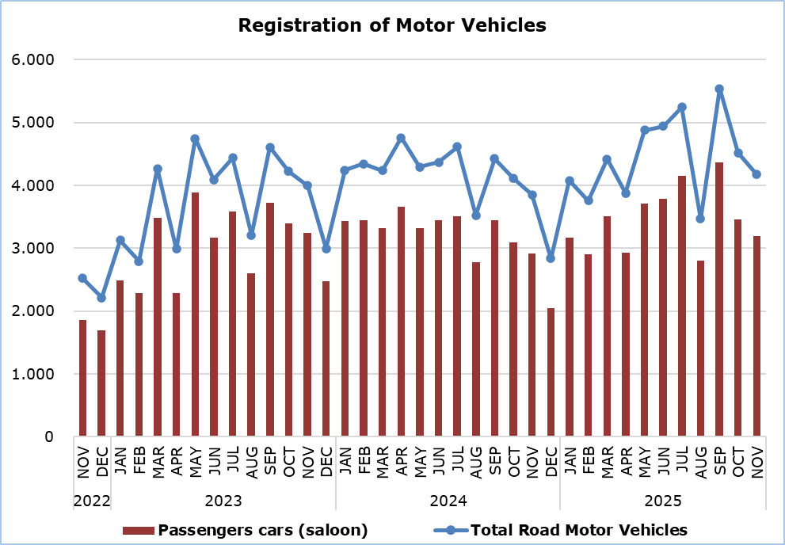

Table
Category of Road Motor Vehicles | Number of Registrations |  |  |  |  |  |  |  |  |  | Percentage Change  (%)
Category of Road Motor Vehicles | Nov  2025 |  | Nov  2024 |  | Jan-Nov  2025 |  | Jan-Nov  2024 |  |  |  | Nov  2025/2024 |  |  | Jan-Nov  2025/2024
Passengers’ cars (saloon) |  | 3.195 |  | 2.920 |  | 37.977 |  | 36.360 |  |  |  |  | 9,4 |  |  | 4,4
Motor coaches and buses |  | 5 |  | 2 |  | 172 |  | 127 |  |  |  | 150,0 |  |  | 35,4
Goods conveyance vehicles |  | 552 |  | 532 |  | 5.694 |  | 5.355 |  |  |  | 3,8 |  |  | 6,3
Mopeds < 50cc |  | 7 |  | 30 |  | 197 |  | 657 |  |  |  | -76,7 |  |  | -70,0
Mechanised cycles > 50cc |  | 348 |  | 309 |  | 4.264 |  | 3.657 |  |  |  | 12,6 |  |  | 16,6
Tractors |  | 32 |  | 27 |  | 287 |  | 279 |  |  |  | 18,5 |  |  | 2,9
Other vehicles |  | 33 |  | 30 |  | 313 |  | 345 |  |  |  | 10,0 |  |  | -9,3
Total |  | 4.172 |  | 3.850 |  | 48.904 |  | 46.780 |  |  |  | 8,4 |  |  | 4,5
New |  | 1.544 |  | 1.595 |  | 20.596 |  | 20.801 |  |  |  | -3,2 |  |  | -1,0
Used |  | 2.628 |  | 2.255 |  | 28.308 |  | 25.979 |  |  |  | 16,5 |  |  | 9,0

METHODOLOGICAL INFORMATION

Scope and Coverage

Data for the Registration of Motor Vehicles are collected on a monthly basis. They include the newly registered motor vehicles, as recorded by the Department of Road Transport.

The registrations are presented by category, make, energy type, new or used, engine cubic capacity, country of manufacture and other vehicle characteristics, based on the information maintained by the Motor Vehicles Registration and Licensing Authority of the Department of Road Transport.

Data Collection

The collection of data is conducted by the Statistical Service, which receives the necessary data from the Department of Road Transport.

Definitions

“Road motor vehicle” means any road vehicle fitted with an engine whence it derives its sole means of propulsion, which is normally used for carrying persons or goods by road, namely:
- Passengers’ cars saloon, which include private cars, taxis, rental cars, learners’ cars and invalid carriages
- Motor coaches and buses, for private and public use
- Goods conveyance vehicles, which include heavy and light goods conveyance vehicles, rental vehicles and road tractors (units of trailers)
- Mopeds and mechanised cycles, which include autocycles, motor tricycles, motorcycles and rental motorcycles
- Tractors, for agriculture and non-agriculture use
- Other vehicles, which include road rollers, mobile motor cranes, heavy locomotives and other vehicles for specific type and use.

Monthly Publication

The report entitled "Registration of Motor Vehicles" is published on a monthly basis since 1982 and is available free of charge in electronic form on the portal of the Statistical Service.

For more information:
CYSTAT Portal, subtheme Services
CYSTAT-DB (Online Database)
Predefined Tables (Excel)
Publications (Excel, from Jan. 2024) (Pdf, until Dec. 2023)

The Predefined Tables, available in Excel format, include data up to December 2022. Data from January 2023 onwards are available only in the CYSTAT-DB Online Database.

Contact
Andrie Milidoni: Tel.: 22602240, E-mail: amilidoni@cystat.mof.gov.cy

