8 November, 2024

**PRESS RELEASE**

REGISTRATION OF MOTOR VEHICLES: **JANUARY - OCTOBER 2024**

**Total Registrations +11,5%**

The Statistical Service announces the publication of the report entitled "Registration of Motor Vehicles" for the period January-October 2024.

In October 2024, the total registrations of motor vehicles numbered 4.111, recording a decrease of 2,7% compared to 4.223 in October 2023. Passenger saloon cars registered a fall of 8,9% to 3.096, from 3.398 in October 2023.

The main developments during the period January-October 2024 compared to the corresponding period of 2023 are summarised as follows:

(a) The total registrations of motor vehicles increased by 11,5% to 42.930 in January-October 2024, from 38.503 in January-October 2023.

(b) Passenger saloon cars increased to 33.440 from 30.897 in January-October 2023, recording a rise of 8,2%. Of the total passenger saloon cars, 13.308 or 39,8% were new and 20.132 or 60,2% were used cars. Rental cars in particular recorded a fall of 29,5% to 3.637.

(c) The share of petrol powered passengers’ cars to the total of this category of vehicles decreased in January-October 2024 to 49,5% (from 58,9% in the corresponding period of the preceding year) and that of diesel powered cars to 10,0% in 2024 from 10,1% in 2023. On the other hand, the share of electric cars rose from 2,6% in 2023 to 3,8% in 2024 and of hybrid cars from 28,3% to 36,7%.

(d) Motor coaches and buses registered in January-October 2024 decreased to 125, from 279 in the same period of 2023.

(e) Goods conveyance vehicles increased by 31,2% to 4.823 in January-October 2024, compared to 3.676 in January-October 2023. In particular, light goods vehicles increased by 34,2% to 3.855, heavy goods vehicles by 29,7% to 576, road tractors (units of trailers) by 57,9% to 199, while rental vehicles decreased by 17,5% to 193.

(f) Mopeds < 50cc registered in January-October 2024 increased to 627 compared to 263 in the corresponding period of the previous year.

(g) Mechanised cycles > 50cc increased by 14,4% to 3.348 in January-October 2024, compared to 2.927 in the same period of 2023.

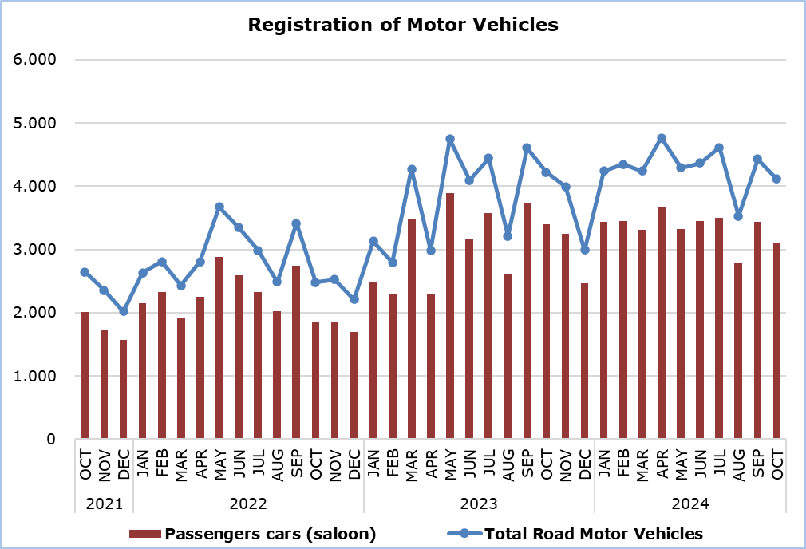

|  |  |  |  |  |  |  |  |
| --- | --- | --- | --- | --- | --- | --- | --- |
| **Table** |  |  |  |  |  |  |  |
| **Category of Road Motor Vehicles** | **Number of Registrations** | | | |  | **Percentage Change**  **(%)** | |
| **Oct**  **2024** | **Oct**  **2023** | **Jan-Oct**  **2024** | **Jan-Oct**  **2023** |  | **Oct**  **2024/2023** | **Jan-Oct**  **2024/2023** |
|
| Passengers’ cars (saloon) | 3.096 | 3.398 | 33.440 | 30.897 |  | -8,9 | 8,2 |
| Motor coaches and buses | 6 | 13 | 125 | 279 |  | -53,8 | -55,2 |
| Goods conveyance vehicles | 512 | 450 | 4.823 | 3.676 |  | 13,8 | 31,2 |
| Mopeds < 50cc | 24 | 33 | 627 | 263 |  | -27,3 | 138,4 |
| Mechanised cycles > 50cc | 415 | 276 | 3.348 | 2.927 |  | 50,4 | 14,4 |
| Tractors | 23 | 16 | 252 | 186 |  | 43,8 | 35,5 |
| Other vehicles | 35 | 37 | 315 | 275 |  | -5,4 | 14,5 |
| **Total** | **4.111** | **4.223** | **42.930** | **38.503** |  | **-2,7** | **11,5** |
| New | 1.621 | 1.718 | 19.206 | 17.737 |  | -5,6 | 8,3 |
| Used | 2.490 | 2.505 | 23.724 | 20.766 |  | -0,6 | 14,2 |

**METHODOLOGICAL INFORMATION**

**Scope and Coverage**

Data for the Registration of Motor Vehicles are collected on a monthly basis. They include the newly registered motor vehicles, as recorded by the Department of Road Transport.

The registrations are presented by category, make, energy type, new or used, engine cubic capacity, country of manufacture and other vehicle characteristics, based on the information maintained by the Motor Vehicles Registration and Licensing Authority of the Department of Road Transport.

**Data Collection**

The collection of data is conducted by the Statistical Service, which receives the necessary data from the Department of Road Transport.

**Definitions**

“Road motor vehicle” means any road vehicle fitted with an engine whence it derives its sole means of propulsion, which is normally used for carrying persons or goods by road, namely:

* Passengers’ cars saloon, which include private cars, taxis, rental cars, learners’ cars and invalid carriages
* Motor coaches and buses, for private and public use
* Goods conveyance vehicles, which include heavy and light goods conveyance vehicles, rental vehicles and road tractors (units of trailers)
* Mopeds and mechanised cycles, which include autocycles, motor tricycles, motorcycles and rental motorcycles
* Tractors, for agriculture and non-agriculture use
* Other vehicles, which include road rollers, mobile motor cranes, heavy locomotives and other vehicles for specific type and use.

**Monthly Publication**

The report entitled "Registration of Motor Vehicles" is published on a monthly basis since 1982 and is available free of charge in electronic form on the portalof the Statistical Service.

***For more information:***

CYSTAT Portal, subtheme [Services](https://www.cystat.gov.cy/en/SubthemeStatistics?s=50)

[CYSTAT-DB](https://cystatdb.cystat.gov.cy/pxweb/en/8.CYSTAT-DB/8.CYSTAT-DB__Services__) (Online Database)

[Predefined Tables](https://www.cystat.gov.cy/en/KeyFiguresList?s=50) (Excel)

[Publications](https://www.cystat.gov.cy/en/PublicationList?s=50) (Excel, from Jan. 2024) (Pdf, until Dec. 2023)

**The Predefined Tables, available in Excel format, include data up to December 2022. Data from January 2023 onwards are available only in the CYSTAT-DB Online Database.**

*Contact*  
Andrie Milidoni: Tel.: 22602240, E-mail: amilidoni@cystat.mof.gov.cy