9 October, 2026

PRESS RELEASE

REGISTRATION OF MOTOR VEHICLES: JANUARY - SEPTEMBER 2026

Total Registrations +9,1%

The Statistical Service announces the publication of the report entitled "Registration of Motor Vehicles" for the period January-September 2026.

In September 2026, the total registrations of motor vehicles numbered 5.326, recording a decrease of 3,9% compared to 5.544 in September 2025. Passenger saloon cars registered a fall of 2,5% to 4.254, from 4.364 in September 2025.

The main developments during the period January-September 2026 compared to the corresponding period of 2025 are summarised as follows:

(a) The total registrations of motor vehicles increased by 9,1% to 43.890 in January-September 2026, from 40.212 in January-September 2025.

(b) Passenger saloon cars increased to 34.156 from 31.325 in January-September 2025, recording a rise of 9,0%. Of the total passenger saloon cars, 10.521 or 30,8% were new and 23.635 or 69,2% were used cars. Rental cars in particular recorded a fall of 17,1% (from 4.559 to 3.780).

(c) The share of petrol powered passengers’ cars to the total of this category of vehicles decreased in January-September 2026 to 34,8% (from 42,8% in the corresponding period of the preceding year), of diesel-powered cars to 8,0% in 2026 from 8,5% in 2025 and of electric cars to 4,2% (from 4,7%). On the other hand, the share of hybrid cars rose from 44,0% to 53,0%.

(d) Motor coaches and buses registered in January-September 2026 increased to 196, from 132 in the same period of 2025.

(e) Goods conveyance vehicles increased by 10,4% to 5.046 in January-September 2026, compared to 4.569 in January-September 2025. In particular, light goods vehicles increased by 8,8% to 3.970, road tractors (units of trailers) by 14,7% to 195, heavy goods vehicles by 16,3% to 621 and rental vehicles by 20,9% to 260.

(f) Mopeds < 50cc registered in January-September 2026 decreased to 109 compared to 170 in the corresponding period of the previous year.

(g) Mechanised cycles > 50cc increased by 8,0% to 3.802 in January-September 2026, compared to 3.522 in the same period of 2025.

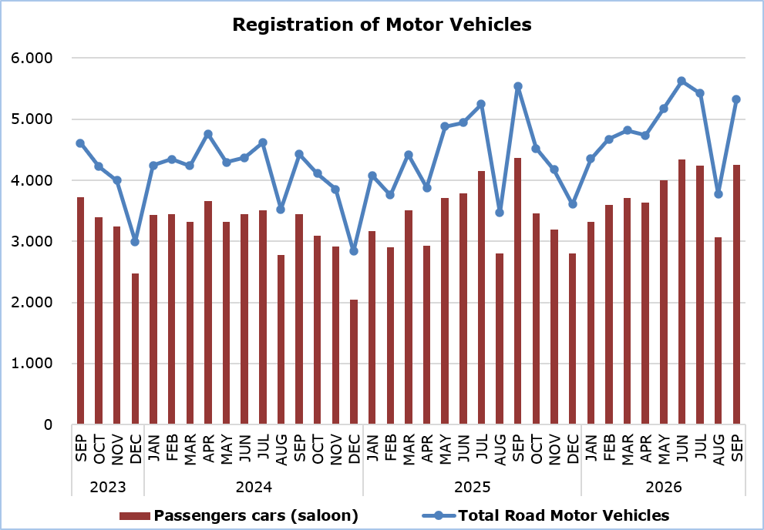

Table
Category of Road Motor Vehicles | Number of Registrations |  |  |  |  |  |  |  |  |  | Percentage Change  (%)
Category of Road Motor Vehicles | Sep  2026 |  | Sep  2025 |  | Jan-Sep  2026 |  | Jan-Sep  2025 |  |  |  | Sep  2026/2025 |  |  | Jan-Sep  2026/2025
Passengers’ cars (saloon) |  | 4.254 |  | 4.364 |  | 34.156 |  | 31.325 |  |  |  |  | -2,5 |  |  | 9,0
Motor coaches and buses |  | 54 |  | 31 |  | 196 |  | 132 |  |  |  | 74,2 |  |  | 48,5
Goods conveyance vehicles |  | 583 |  | 634 |  | 5.046 |  | 4.569 |  |  |  | -8,0 |  |  | 10,4
Mopeds < 50cc |  | 6 |  | 15 |  | 109 |  | 170 |  |  |  | -60,0 |  |  | -35,9
Mechanised cycles > 50cc |  | 374 |  | 428 |  | 3.802 |  | 3.522 |  |  |  | -12,6 |  |  | 8,0
Tractors |  | 26 |  | 31 |  | 246 |  | 237 |  |  |  | -16,1 |  |  | 3,8
Other vehicles |  | 29 |  | 41 |  | 335 |  | 257 |  |  |  | -29,3 |  |  | 30,4
Total |  | 5.326 |  | 5.544 |  | 43.890 |  | 40.212 |  |  |  | -3,9 |  |  | 9,1
New |  | 1.776 |  | 2.132 |  | 16.417 |  | 17.296 |  |  |  | -16,7 |  |  | -5,1
Used |  | 3.550 |  | 3.412 |  | 27.473 |  | 22.916 |  |  |  | 4,0 |  |  | 19,9

METHODOLOGICAL INFORMATION

Scope and Coverage

Data for the Registration of Motor Vehicles are collected on a monthly basis. They include the newly registered motor vehicles, as recorded by the Department of Road Transport.

The registrations are presented by category, make, energy type, new or used, engine cubic capacity, country of manufacture and other vehicle characteristics, based on the information maintained by the Motor Vehicles Registration and Licensing Authority of the Department of Road Transport.

Data Collection

The collection of data is conducted by the Statistical Service, which receives the necessary data from the Department of Road Transport.

Definitions

“Road motor vehicle” means any road vehicle fitted with an engine whence it derives its sole means of propulsion, which is normally used for carrying persons or goods by road, namely:
- Passengers’ cars saloon, which include private cars, taxis, rental cars, learners’ cars and invalid carriages
- Motor coaches and buses, for private and public use
- Goods conveyance vehicles, which include heavy and light goods conveyance vehicles, rental vehicles and road tractors (units of trailers)
- Mopeds and mechanised cycles, which include autocycles, motor tricycles, motorcycles and rental motorcycles
- Tractors, for agriculture and non-agriculture use
- Other vehicles, which include road rollers, mobile motor cranes, heavy locomotives and other vehicles for specific type and use.

Monthly Publication

The report entitled "Registration of Motor Vehicles" is published on a monthly basis since 1982 and is available free of charge in electronic form on the portal of the Statistical Service.

For more information:
CYSTAT Portal, subtheme Services
CYSTAT-DB (Online Database)
Predefined Tables (Excel)
Publications (Excel, from Jan. 2024) (Pdf, until Dec. 2023)

The Predefined Tables, available in Excel format, include data up to December 2022. Data from January 2023 onwards are available only in the CYSTAT-DB Online Database.

Contact
Andrie Milidoni: Tel.: 22602240, E-mail: amilidoni@cystat.mof.gov.cy

