6 May, 2026

PRESS RELEASE

REGISTERED UNEMPLOYED: APRIL 2026

The unemployed persons, registered at the District Labour Offices on the last day of April 2026, reached 8.962 persons. Based on the seasonally adjusted data which reflect the trend of unemployment, the number of registered unemployed for April 2026 increased to 10.585 persons, in comparison to 10.316 in the previous month. (Table 1)

In comparison with April 2025, an increase of 844 persons or 10,4% was recorded. This increase is mainly attributed to the sectors of accommodation and food service activities, administrative and support service activities, transportation and professional, scientific and technical activities. (Table 2)

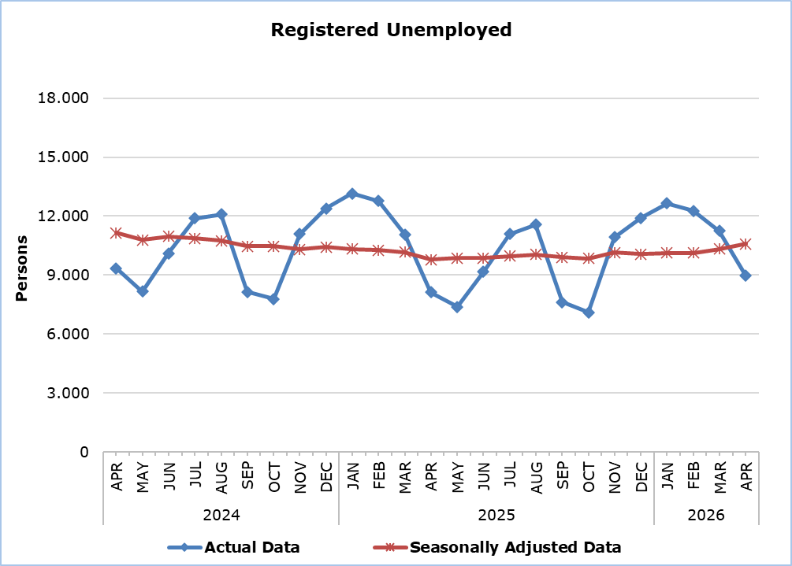

Table 1
Month and Year | Registered Unemployed – Actual Data | Registered Unemployed – Seasonally Adjusted Data
2026
April | 8.962 | 10.585
March | 11.243 | 10.316
February | 12.273 | 10.129
January | 12.650 | 10.121
2025
December | 11.901 | 10.062
November | 10.924 | 10.136
October | 7.099 | 9.840
September | 7.624 | 9.913
August | 11.556 | 10.047
July | 11.088 | 9.963
June | 9.153 | 9.867
May | 7.378 | 9.864
April | 8.118 | 9.782
March | 11.073 | 10.154
February | 12.761 | 10.273
January | 13.147 | 10.321
2024
December | 12.382 | 10.420
November | 11.087 | 10.308
October | 7.781 | 10.474
September | 8.142 | 10.472
August | 12.079 | 10.751
July | 11.877 | 10.857
June | 10.112 | 10.970
May | 8.159 | 10.779
April | 9.343 | 11.138
March | 12.277 | 11.337

Table 2
Nace Rev. 2 | Economic Activity | Registered Unemployed  (actual data)
Nace Rev. 2 | Economic Activity | April  2025 | March  2026 | April  2026
A | Agriculture, Forestry and Fishing | 38 | 45 | 46
B | Mining and Quarrying | 5 | 13 | 8
C | Manufacturing | 495 | 502 | 474
D | Electricity, Gas, Steam and Air Conditioning Supply | 5 | 5 | 4
E | Water Supply, Sewerage, Waste Management and Remediation Activities | 25 | 15 | 15
F | Construction | 447 | 383 | 374
G | Wholesale and Retail Trade, Repair of Motor Vehicles and Motorcycles | 1.493 | 1.692 | 1.489
H | Transportation and Storage | 367 | 587 | 453
I | Accommodation and Food Service Activities | 1.403 | 3.503 | 1.986
J | Information and Communication | 392 | 419 | 427
K | Financial and Insurance Activities | 389 | 386 | 392
L | Real Estate Activities | 107 | 134 | 127
M | Professional, Scientific and Technical Activities | 744 | 851 | 816
N | Administrative and Support Service Activities | 406 | 616 | 519
O | Public Administration and Defense, Compulsory Social Security | 577 | 665 | 557
P | Education | 234 | 262 | 253
Q | Human Health and Social Work Activities | 245 | 306 | 301
R | Arts, Entertainment and Recreation | 189 | 269 | 203
S | Other Service Activities | 221 | 294 | 245
T | Activities of Households | 7 | 12 | 11
U | Activities of Extra-territorial Organizations and Bodies | 11 | 12 | 10
 | Newcomers | 318 | 272 | 252
 | Total | 8.118 | 11.243 | 8.962

METHODOLOGICAL INFORMATION

Registered Unemployed
The number of registered unemployed concerns the persons aged 15 years and over who apply at the District and Local Labour Offices of the Department of Labour to seek employment and are registered as unemployed. These persons have to be able and available for work and must be actively looking for a job. The monthly number of registered unemployed concerns the persons who during the last day of the month have an active application for seeking employment.

The number of registered unemployed does not include self-employed or persons who seek part-time employment, nor persons who seek employment in certain areas or for a specific employer.

Seasonally Adjusted Data
Seasonal adjustment is a statistical technique that removes the seasonal component of a time series, making more visible the underlying trend in the change of a characteristic. CYSTAT uses the JDemetra+ 2.2.2 software which was developed by Eurostat. Seasonally adjusted series are produced by the TRAMO&SEATS algorithm. It should be noted that due to seasonal adjustment the whole series with the monthly estimates is recalculated every time a new month is added in time series. As a result, estimations for the previous months are often revised. In March 2020 a readjustment of the applied model was implemented.

Methodological Changes
According to information provided by the Department of Labour, from Tuesday June 15, 2021, the automatic renewal of registrations was terminated and the online platform of the Public Employment Service was activated to allow the registration of a new job application, its renewal, as well as a job vacancy registration. This settlement may affect the comparison of the monthly unemployment data recorded through this procedure with the data recorded from the previous procedures.

Classification System
Registered unemployed by economic activity are published based on the Statistical Classification of Economic Activities in the European Community, Rev. 2 (NACE Rev.2).

For more information:
CYSTAT Portal, subtheme Labour Market
CYSTAT-DB (Online Database)
Methodological Information

Contact
Christophoros Michaelides: Tel: +35722602154, Email.: cmichaelides@cystat.mof.gov.cy
Maria Hadjiprokopi: Tel: +35722602146, Email: mhadjiprokopi@cystat.mof.gov.cy

