6 March, 2025

**PRESS RELEASE**

###### REGISTERED UNEMPLOYED: FEBRUARY 2025

The unemployed persons, registered at the District Labour Offices on the last day of February 2025, reached 12.761 persons. Based on the seasonally adjusted data that show the trend of unemployment, the number of registered unemployed for February 2025 decreased to 10.272 persons, in comparison to 10.417 in the previous month. (Table 1)

In comparison with February 2024, a decrease of 1.543 persons or 10,8% was recorded, attributed mainly to the sectors of financial and insurance activities, accommodation and food service activities, trade, construction, as well as to the decrease recorded for newcomers in the labour market. (Table 2)

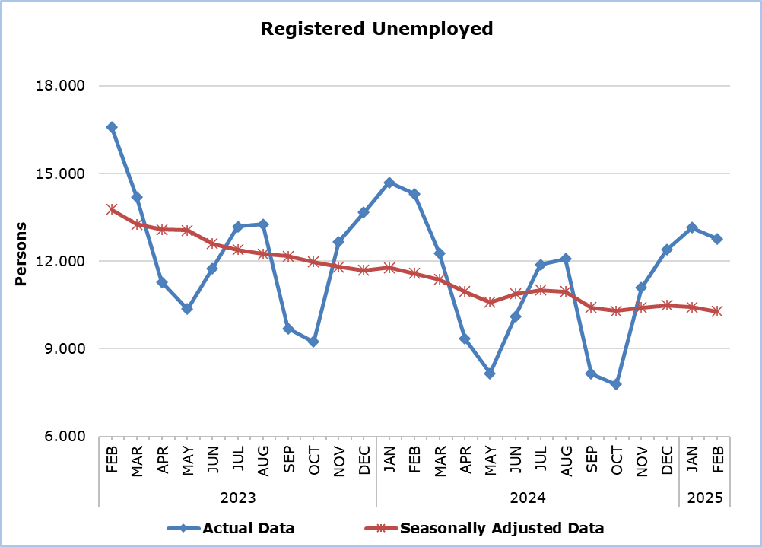

|  |  |  |
| --- | --- | --- |
| **Table 1** | | |
| **Month and Year** | **Registered Unemployed – Actual Data** | **Registered Unemployed – Seasonally Adjusted Data** |
| **2025** |  |  |
| **February** | **12.761** | **10.272** |
| January | 13.147 | 10.417 |
| **2024** |  |  |
| December | 12.382 | 10.487 |
| November | 11.087 | 10.403 |
| October | 7.781 | 10.287 |
| September | 8.142 | 10.403 |
| August | 12.079 | 10.954 |
| July | 11.877 | 11.003 |
| June | 10.112 | 10.877 |
| May | 8.159 | 10.589 |
| April | 9.343 | 10.956 |
| March | 12.277 | 11.370 |
| February | 14.304 | 11.586 |
| January | 14.699 | 11.778 |
| **2023** |  |  |
| December | 13.670 | 11.687 |
| November | 12.662 | 11.804 |
| October | 9.232 | 11.973 |
| September | 9.693 | 12.169 |
| August | 13.256 | 12.240 |
| July | 13.187 | 12.382 |
| June | 11.747 | 12.600 |
| May | 10.357 | 13.049 |
| April | 11.284 | 13.075 |
| March | 14.197 | 13.259 |
| February | 16.597 | 13.762 |
| January | 16.758 | 13.797 |
|  |  |  |

|  |  |  |  |  |
| --- | --- | --- | --- | --- |
| **Table 2** | | | | |
| **Nace Rev.2** | **Economic Activity** | **Registered Unemployed**  **(actual data)** | | |
| **February**  **2024** | **January**  **2025** | **February**  **2025** |
| A | Agriculture, Forestry and Fishing | 72 | 52 | 48 |
| B | Mining and Quarrying | 9 | 9 | 9 |
| C | Manufacturing | 636 | 582 | 597 |
| D | Electricity, Gas, Steam and Air Conditioning Supply | 4 | 4 | 4 |
| E | Water Supply, Sewerage, Waste Management and Remediation Activities | 30 | 21 | 20 |
| F | Construction | 697 | 559 | 530 |
| G | Wholesale and Retail Trade, Repair of Motor Vehicles and Motorcycles | 2.003 | 1.868 | 1.833 |
| H | Transportation and Storage | 747 | 725 | 713 |
| I | Accommodation and Food Service Activities | 4.754 | 4.768 | 4.508 |
| J | Information and Communication | 424 | 398 | 407 |
| K | Financial and Insurance Activities | 717 | 410 | 402 |
| L | Real Estate Activities | 118 | 151 | 156 |
| M | Professional, Scientific and Technical Activities | 891 | 730 | 728 |
| N | Administrative and Support Service Activities | 602 | 580 | 566 |
| O | Public Administration and Defense, Compulsory Social Security | 752 | 738 | 712 |
| P | Education | 326 | 252 | 255 |
| Q | Human Health and Social Work Activities | 257 | 266 | 273 |
| R | Arts, Entertainment and Recreation | 335 | 301 | 307 |
| S | Other Service Activities | 350 | 329 | 316 |
| T | Activities of Households | 18 | 11 | 10 |
| U | Activities of Extra-territorial Organizations and Bodies | 9 | 8 | 9 |
|  | Newcomers | 553 | 385 | 358 |
|  | **Total** | **14.304** | **13.147** | **12.761** |

**METHODOLOGICAL INFORMATION**

**Registered Unemployed**

The number of registered unemployed concerns the persons aged 15 years and over who apply at the District and Local Labour Offices of the Department of Labour to seek employment and are registered as unemployed. These persons have to be able and available for work and must be actively looking for a job. The monthly number of registered unemployed concerns the persons who during the last day of the month have an active application for seeking employment.

The number of registered unemployed does not include self-employed or persons who seek part-time employment, nor persons who seek employment in certain areas or for a specific employer.

**Seasonally Adjusted Data**

Seasonal adjustment is a statistical technique that removes the seasonal component of a time series, making more visible the underlying trend in the change of a characteristic. CYSTAT uses the JDemetra+ 2.2.2 software which was developed by Eurostat. Seasonally adjusted series are produced by the TRAMO&SEATS algorithm. It should be noted that due to seasonal adjustment the whole series with the monthly estimates is recalculated every time a new month is added in time series. As a result, estimations for the previous months are often revised. In March 2020 a readjustment of the applied model was implemented.

**Methodological Changes**

According to information provided by the Department of Labour, from Tuesday June 15, 2021, the automatic renewal of registrations was terminated and the online platform of the Public Employment Service was activated to allow the registration of a new job application, its renewal, as well as a job vacancy registration. This settlement may affect the comparison of the monthly unemployment data recorded through this procedure with the data recorded from the previous procedures.

**Classification System**

Registered unemployed by economic activity are published based on the Statistical Classification of Economic Activities in the European Community, Rev. 2 (NACE Rev.2).

***For more information:***

CYSTAT Portal, subtheme [Labour Market](https://www.cystat.gov.cy/en/SubthemeStatistics?s=43)

[CYSTAT-DB](https://cystatdb.cystat.gov.cy/pxweb/en/8.CYSTAT-DB/8.CYSTAT-DB__Labour%20Market__) (Online Database)

[Predefined Tables](https://www.cystat.gov.cy/en/KeyFiguresList?s=43) (Excel)

[Methodological Information](https://www.cystat.gov.cy/en/MethodologicalDetails?m=2064)

**The data included in the Predefined Tables in Excel format are available up to December 2021. Data from January 2022 onwards are available only in the CYSTAT-DB Online Database.**

*Contact*

Christophoros Michaelides: Tel: +35722602154, Email.: [cmichaelides@cystat.mof.gov.cy](mailto:cmichaelides@cystat.mof.gov.cy)

Maria Hadjiprokopi: Tel: +35722602146, Email: [mhadjiprokopi@cystat.mof.gov.cy](mailto:mhadjiprokopi@cystat.mof.gov.cy)