5 July, 2022

PRESS RELEASE

REGISTERED UNEMPLOYED: JUNE 2022

The unemployed persons, registered at the District Labour Offices on the last day of June 2022, reached 12.332 persons. Based on the seasonally adjusted data that show the trend of unemployment, the number of registered unemployed for June 2022 increased to 13.319 persons in comparison to 12.956 in the previous month. (Table 1)

In comparison with June 2021, a decrease of 14.362 persons or 53,8% was recorded, attributed mainly to the sectors of accommodation and food service activities (a decrease of 3.222), trade (a decrease of 3.015), construction (a decrease of 947), manufacturing (a decrease of 871), transportation and storage (a decrease of 733), as well as to the decrease of 1.153 persons recorded in newcomers to the labour market. (Table 2)

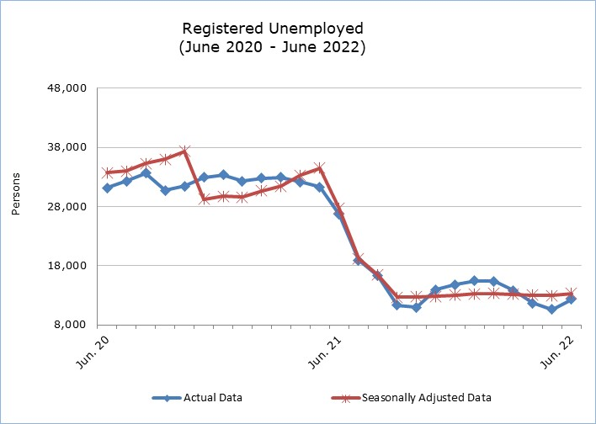

Table 1
Month and Year |  | Registered Unemployed – Actual Data |  | Registered Unemployed – Seasonally Adjusted Data
2022
June |  | 12.332 |  | 13.319
May |  | 10.586 |  | 12.956
April |  | 11.664 |  | 13.049
March |  | 13.818 |  | 13.203
February |  | 15.364 |  | 13.306
January |  | 15.430 |  | 13.214
2021
December |  | 14.800 |  | 13.012
November |  | 13.977 |  | 12.780
October |  | 10.974 |  | 12.762
September |  | 11.324 |  | 12.697
August |  | 16.281 |  | 16.446
July |  | 18.950 |  | 19.225
June |  | 26.694 |  | 27.667
May |  | 31.287 |  | 34.483
April |  | 32.186 |  | 33.316
March |  | 32.933 |  | 31.457
February |  | 32.789 |  | 30.675
January |  | 32.333 |  | 29.636
2020
December |  | 33.382 |  | 29.736
November |  | 32.968 |  | 29.240
October |  | 31.487 |  | 37.382
September |  | 30.718 |  | 36.040
August |  | 33.649 |  | 35.274
July |  | 32.313 |  | 34.015
June |  | 31.158 |  | 33.746
May |  | 29.604 |  | 33.301
Table 2
Nace Rev.2 | Economic Activity |  | Registered Unemployed  (actual data)
Nace Rev.2 |  |  | June  2021 |  | May  2022 | June  2022
A | Agriculture, Forestry and Fishing |  | 175 |  | 73 | 89
B | Mining and Quarrying |  | 42 |  | 11 | 11
C | Manufacturing |  | 1.585 |  | 734 | 714
D | Electricity, Gas, Steam and Air Conditioning Supply |  | 12 |  | 5 | 6
E | Water Supply, Sewerage, Waste Management and Remediation Activities |  | 90 |  | 34 | 33
F | Construction |  | 1.911 |  | 977 | 964
G | Wholesale and Retail Trade, Repair of Motor Vehicles and Motorcycles |  | 4.956 |  | 1.950 | 1.941
H | Transportation and Storage |  | 1.092 |  | 371 | 359
I | Accommodation and Food Service Activities |  | 4.430 |  | 1.376 | 1.208
J | Information and Communication |  | 713 |  | 355 | 380
K | Financial and Insurance Activities |  | 1.344 |  | 708 | 718
L | Real Estate Activities |  | 239 |  | 100 | 95
M | Professional, Scientific and Technical Activities |  | 1.416 |  | 758 | 750
N | Administrative and Support Service Activities |  | 1.067 |  | 495 | 483
O | Public Administration and Defense, Compulsory Social Security |  | 1.915 |  | 671 | 1.472
P | Education |  | 1.758 |  | 385 | 1.325
Q | Human Health and Social Work Activities |  | 540 |  | 287 | 309
R | Arts, Entertainment and Recreation |  | 575 |  | 192 | 233
S | Other Service Activities |  | 720 |  | 254 | 334
T | Activities of Households |  | 61 |  | 22 | 20
U | Activities of Extra-territorial Organizations and Bodies |  | 19 |  | 9 | 7
 | Newcomers |  | 2.034 |  | 819 | 881
 | Total |  | 26.694 |  | 10.586 | 12.332

METHODOLOGICAL NOTES

Registered Unemployed
The number of registered unemployed concerns the persons aged 15 years and over who apply at the District and Local Labour Offices of the Department of Labour to seek employment and are registered as unemployed. These persons have to be able and available for work and must be actively looking for a job. The monthly number of registered unemployed concerns the persons who during the last day of the month have an active application for seeking employment.

The number of registered unemployed does not include self-employed or persons who seek part-time employment, nor persons who seek employment in certain areas or for a specific employer.

Seasonally Adjusted data
Seasonal adjustment is a statistical technique that removes the seasonal component of a time series, making more visible the underlying trend in the change of a characteristic. CYSTAT uses the JDemetra+ 2.2.2 software which was developed by Eurostat. Seasonally adjusted series are produced by the TRAMO&SEATS algorithm. It should be noted that due to seasonal adjustment the whole series with the monthly estimates is recalculated every time a new month is added in time series. As a result, estimations for the previous months are often revised. In March 2020 a readjustment of the applied model was implemented.

Recent Methodological Changes
According to information provided by the Department of Labour, from Tuesday June 15, 2021, the automatic renewal of registrations was terminated and the online platform of the Public Employment Service was activated to allow the registration of a new job application, its renewal, as well as a job vacancy registration. This new settlement may affect the comparison of the monthly unemployment data recorded through the new procedure with the data recorded from the previous procedures. It is currently being evaluated by the Department of Labour.

Classification System
Registered unemployed by economic activity are published based on the Statistical Classification of Economic Activities in the European Community, Rev. 2 (NACE Rev.2).

For more information:
CYSTAT Portal, subtheme Labour Market
CYSTAT-DB (Online Database)
Predefined Tables (Excel)
Methodological Information

The data included in the Predefined Tables in Excel format are available up to December 2021. Data from January 2022 onwards are available only in the CYSTAT-DB Online Database.

Contact
Christophoros Michaelides: Tel: +35722602154, Email.: cmichaelides@cystat.mof.gov.cy
Maria Hadjiprokopi: Tel: +35722602146, Email: mhadjiprokopi@cystat.mof.gov.cy

