4 November, 2026

PRESS RELEASE

REGISTERED UNEMPLOYED: OCTOBER 2026

The unemployed persons, registered at the District Labour Offices on the last day of October 2026, reached 7.790 persons. Based on the seasonally adjusted data, which reflect the trend in unemployment, the number of registered unemployed persons decreased to 10.711 in October 2026, compared with 10.741 in the previous month. (Table 1)

Compared with October 2025, the number of registered unemployed persons increased by 691 persons, or 9,7%. This increase is mainly attributed to the sectors of information and communication, administrative and support service activities and professional, scientific and technical activities. (Table 2)

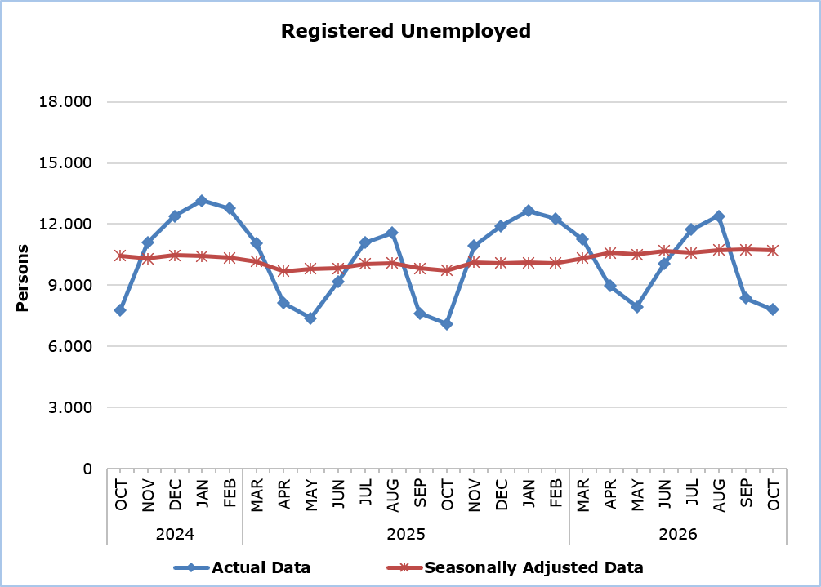

Table 1
Month and Year | Registered Unemployed – Actual Data | Registered Unemployed – Seasonally Adjusted Data
2026
October | 7.790 | 10.711
September | 8.366 | 10.741
August | 12.385 | 10.718
July | 11.728 | 10.591
June | 10.056 | 10.679
May | 7.936 | 10.505
April | 8.962 | 10.590
March | 11.243 | 10.316
February | 12.273 | 10.078
January | 12.650 | 10.096
2025
December | 11.901 | 10.077
November | 10.924 | 10.131
October | 7.099 | 9.731
September | 7.624 | 9.832
August | 11.556 | 10.092
July | 11.088 | 10.050
June | 9.153 | 9.815
May | 7.378 | 9.809
April | 8.118 | 9.693
March | 11.073 | 10.170
February | 12.761 | 10.342
January | 13.147 | 10.418
2024
December | 12.382 | 10.474
November | 11.087 | 10.305
October | 7.781 | 10.440
September | 8.142 | 10.415

Table 2
Nace Rev. 2 | Economic Activity | Registered Unemployed  (actual data)
Nace Rev. 2 | Economic Activity | October  2025 | September  2026 | October  2026
A | Agriculture, Forestry and Fishing | 32 | 46 | 34
B | Mining and Quarrying | 7 | 3 | 6
C | Manufacturing | 449 | 506 | 502
D | Electricity, Gas, Steam and Air Conditioning Supply | 8 | 4 | 5
E | Water Supply, Sewerage, Waste Management and Remediation Activities | 22 | 16 | 18
F | Construction | 392 | 394 | 390
G | Wholesale and Retail Trade, Repair of Motor Vehicles and Motorcycles | 1.324 | 1.402 | 1.332
H | Transportation and Storage | 261 | 293 | 294
I | Accommodation and Food Service Activities | 852 | 815 | 890
J | Information and Communication | 390 | 549 | 565
K | Financial and Insurance Activities | 358 | 407 | 399
L | Real Estate Activities | 85 | 128 | 117
M | Professional, Scientific and Technical Activities | 785 | 855 | 849
N | Administrative and Support Service Activities | 362 | 436 | 466
O | Public Administration and Defense, Compulsory Social Security | 595 | 1.050 | 655
P | Education | 277 | 491 | 340
Q | Human Health and Social Work Activities | 270 | 299 | 291
R | Arts, Entertainment and Recreation | 153 | 170 | 165
S | Other Service Activities | 191 | 215 | 198
T | Activities of Households | 10 | 9 | 10
U | Activities of Extra-territorial Organizations and Bodies | 9 | 10 | 9
 | Newcomers | 267 | 268 | 255
 | Total | 7.099 | 8.366 | 7.790

METHODOLOGICAL INFORMATION

Registered Unemployed
The number of registered unemployed persons refers to persons aged 15 years and over who apply to the District and Local Labour Offices of the Department of Labour in order to seek employment and who are registered as unemployed. These persons must be able and available for work and must be actively looking for a job. The monthly number of registered unemployed persons refers to persons who, on the last day of the month, have an active application for seeking employment.

The number of registered unemployed does not include self-employed or persons who seek part-time employment, nor persons who seek employment in certain areas or for a specific employer.

Seasonally Adjusted Data
Seasonal adjustment is a statistical technique that removes the seasonal component of a time series, making more visible the underlying trend in the change of a characteristic. CYSTAT uses the JDemetra+ 2.2.6 software which was developed by Eurostat. Seasonally adjusted series are produced by the TRAMO&SEATS algorithm. It should be noted that due to seasonal adjustment the whole series with the monthly estimates is recalculated every time a new month is added in time series. As a result, estimates for previous months are often revised. In March 2020 a readjustment of the applied model was implemented.

Methodological Changes
According to information provided by the Department of Labour, from Tuesday June 15, 2021, the automatic renewal of registrations was terminated and the online platform of the Public Employment Service was activated to allow the registration of a new job application, its renewal, as well as a job vacancy registration. This change may affect the comparison of the monthly unemployment data recorded through this procedure with the data recorded from the previous procedures.

Classification System
Registered unemployed by economic activity are published based on the Statistical Classification of Economic Activities in the European Community, Rev. 2 (NACE Rev.2).

For more information:
CYSTAT Portal, subtheme Labour Market
CYSTAT-DB (Online Database)
Methodological Information

Contact
Christophoros Michaelides: Tel: +357 22602154, Email.: cmichaelides@cystat.mof.gov.cy
Charoulla Charalambous: Tel: +357 22602123, Email: ccharalambous@cystat.mof.gov.cy

