2 May, 2025

**PRESS RELEASE**

TURNOVER INDEX OF RETAIL TRADE EXCEPT OF MOTOR VEHICLES: **MARCH 2025**

**Annual Change +5,6% in Value and +5,6% in Volume**

The Turnover Value Index of Retail Trade for March 2025 increased by 5,6% compared to the corresponding month of the previous year (Table 1). For the same month, the Turnover Volume Index of Retail Trade increased by 5,6% compared to the corresponding month of the previous year (Table 2).

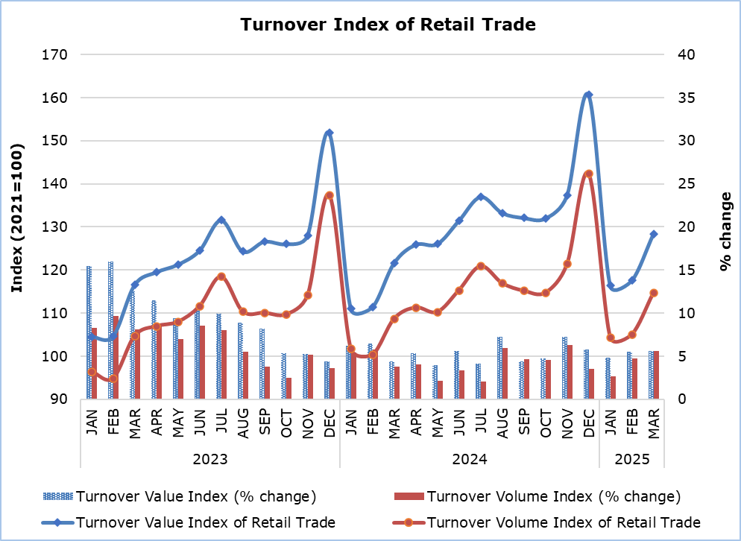

|  |  |  |  |  |  |
| --- | --- | --- | --- | --- | --- |
| **Table 1** | | | | | |
| **Code**  **(NACE Rev. 2)** | **Economic Activity** | **Value Index (2021=100)** |  | **Percentage Change**  **(%)** | |
| **March**  **2025** | **March**  **2025/2024** | **Jan - Mar**  **2025/2024** |
| 47.1 | Food, beverages or tobacco in non-specialised stores (supermarkets) | 137,9 |  | 7,1 | 6,9 |
| 47.2 | Food, beverages and tobacco in specialised stores | 136,7 |  | 3,7 | 5,6 |
| 47.3 | Automotive fuel | 117,7 |  | -1,3 | 3,3 |
| 47.4 | Information and communication equipment | 102,3 |  | 2,1 | 1,3 |
| 47.5 | Other household equipment (construction materials, carpets, furniture, electrical appliances, lighting) | 118,2 |  | 7,1 | 2,8 |
| 47.6 | Cultural and recreation goods (books, stationery, sports equipment, toys) | 132,2 |  | 7,8 | 12,7 |
| 47.71+47.72 | Clothing and footwear | 117,5 |  | 7,4 | 4,2 |
| 47.73+47.74  +47.75 | Pharmaceuticals, orthopedic goods, cosmetics | 125,0 |  | 2,8 | 1,9 |
| 47.76+47.77  +47.78+47.79 | Flowers, plants, watches, jewellery, optical goods and second-hand goods | 133,5 |  | 7,8 | 7,7 |
| 47.8+47.9 | Retail sale not in stores | 99,5 |  | -4,3 | -3,9 |
| 47 except 47.3 | Retail trade except of automotive fuel | 129,7 |  | 6,4 | 5,6 |
| 47.11+47.2 | Edible goods | 139,1 |  | 7,1 | 7,0 |
| 47.19+47.4 to 47.9 | Non edible goods | 119,3 |  | 5,4 | 3,9 |
|  |  |  |  |  |  |
| **47** | **RETAIL TRADE, EXCEPT OF MOTOR VEHICLES** | **128,4** |  | **5,6** | **5,3** |

|  |  |  |  |  |  |
| --- | --- | --- | --- | --- | --- |
| **Table 2** | | | | | |
| **Code**  **(NACE Rev. 2)** | **Economic Activity** | **Volume Index (2021=100)** |  | **Percentage Change**  **(%)** | |
| **March**  **2025** | **March**  **2025/2024** | **Jan - Mar**  **2025/2024** |
| 47.1 | Food, beverages or tobacco in non-specialised stores (supermarkets) | 119,0 |  | 5,9 | 4,9 |
| 47.2 | Food, beverages and tobacco in specialised stores | 113,4 |  | -0,7 | 0,0 |
| 47.3 | Automotive fuel | 101,4 |  | -1,3 | 0,9 |
| 47.4 | Information and communication equipment | 118,4 |  | 9,5 | 7,9 |
| 47.5 | Other household equipment (construction materials, carpets, furniture, electrical appliances, lighting) | 106,9 |  | 7,7 | 3,2 |
| 47.6 | Cultural and recreation goods (books, stationery, sports equipment, toys) | 121,1 |  | 7,8 | 12,4 |
| 47.71+47.72 | Clothing and footwear | 123,0 |  | 16,7 | 9,9 |
| 47.73+47.74  +47.75 | Pharmaceuticals, orthopedic goods, cosmetics | 115,0 |  | 0,3 | -0,3 |
| 47.76+47.77  +47.78+47.79 | Flowers, plants, watches, jewellery, optical goods and second-hand goods | 111,9 |  | 3,8 | 3,4 |
| 47.8+47.9 | Retail sale not in stores | 93,9 |  | -2,6 | -2,8 |
| 47 except 47.3 | Retail trade except of automotive fuel | 116,3 |  | 6,3 | 4,7 |
| 47.11+47.2 | Edible goods | 119,4 |  | 5,5 | 4,5 |
| 47.19+47.4 to 47.9 | Non edible goods | 112,8 |  | 7,3 | 5,0 |
|  |  |  |  |  |  |
| **47** | **RETAIL TRADE, EXCEPT OF MOTOR VEHICLES** | **114,7** |  | **5,6** | **4,3** |

**METHODOLOGICAL INFORMATION**

**Scope and Coverage**

The purpose of the Turnover Index of Retail Trade, except of Motor Vehicles is to monitor short-term developments in Retail Trade. The Index covers activities in division 47 of the Statistical Classification of Economic Activities of the European Union, NACE Rev. 2. Turnover comprises the total amounts invoiced by an enterprise during the reference period and this corresponds to the market sales of goods and services, excluding VAT but including other duties and taxes on the goods.

**Data Collection**

The Statistical Service collects data monthly by telephone enquiries or e-mail.

**Compilation Method and Dissemination Practices**

The Index is using 2021 as the base year, meaning that it shows the monthly changes in turnover in relation to the monthly turnover average of the year 2021. In the base year, the average of the Turnover Index for the twelve months is 100,0. For example, a monthly Turnover Index of 105,3 means that the turnover for the specific month has increased by 5,3% in relation to the average monthly turnover of 2021.

The Turnover Value Index is calculated at current prices, while the Turnover Volume Index is calculated at constant prices and is derived by deflating the Turnover Value Index, using the Consumer Price Index (CPI) as deflator.

The aggregated Index is a weighted average of the Turnover Ιndices of the various classes (subsets of activities) of Retail Trade, as defined in NACE Rev. 2. The weights used are derived from the results of the annual Wholesale and Retail Trade Survey in the base year (2021) and reflect the share of turnover of each class in relation to the total turnover of the retail trade sector.

The compilation of the Index follows the provisions of Regulation (EU) 2019/2152 on European business statistics. The Index is transmitted every month to the Statistical Office of the European Union (Eurostat). In addition to gross data, both seasonally and calendar adjusted data are transmitted. The Index is published at national level only in its gross form.

***For more information:***

CYSTAT Portal, subtheme [Trade](https://www.cystat.gov.cy/en/SubthemeStatistics?s=52)

[CYSTAT-DB](https://cystatdb.cystat.gov.cy/pxweb/en/8.CYSTAT-DB/8.CYSTAT-DB__Trade__Wholesale) (Online Database)

[Predefined Tables](https://www.cystat.gov.cy/en/KeyFiguresList?s=52) (Excel)

[Methodological Information](https://www.cystat.gov.cy/en/MethodologicalDetails?m=2322)

**Data for base year 2021=100 are available only in the CYSTAT-DB Online Database.**

*Contact*

Evangelia Efstathiou: Tel.: 22602196, E-mail: [eefstathiou@cystat.mof.gov.cy](mailto:eefstathiou@cystat.mof.gov.cy)