17 October, 2022

**PRESS RELEASE**

###### RISK OF POVERTY AND SOCIAL EXCLUSION 2021

On the occasion of the **International Day for the Eradication of Poverty**, which takes place each year on October 17 throughout the world, the Statistical Service of Cyprus publishes an Infographic on “[Poverty or Social Exclusion 2021](https://library.cystat.gov.cy/Infographics/Cystat-Poverty-EN-2021.pdf)”. In Cyprus, the percentage of the population that was at risk of poverty or social exclusion, meaning that population was living in households whose disposable income was below the at-risk-of-poverty threshold (€10.011 person equivalent) or was severely materially and socially deprived or was living in households with very low work intensity, reached 17,3% in 2021 compared to 17,6% in 2020. The decrease corresponds to approximately 2.000 fewer persons at risk of poverty or social exclusion in 2021 (154 thous.), compared to 2020 (156 thous.).

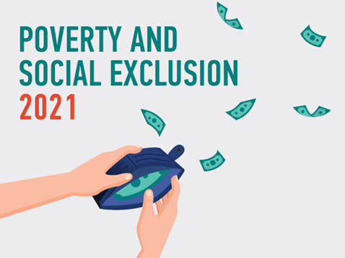

***For more information:***

CYSTAT Portal, subtheme [Living Conditions and Social Protection](https://www.cystat.gov.cy/en/SubthemeStatistics?s=44)

[Predefined Tables](https://www.cystat.gov.cy/en/KeyFiguresList?s=44) (Excel)

[Methodological Information](https://www.cystat.gov.cy/en/MethodologicalDetails?m=2100)

*Contact*

Charalambos Charalambous: Tel:+35722602241, Email: [chcharalambous@cystat.mof.gov.cy](mailto:chcharalambous@cystat.mof.gov.cy)