15 May, 2025

**PRESS RELEASE**

ROAD FREIGHT TRANSPORT: **4th QUARTER 2024**

**Freight transport in Cyprus -9,7% and from and to Cyprus +3,4%**

The Statistical Service announces the release of the latest figures for road freight transport for the fourth quarter of 2024.

During the period October-December 2024, the total weight of goods transported by road in Cyprus decreased by 9,7% compared to the corresponding period of 2023, while the weight of freight transported from and to Cyprus increased by 3,4%.

During the period January-December 2024, the total weight of goods transported by road in Cyprus increased by 3,2% compared to the corresponding period of 2023, while the weight of freight transported from and to Cyprus also increased by 2,0%.

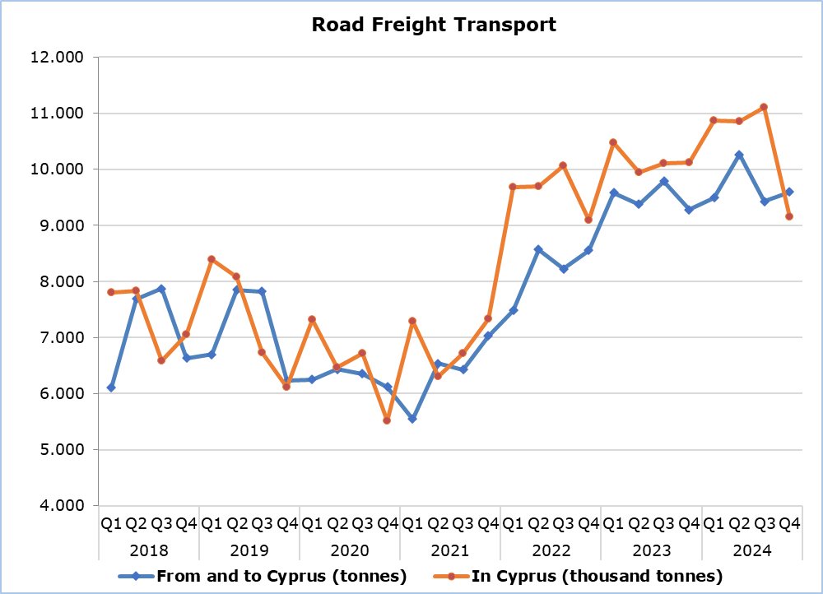

|  |  |  |  |  |  |  |  |  |  |
| --- | --- | --- | --- | --- | --- | --- | --- | --- | --- |
| **Table 1** | | | | |  |  |  |  |  |
| **Road Freight Transport** | **Tonnes**  **(thousand)** | | | |  | **Percentage Change**  **(%)** | | | |
| **Oct-Dec**  **2023** | **Oct-Dec**  **2024** | **Jan-Dec**  **2023** | **Jan-Dec**  **2024** |  | **Oct-Dec**  **2024/2023** | | **Jan-Dec**  **2024/2023** | |
| In Cyprus | 10.126,4 | 9.145,6 | 40.660,7 | 41.965,9 |  | -9,7 | | 3,2 | |
| From and to Cyprus | 9,3 | 9,6 | 38,0 | 38,8 |  | 3,4 | | 2,0 | |

|  |  |  |  |  |  |  |  |  |  |
| --- | --- | --- | --- | --- | --- | --- | --- | --- | --- |
| **Table 2** | | | | |  |  |  |  |  |
| **Road Freight Transport** | **Tonnekilometres**  **(million)** | | | |  | **Percentage Change**  **(%)** | | | |
| **Oct-Dec**  **2023** | **Oct-Dec**  **2024** | **Jan-Dec**  **2023** | **Jan-Dec**  **2024** |  | **Oct-Dec**  **2024/2023** | | **Jan-Dec**  **2024/2023** | |
| In Cyprus | 230,3 | 258,4 | 986,0 | 1.018,6 |  | 12,2 | | 3,3 | |
| From and to Cyprus | 8,0 | 9,5 | 37,3 | 38,8 |  | 18,2 | | 3,8 | |

**METHODOLOGICAL INFORMATION**

**Scope and Coverage**

The aim of the Road Freight Transport Survey is the collection of statistical data concerning the carriage of goods by road in Cyprus or from and to Cyprus, by means of road transport vehicles. It concerns only vehicles registered in Cyprus, at the Department of Road Transport.

For the national carriage of goods, a sample is selected from the vehicle’s register. Only vehicles whose load capacity is more than 3 tonnes are sampled. The sample consists of 9 categories (strata) according to the load capacity of the vehicle and the type of transport (hire or reward and own account) and covers all 52 weeks of the year.

The international carriage of goods covers all movements of freight (inbound and outbound journeys) around the year.

The data compiled are transmitted to Eurostat according to the Regulation (EU) No 70/2012 on statistical returns in respect of the carriage of goods by road.

**Data Collection**

The unit of enumeration is the goods road transport vehicle. The data collected for each vehicle relates to their characteristics, the route and the goods carried.

For the national carriage of goods, data is collected through telephone interviews around the year by enumerators, while for the international carriage of goods the data are collected directly from the companies that own the specific vehicles.

**Definitions**

A *tonne-kilometre* (tkm) is a unit of measure of freight transport which represents the transport of one tonne of goods by a given transport mode over a distance of one kilometre.

***For more information*:**

CYSTAT Portal, subtheme [Services](https://www.cystat.gov.cy/en/SubthemeStatistics?s=50)

[CYSTAT-DB](https://cystatdb.cystat.gov.cy/pxweb/en/8.CYSTAT-DB/8.CYSTAT-DB__Services__) (Online Database)

[Predefined Tables](https://www.cystat.gov.cy/en/KeyFiguresList?s=50) (Excel)

[Methodological Ιnformation](https://www.cystat.gov.cy/en/MethodologicalDetails?m=2114)

**The Predefined Tables, available in Excel format, include data up to the fourth quarter of 2022. Data from the first quarter of 2023 onwards are available only in the CYSTAT-DB Online Database.**

*Contact*

Andrie Milidoni: Tel.: 22602240, E-mail: [amilidoni@cystat.mof.gov.cy](mailto:amilidoni@cystat.mof.gov.cy)