15 May, 2026

PRESS RELEASE

ROAD FREIGHT TRANSPORT: 4th QUARTER 2025

Freight Transport In Cyprus +19,4% and From and To Cyprus +14,2%

The Statistical Service announces the release of the latest figures for road freight transport for the fourth quarter of 2025.

During the period October-December 2025, the total weight of goods transported by road in Cyprus increased by 19,4% compared to the corresponding period of 2024, while the weight of freight transported from and to Cyprus also increased by 14,2%.

During the period January-December 2025, the total weight of goods transported by road in Cyprus increased by 4,8% compared to the corresponding period of 2024, while the weight of freight transported from and to Cyprus also increased by 10,0%.

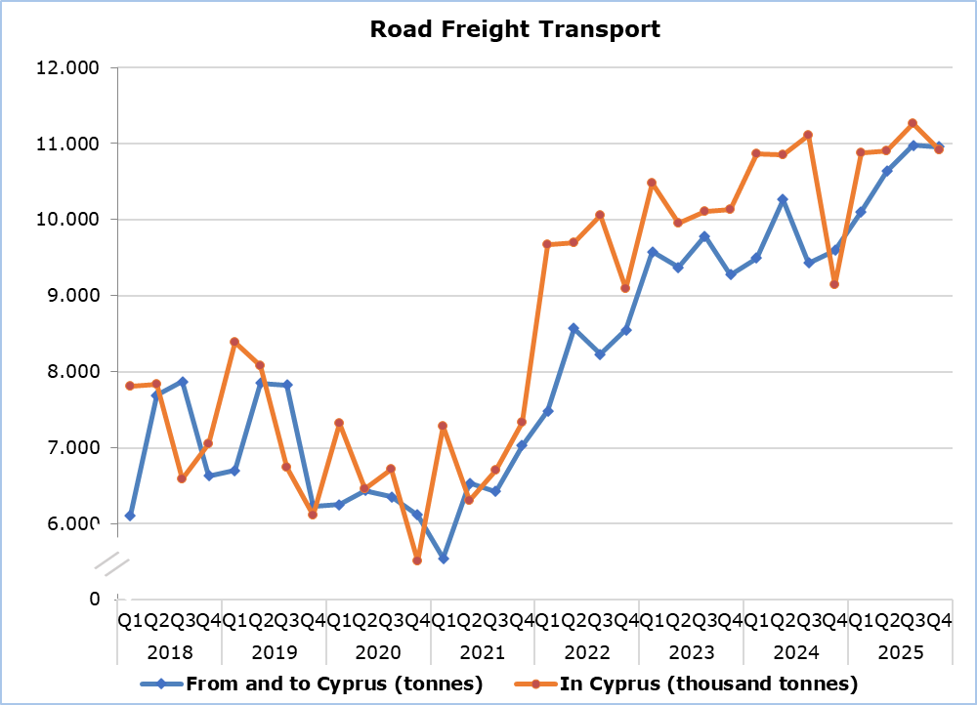

Table 1
Road Freight Transport | Tonnes  (thousand) |  |  |  |  | Percentage Change  (%)
Road Freight Transport | Oct-Dec  2024 | Oct-Dec  2025 | Jan-Dec  2024 | Jan-Dec  2025 |  | Oct-Dec  2025/2024 |  | Jan-Dec  2025/2024
In Cyprus | 9.145,6 | 10.920,1 | 41.965,9 | 43.974,4 |  | 19,4 |  | 4,8
From and to Cyprus | 9,6 | 11,0 | 38,8 | 42,7 |  | 14,2 |  | 10,0

Table 2
Road Freight Transport | Tonnekilometres  (million) |  |  |  |  | Percentage Change  (%)
Road Freight Transport | Oct-Dec  2024 | Oct-Dec  2025 | Jan-Dec  2024 | Jan-Dec  2025 |  | Oct-Dec  2025/2024 |  | Jan-Dec  2025/2024
In Cyprus | 258,4 | 227,0 | 1.018,6 | 1.029,8 |  | -12,1 |  | 1,1
From and to Cyprus | 9,5 | 5,9 | 38,8 | 34,7 |  | -37,8 |  | -10,4

METHODOLOGICAL INFORMATION

Scope and Coverage

The aim of the Road Freight Transport Survey is the collection of statistical data concerning the carriage of goods by road in Cyprus or from and to Cyprus, by means of road transport vehicles. It concerns only vehicles registered in Cyprus, at the Department of Road Transport.

For the national carriage of goods, a sample is selected from the vehicle’s register. Only vehicles whose load capacity is more than 3 tonnes are sampled. The sample consists of 9 categories (strata) according to the load capacity of the vehicle and the type of transport (hire or reward and own account) and covers all 52 weeks of the year.

The international carriage of goods covers all movements of freight (inbound and outbound journeys) around the year.

The data compiled are transmitted to Eurostat according to the Regulation (EU) No 70/2012 on statistical returns in respect of the carriage of goods by road.

Data Collection

The unit of enumeration is the goods road transport vehicle. The data collected for each vehicle relates to their characteristics, the route and the goods carried.

For the national carriage of goods, data is collected through telephone interviews around the year by enumerators, while for the international carriage of goods the data are collected directly from the companies that own the specific vehicles.

Definitions

A tonne-kilometre (tkm) is a unit of measure of freight transport which represents the transport of one tonne of goods by a given transport mode over a distance of one kilometre.

For more information:
CYSTAT Portal, subtheme Services
CYSTAT-DB (Online Database)
Predefined Tables (Excel)
Methodological Ιnformation

The Predefined Tables, available in Excel format, include data up to the fourth quarter of 2022. Data from the first quarter of 2023 onwards are available only in the CYSTAT-DB Online Database.

Contact
Andrie Milidoni: Tel.: 22602240, E-mail: amilidoni@cystat.mof.gov.cy

