17 October, 2024

**PRESS RELEASE**

INCOME AND LIVING CONDITIONS OF THE HOUSEHOLDS:

**MATERIAL AND SOCIAL DEPRIVATION 2023**

###### Severe Material and Social Deprivation

Based on the results of the Household Income and Living Conditions Survey of 2023, 2,4% of the population (22.000 persons) lived in conditions of severe material and social deprivation, compared to 2,7% in 2022. This indicator shows the percentage of the population that is deprived, due to financial difficulties, of at least 7 items from a list of 13 goods, services and social activities, examined in this survey (more information on the method of calculating this indicator, can be found in the methodological information).

Figure 1 shows the evolution of the indicator from 2015 to 2023 in Cyprus and the EU27. Since 2015, this indicator in Cyprus has remained consistently below the EU27 average and has been on a downward trend.

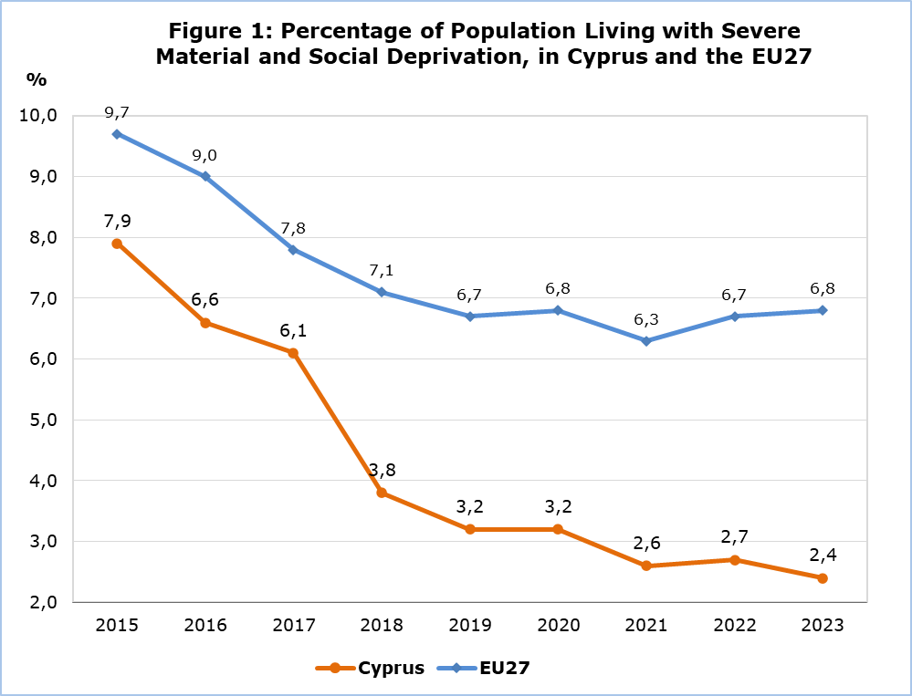

Figure 2 presents the indicator of severe material and social deprivation by age group for the years 2015-2023. The survey data shows that children under the age of 18, although over time they have recorded the highest rates, in 2023 their percentage has decreased by 1,6 percentage points (from 4,4% in 2022 to 2,8% in 2023), thus approaching the percentages of the other age groups. This is followed by persons aged 18-64 with a percentage of 2,4% and by persons aged 65 and over with a rate of 1,9%. Since 2015, the greatest improvement is observed in children, with a gradual decrease of 7,6 percentage points (from 10,4% in 2015 to 2,8% in 2023) and in persons aged 18-64, with a decrease of 5,8 percentage points (from 8,2% to 2,4%). Although, persons aged 65 and over have the lowest rates of severe material and social deprivation over time, in 2023 an increase is observed in their rate, by 1,0 percentage point (from 0,9% to 1,9%).

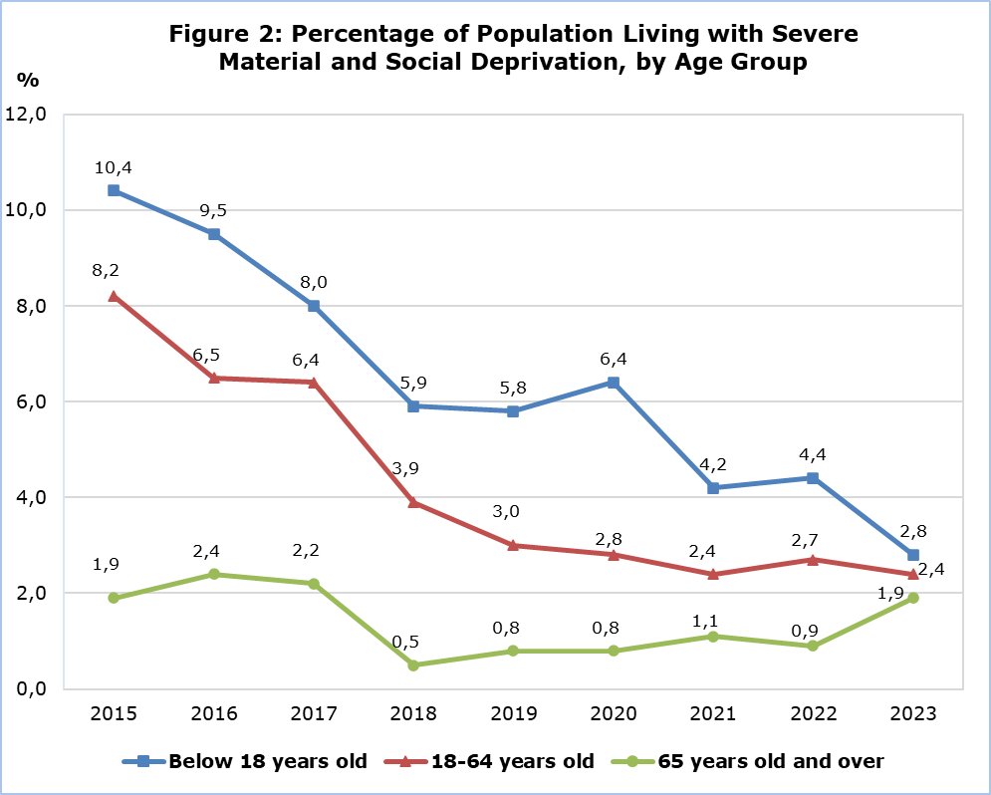

**Deprivation of Goods, Services and Social Activities by Component**

Figure 3 presents the percentages of the population who are materially and socially deprived, by deprivation component, for the years 2022 and 2023 in Cyprus and in the EU27 average for 2023.

Based on these data, it is mainly noted the inability of the population, to afford facing unexpected but necessary financial expenses with 37,6% (EU27: 31,2%), to afford paying for one week holiday with 36,0% (EU27: 28,5%) and to afford replacing worn-out furniture with 29,6% (EU27: 21,2%).

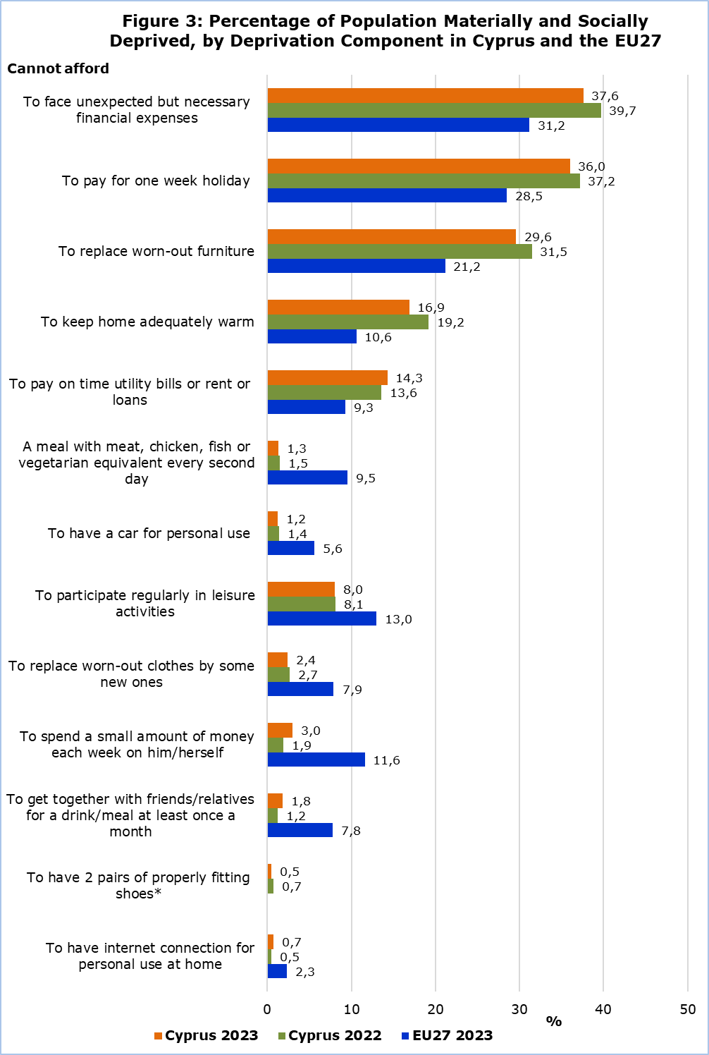

*No data are available for the average of the EU27 for the component “To have 2 pairs of properly fitting shoes”.

Figure 4 presents for the year 2023, the percentages of the population who are materially and socially deprived by component and by income category (total, above and below the at-risk-of-poverty threshold)**[1]**. It is evident that persons below the at-risk-of-poverty threshold (i.e. at-risk-of-poverty) are worse off than those above the at-risk-of-poverty threshold (non- at-risk-of-poverty).

The survey results have indicated the inability of the population who are at risk of poverty, to afford facing unexpected but necessary financial expenses with 76,8% (the non-at risk of poverty with 31,3%), to afford paying for one week holiday with 75,0% (the non-at risk of poverty with 29,7%), to afford replacing worn-out furniture with 56,8% (the non-at risk of poverty with 25,2%) and to afford keeping home adequately warm with 43,6% (the non-at risk of poverty with 12,6%).

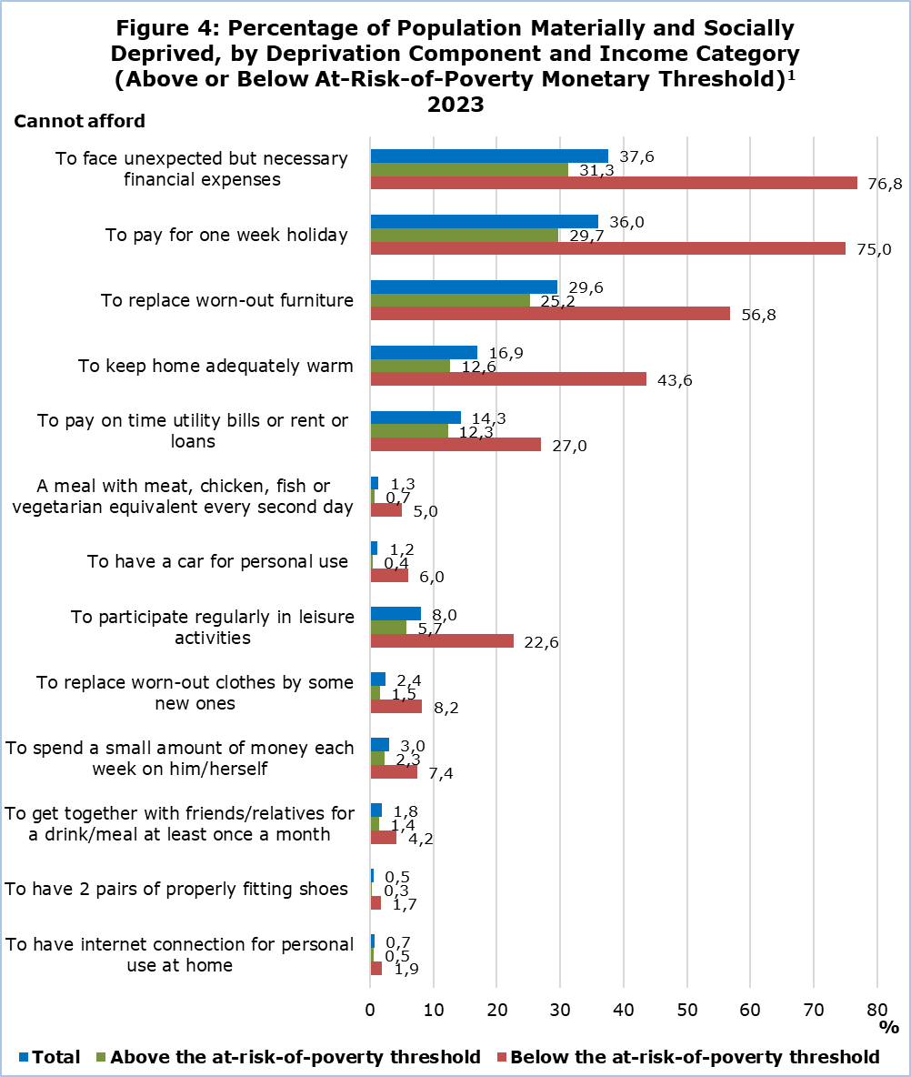

|  |  |  |  |  |  |  |  |  |  |  |
| --- | --- | --- | --- | --- | --- | --- | --- | --- | --- | --- |
| **Table 1** | |  |  |  |  |  |  |  |  |  |
| **Severe Material and Social Deprivation** | | **2015** | **2016** | **2017** | **2018** | **2019** | **2020** | **2021** | **2022** | **2023** |
| **By Sex** | Total | 7,9 | 6,6 | 6,1 | 3,8 | 3,2 | 3,2 | 2,6 | 2,7 | 2,4 |
| Males | 8,0 | 6,9 | 6,2 | 3,9 | 3,4 | 3,3 | 2,3 | 2,6 | 2,3 |
| Females | 7,8 | 6,3 | 6,1 | 3,7 | 3,0 | 3,2 | 2,8 | 2,8 | 2,5 |
| **By Age Group** | 0-17 | 10,4 | 9,5 | 8,0 | 5,9 | 5,8 | 6,4 | 4,2 | 4,4 | 2,8 |
| 18-64 | 8,2 | 6,5 | 6,4 | 3,9 | 3,0 | 2,8 | 2,4 | 2,7 | 2,4 |
| 65+ | 1,9 | 2,4 | 2,2 | 0,5 | 0,8 | 0,8 | 1,1 | 0,9 | 1,9 |

|  |  |  |  |  |  |  |  |  |  |
| --- | --- | --- | --- | --- | --- | --- | --- | --- | --- |
| **Table 2** |  |  |  |  |  |  |  |  |  |
| **Severe Material and Social Deprivation** **by Country of the EU** | **2015** | **2016** | **2017** | **2018** | **2019** | **2020** | **2021** | **2022** | **2023** |
| Slovenia | 4,8 | 4,1 | 4,5 | 3,2 | 2,2 | 2,6 | 1,8 | 1,4 | 2,0 |
| **Cyprus** | **7,9** | **6,6** | **6,1** | **3,8** | **3,2** | **3,2** | **2,6** | **2,7** | **2,4** |
| Luxembourg | 2,5 | 2,0 | 1,9 | 1,6 | 1,4 | 1,7 | 2,4 | 2,0 | 2,5 |
| Sweden | 1,1 | 0,7 | 1,0 | 1,4 | 1,5 | 2,0 | 1,4 | 2,3 | 2,5 |
| Estonia | 3,5 | 2,2 | 4,0 | 3,1 | 2,6 | 2,3 | 1,9 | 3,3 | 2,5 |
| Netherlands | 3,2 | 2,6 | 2,6 | 2,6 | 2,8 | 2,2 | 2,1 | 2,5 | 2,6 |
| Czechia | 4,5 | 3,5 | 3,4 | 2,4 | 2,1 | 1,9 | 1,8 | 2,1 | 2,7 |
| Finland | 1,0 | 1,2 | 1,8 | 2,2 | 1,9 | 1,8 | 1,1 | 1,9 | 2,8 |
| Croatia | 8,4 | 7,3 | 7,1 | 6,1 | 4,6 | 4,4 | 3,5 | 4,0 | 2,8 |
| Poland | 7,8 | 5,4 | 5,3 | 4,5 | 3,5 | 2,6 | 2,9 | 2,8 | 3,0 |
| Austria | 2,9 | 3,3 | 3,4 | 2,8 | 2,7 | 3,0 | 1,8 | 2,3 | 3,7 |
| Malta | 8,2 | 5,2 | 4,3 | 4,7 | 5,0 | 5,1 | 5,4 | 4,9 | 4,1 |
| Italy | 12,1 | 10,1 | 6,6 | 6,5 | 6,4 | 6,2 | 5,9 | 4,5 | 4,7 |
| Denmark | 3,2 | 2,6 | 3,6 | 3,5 | 3,8 | 3,5 | 3,1 | 3,2 | 4,9 |
| Portugal | 10,9 | 9,1 | 8,0 | 6,6 | 5,6 | 5,4 | 6,0 | 5,3 | 4,9 |
| Ireland | 9,4 | 8,0 | 6,9 | 6,1 | 7,1 | 5,7 | 5,1 | 5,8 | 6,0 |
| Belgium | 7,2 | 8,4 | 7,2 | 6,5 | 6,3 | 6,7 | 6,3 | 5,8 | 6,1 |
| Lithuania | 14,6 | 15,4 | 14,4 | 12,0 | 9,7 | 8,1 | 6,4 | 6,0 | 6,1 |
| Latvia | 15,4 | 12,6 | 12,9 | 10,4 | 7,5 | 7,0 | 5,3 | 7,8 | 6,2 |
| France | 6,8 | 6,7 | 6,3 | 6,7 | 7,3 | 7,0 | 5,9 | 7,5 | 6,6 |
| **EU27** | **9,7** | **9,0** | **7,8** | **7,1** | **6,7** | **6,8** | **6,3** | **6,7** | **6,8** |
| Germany | 5,7 | 4,7 | 3,7 | 3,4 | 3,0 | 4,4 | 4,3 | 6,1 | 6,9 |
| Slovakia | 8,4 | 7,6 | 6,3 | 5,4 | 5,9 | 4,5 | 5,7 | 6,3 | 7,0 |
| Spain | 7,4 | 8,5 | 8,3 | 8,7 | 7,7 | 8,5 | 8,3 | 7,7 | 9,0 |
| Hungary | 24,1 | 20,6 | 16,1 | 11,9 | 10,9 | 10,7 | 10,2 | 9,1 | 10,4 |
| Greece | 17,6 | 18,4 | 18,3 | 16,1 | 15,8 | 14,9 | 13,9 | 13,9 | 13,5 |
| Bulgaria | 36,8 | 33,5 | 30,0 | 22,3 | 22,1 | 22,1 | 19,1 | 18,7 | 18,0 |
| Romania | 34,0 | 35,9 | 32,4 | 28,3 | 24,5 | 25,3 | 23,1 | 24,3 | 19,8 |

**METHODOLOGICAL INFORMATION**

**Survey Identity**

The survey on Income and Living Conditions of the Households (EU-SILC) is conducted in accordance to Regulation (EC) No. 2019/1700 of the European Parliament and of the Council and is used by the European Statistical Service (EUROSTAT) as the main source of comparable information among the member states of the European Union (EU) on matters related to poverty and social exclusion.

The main objective of the survey is the study of various socio-economic indicators, which affect the living conditions of the population, the compilation of systematic statistics in relation to the income inequalities, the inequalities in living conditions of the households, poverty and social exclusion, as well as the compilation of structural social cohesion indicators.

**Coverage and Data Collection**

The survey conducted in 2023, with income reference period the year 2022, covered a sample of 4.281 households in all districts of Cyprus, in both urban and rural areas.

The survey is carried out since 2005 on an annual basis with a rotational sample and consists of two components, the cross-sectional and the longitudinal one. The cross-sectional refers to a point in time or period, whereas the longitudinal refers to the changes that arise on a personal level during a period of three to four years.

The data collection was carried out with personal and telephone interviews at the households using electronic questionnaires.

**Definitions**

**Severe material and social deprivation (SMSD)**: Severely materially and socially deprived is the population who cannot afford a certain good, service or social activity. It refers to the population experiencing enforced lack of at least 7 out of 13 deprivation items (6 related to the individual and 7 related to the household):

At household level *(information provided by the head of the household):*

Cannot afford:

1) to face unexpected but necessary financial expenses (2023: of an amount of *€8351)*

2) to pay one week holiday,

3) to pay on time utility bills or rent or loan (to be confronted with payment arrears),

4) a meal with meat, chicken, fish or vegetarian equivalent every second day,

5) to keep home adequately warm,

6) to have a car for personal use,

7) to replace worn-out furniture.

*1The amount of €835 is determined in the survey by the monthly equivalised disposable income of the annual at-risk-of-poverty threshold resulting from the most recent available data and is independent of the size and composition of the household. (The corresponding amount for 2022 was also €835)*

At individual level:

Cannot afford:

1) to have internet connection for personal use at home,

2) to replace worn-out clothes by new ones,

3) to have 2 pairs of properly fitting shoes (including a pair of all-weather shoes),

4) to spend a small amount of money each week on him/herself,

5) to participate regularly in leisure activities,

6) to get together with friends/relatives for a drink/meal at least once a month.

The 6 items at individual level are only collected for people aged 16 or over. For the children below 16 it is estimated by applying the rule: if at least half the number of adults in the household lack an item, then the children living in that household are considered deprived from that item as well.

**At risk of poverty threshold**:  is set at 60% of the national median equivalised disposable income, which is calculated by dividing the total disposable income of the household (total disposable income of all its members after social transfers) by the equivalised household size, which is calculated using the following weights: First adult=1,0 unit, second and each subsequent household member aged 14 years and over=0,5 and each household member aged under 14=0,3.

***For more information:***

CYSTAT Portal, subtheme [Living Conditions and Social Protection](https://www.cystat.gov.cy/en/SubthemeStatistics?s=44)

[Predefined Tables](https://www.cystat.gov.cy/en/KeyFiguresList?s=44) (Excel)

[Methodological Information](https://www.cystat.gov.cy/en/MethodologicalDetails?m=2100)

*Contact*

Charalambos Charalambous: Tel:+35722602241, Email: [chcharalambous@cystat.mof.gov.cy](mailto:chcharalambous@cystat.mof.gov.cy)

Demetra Costa: Tel:+35722605112, Email: [dcosta@cystat.mof.gov.cy](mailto:dcosta@cystat.mof.gov.cy)

1. In the 2023 Survey, the income reference period is 2022 and the at-risk-of-poverty threshold was €11.324.