11 June, 2024

**PRESS RELEASE**

SURVEY ON INCOME AND LIVING CONDITIONS OF THE HOUSEHOLDS: **RISK OF POVERTY 2023**

**At Risk of Poverty or Social Exclusion (AROPE)**

According to the results of the Survey on Income and Living Conditions 2023, with income reference period the year 2022, 16,7% of the population or 153.000 persons were at risk of poverty or social exclusion (AROPE indicator, the main indicator to monitor the EU 2030 target on poverty and social exclusion). Namely, 16,7% of the population was living in households whose disposable income was below the at-risk- of-poverty threshold or was severely materially and socially deprived or was living in households with very low work intensity.

The indicator for 2023 remained at the same level compared to the previous year, when it was also at 16,7%. Therefore, the indicator remained unchanged in 2023, after the continuous downward trend of the recent years. Even though the improvement in recent years has been reflected in both women and men, still throughout the years, women are maintaining their unfavorable position in respect to men. In 2023, the relevant indicator for women was 18,1% and for men 15,3%. Figure 1 shows the evolution of the indicator (AROPE) in the years 2015 to 2023.

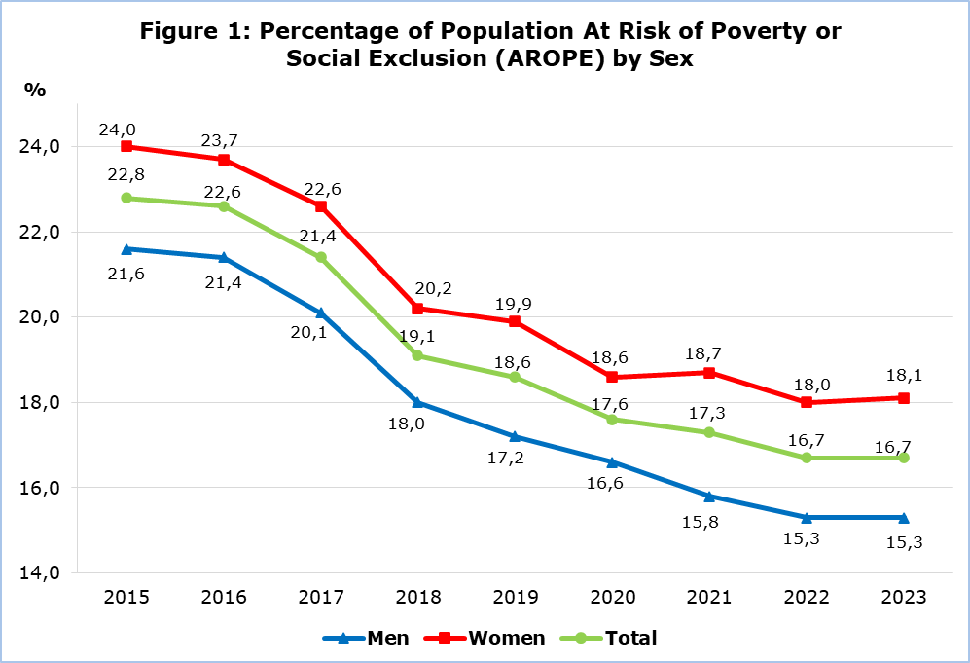

Figure 2, presents the results of the 3 sub-indicators contributing to the computation of the strategic indicator at risk of poverty or social exclusion, (at risk of poverty, severe material and social deprivation, very low work intensity). From Figure 2, it can be seen that the indicator for severe material and social deprivation decreased by 0,3 percentage points (from 2,7% in 2022 to 2,4% in 2023), the risk of poverty indicator remained at exactly the same levels (13,9%) and the indicator for the percentage of the population living in households with very low work intensity showed an increase of 0,3 percentage points (from 4,1% in 2022, to 4,4% in 2023). Based on these results, in 2023 the at risk of poverty or social exclusion indicator remained stable (16,7%) (more information in the definitions in the methodological part).

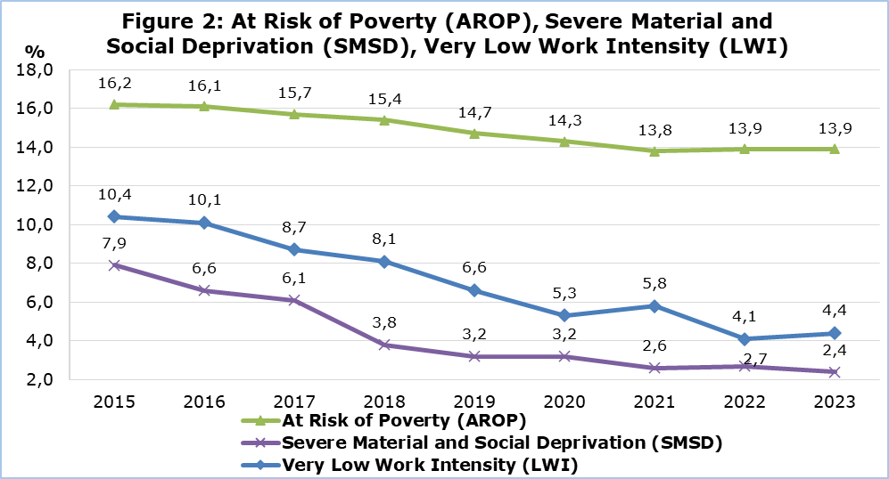

**At Risk of Poverty (AROP)**

In 2023, the percentage of the population that was at risk of poverty, meaning that its disposable income was below the at-risk-of-poverty threshold, was 13,9% or 128.000 persons, remaining at the same level with that of 2022 (13,9%). The at-risk-of-poverty threshold, which is defined at the 60% of the median total equivalized disposable income of the households, was estimated in 2023 at €11.324 for single person households and at €23.780 for households with 2 adults and 2 children younger than 14 years old, exhibiting an increase of 5,7% in respect to 2022, where the respective thresholds were €10.713 and €22.498. The median equivalized disposable income (one person) in 2023 was €18.873 in comparison to €17.856 in 2022. In Figure 3, the trend of the at-risk-of-poverty rate is presented together with the at risk of poverty threshold from 2008 to 2023.

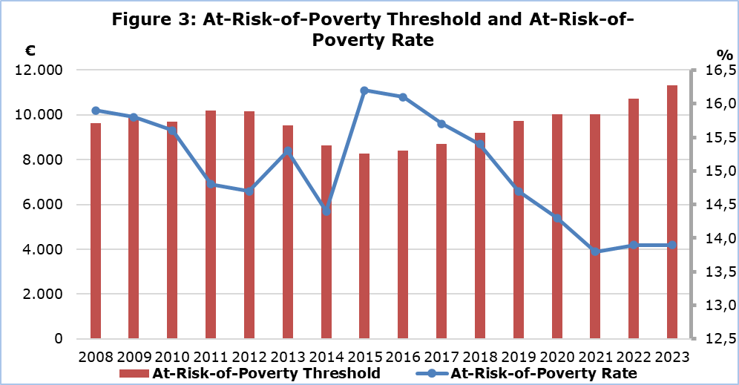

**At Risk of Poverty Before and After Social Transfers**

The percentage of the population living at risk of poverty, before any social benefits1 and pensions2 (social transfers) were included in the disposable income of the households, was estimated at 33,1%. When only pensions were included in the disposable income of the households, this percentage was reduced to 20,0%, while when social benefits were further included, the percentage was reduced to 13,9% (Figure 4). Consequently, it is confirmed that social transfers contribute to the reduction of the percentage of the people living at risk of poverty. In 2023, all the social transfers reduced the indicator by 19,2 percentage points, (13,1 pp as a result of pensions and 6,1 as a result of the social benefits).

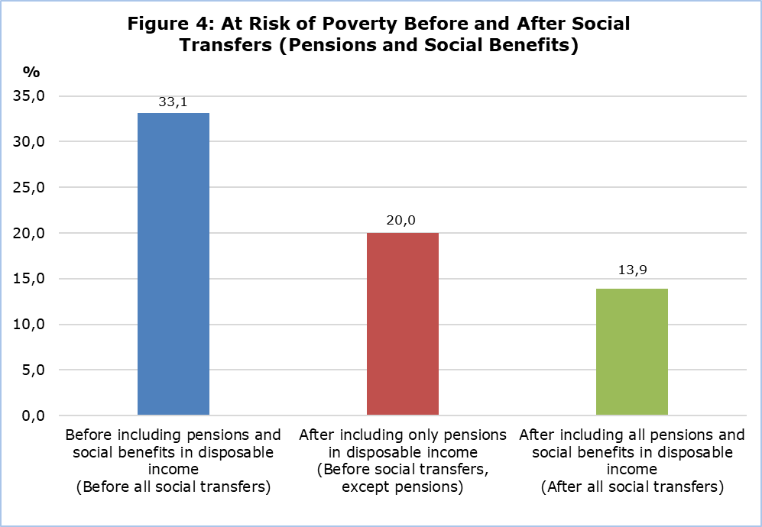

1 Social benefits: Minimum Guaranteed Income, maternity allowance, child allowance, single parent benefit, for the

disabled, unemployment benefit, allowance for the care of the elderly, etc.

2 Pensions: old age, widow’s, orphan’s, disability, etc.

|  |  |  |  |  |  |  |  |  |
| --- | --- | --- | --- | --- | --- | --- | --- | --- |
| **Table** |  |  |  |  |  |  |  |  |
| **Indicator** |  |  | **2015** | **2019** | **2020** | **2021** | **2022** | **2023** |
| **At-risk-of-poverty or social exclusion rate (AROPE)** | **Total** | % | **22,8** | **18,6** | **17,6** | **17,3** | **16,7** | **16,7** |
| Men | % | 21,6 | 17,2 | 16,6 | 15,8 | 15,3 | 15,3 |
| Women | % | 24,0 | 19,9 | 18,6 | 18,7 | 18,0 | 18,1 |
| **At-risk-of-poverty threshold** | 1 person households | € | 8.276 | 9.729 | 10.022 | 10.011 | 10.713 | 11.324 |
| Households with 2 adults and 2 children younger than 14 years old | € | 17.380 | 20.431 | 21.047 | 21.024 | 22.498 | 23.780 |
| **At-risk-of-poverty rate by age (AROP)**  *(after social transfers)* | **Total** | **%** | **16,2** | **14,7** | **14,3** | **13,8** | **13,9** | **13,9** |
| 0-17 | % | 16,7 | 16,7 | 16,1 | 15,8 | 14,9 | 14,0 |
| 18-64 | % | 15,9 | 11,9 | 12,0 | 11,9 | 11,9 | 11,5 |
| 65+ | % | 17,3 | 24,6 | 21,9 | 19,5 | 20,8 | 23,6 |
| **At-risk-of-poverty rate before social transfers except pensions** | **Total** | **%** | **25,4** | **22,7** | **21,9** | **22,1** | **20,1** | **20,0** |
| **At-risk-of-poverty rate before all social transfers** | **Total** | **%** | **38,8** | **35,1** | **35,2** | **35,8** | **33,3** | **33,1** |
| **Severe material and social deprivation (SMSD)** | **Total** | % | **7,9** | **3,2** | **3,2** | **2,6** | **2,7** | **2,4** |
| **Percentage of population aged 0-64 living in households with very low work intensity, by sex (LWI)** | **Total** | **%** | **10,4** | **6,6** | **5,3** | **5,8** | **4,1** | **4,4** |
| Men | % | 9,9 | 6,1 | 5,1 | 5,9 | 3,8 | 4,1 |
| Women | % | 10,9 | 8,4 | 7,1 | 5,8 | 4,4 | 4,8 |
| **Mean annual disposable income of the household** |  | € | 29.959 | 33.584 | 33.862 | 34.227 | 35.699 | 38.147 |

**METHODOLOGICAL INFORMATION**

**Survey Identity**

The survey on Income and Living Conditions of the Households (EU-SILC) is conducted in accordance to Regulation (EC) No. 2019/1700 of the European Parliament and of the Council and is used by the European Statistical Service (EUROSTAT) as the main source of comparable information among the member states of the European Union (EU) on matters related to poverty and social exclusion.

The main objective of the survey is the study of various socio-economic indicators, which affect the living conditions of the population, the compilation of systematic statistics in relation to the income inequalities, the inequalities in living conditions of the households, poverty and social exclusion, as well as the compilation of structural social cohesion indicators.

**Coverage and Data Collection**

The survey conducted in 2022, with income reference period the year 2020, covered a sample of 4.281 households in all districts of Cyprus, in both urban and rural areas.

The survey is carried out since 2005 on an annual basis with a rotational sample and consists of two components, the cross-sectional and the longitudinal one. The cross-sectional refers to a point in time or period, whereas the longitudinal refers to the changes that arise on a personal level during a period of three to four years.

The data collection was carried out with personal and telephone interviews at the households using electronic questionnaires.

**Definitions**

**At risk of poverty or social exclusion rate (AROPE)**: At-risk-of-poverty or social exclusion rate is the percentage of the population who are: at risk of monetary poverty or severely materially and socially deprived or living in a household with a very low work intensity. Persons are only counted once even if they are present in several sub-indicators.

The indicator at-risk-of-poverty or social exclusion is the main indicator to monitor the EU 2030 target on poverty and social exclusion. The relevant target refers to the reduction of the number of people at risk of poverty or social exclusion by at least 15 million by 2030, and out of them, at least 5 million should be children.

**At risk of poverty threshold**: is set at 60% of the national median equivalised disposable income, which is calculated by dividing the total disposable income of the household (total disposable income of all its members after social transfers) by the equivalised household size, which is calculated using the following weights: First adult=1,0 unit, second and each subsequent household member aged 14 years and over=0,5 and each household member aged under 14=0,3.

**At risk of poverty rate (AROP)**: The at-risk-of-poverty rate is the share of persons with an equivalised disposable income (after social transfers) below the at-risk-of-poverty threshold. It measures relative poverty and not absolute poverty.

**Severe material and social deprivation (SMSD)**: Severely materially and socially deprived is the population who cannot afford a certain good, service or social activity. It refers to the population experiencing enforced lack of at least 7 out of 13 deprivation items (6 related to the individual and 7 related to the household):

At household level:

Cannot afford:

1) to face unexpected expenses,

2) a week holiday away from home,

3) to pay rent or utility bills or loans (to be confronted with payment arrears),

4) a meal with meat, chicken, fish or vegetarian equivalent every second day,

5) to keep home adequately warm,

6) to have a car/van for personal use,

7) to replace worn-out furniture.

At individual level:

Cannot afford:

1) to have an internet connection,

2) to replace worn-out clothes by some new ones,

3) to have 2 pairs of properly fitting shoes (including a pair of all-weather shoes),

4) to spend a small amount of money each week on him/herself,

5) to have regular leisure activities,

6) to get together with friends/family for a drink/meal at least once a month.

The 6 items at individual level are only collected for people aged 16 or over. For the children below 16 it is estimated by applying the rule: if at least half the number of adults in the household lack an item, then the children living in that household are considered deprived from that item as well.

**Very low work intensity (LWI)**: The percentage of the population aged 0-64 that was living in households whose adults aged 18-64 worked less than 20% of their work potential during the past year. From the adults are excluded the students aged 18-24, people who are retired according to their self-defined current economic status or who receive any pension (except survivor’s pension), people in the age bracket 60-64 who are inactive and living in a household where the main income is pensions (except survivor’s pension).

**Social transfers:** Are the social benefits/allowances and pensions. The ***social benefits/allowances*** include the Minimum Guaranteed Income, maternity allowance, child allowance, single parent benefit, benefit for the disabled, unemployment benefit, allowance for the care of the elderly, etc. ***Pensions*** include old age pensions, widow’s pension, orphan’s pension, disability pension, etc.

***For more information:***

CYSTAT Portal, subtheme [Living Conditions and Social Protection](https://www.cystat.gov.cy/en/SubthemeStatistics?s=44)

[Predefined Tables](https://www.cystat.gov.cy/en/KeyFiguresList?s=44) (Excel)

[Methodological Information](https://www.cystat.gov.cy/en/MethodologicalDetails?m=2100)

*Contact*

Charalambos Charalambous: Tel:+35722602241, Email: [chcharalambous@cystat.mof.gov.cy](mailto:chcharalambous@cystat.mof.gov.cy)

Demetra Costa: Tel:+35722605112, Email: [dcosta@cystat.mof.gov.cy](mailto:dcosta@cystat.mof.gov.cy)