20 March, 2025

**PRESS RELEASE**

SURVEY ON INCOME AND LIVING CONDITIONS OF THE HOUSEHOLDS: **RISK OF POVERTY 2024**

**At Risk of Poverty or Social Exclusion (AROPE)**

According to the results of the Survey on Income and Living Conditions 2024, with income reference period the year 2023, 17,1% of the population or 164 thousand persons were at risk of poverty or social exclusion (AROPE indicator, the main indicator to monitor the EU 2030 target on poverty and social exclusion). Specifically, 17,1% of the population was living in households whose disposable income was below the at-risk- of-poverty threshold or was severely materially and socially deprived or was living in households with very low work intensity.

The indicator for 2024 is slightly improved compared to 2023 which was at 17,4% (revised data, more explanations in the Methodological Information). In 2024, the indicator for women was at 18,5% and for men at 15,6%, maintaining their unfavorable position in respect to men. Figure 1 shows the comparison of the indicator (AROPE) by sex for the years 2023 and 2024.

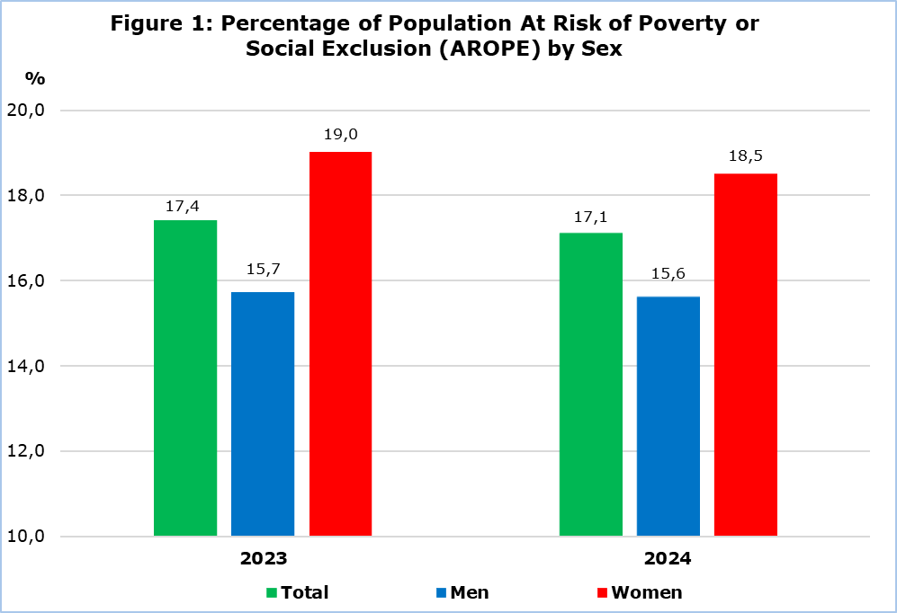

Figure 2, presents the results of the three sub-indicators contributing to the computation of the strategic indicator at risk of poverty or social exclusion, (at risk of poverty, severe material and social deprivation, very low work intensity). From Figure 2, it can be seen that the risk of poverty indicator decreased by 0,3 percentage points (from 14,9% in 2023 to 14,6% in 2024), the indicator for the percentage of the population living in households with very low work intensity showed a decrease of also 0,3 percentage points (from 4,5% in 2023, to 4,2% in 2024) and the indicator for severe material and social deprivation increased slightly by 0,1 percentage points (from 2,4% in 2023 to 2,5% in 2024). As a result, the at-risk-of-poverty or social exclusion indicator in 2024 decreased to 17,1% (more explanations in the Methodological Information).

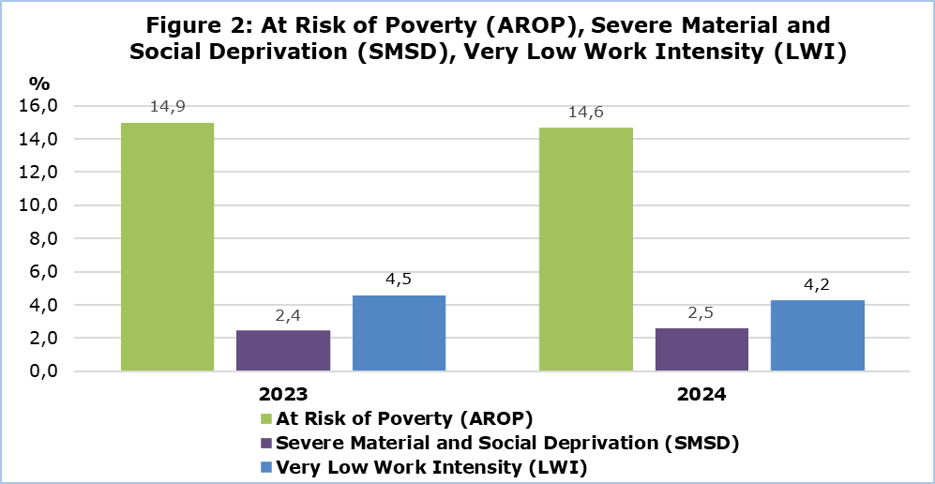

**At Risk of Poverty (AROP)**

In 2024, the percentage of the population that was at risk of poverty, meaning that their disposable income was below the at-risk-of-poverty threshold, was 14,6%, showing a slight decrease compared to 2023, which was at 14,9%. The at-risk-of-poverty threshold, which is defined at the 60% of the median total equivalized disposable income of the households, was estimated in 2024 at €12.400 for single person households and at €26.039 for households with two adults and two children younger than 14 years old, exhibiting an increase of 7,4% compared to 2023, where the respective thresholds were €11.548 and €24.250. In addition, it should be noted that, the median equivalized disposable income (one person) in 2024 was €20.667 compared to €19.247 in 2023. Figure 3, shows the comparison of the At-risk-of-Poverty Rate (AROP) and the At-risk-of-Poverty Threshold for the years 2023 and 2024.

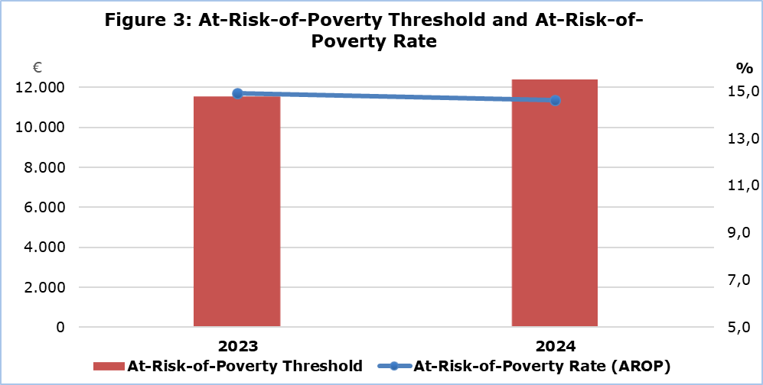

**At Risk of Poverty Before and After Social Transfers**

In 2024, the percentage of the population living at risk of poverty before including any social benefits1 and pensions2 (social transfers) in the disposable income of the households, was estimated at 34,2%. When only pensions were included in the disposable income of the households, this percentage decreased to 21,0%, while when social benefits were also included, the percentage was further decreased to 14,6% (Figure 4). Consequently, it is confirmed that social transfers contribute to the reduction of the percentage of the people living at risk of poverty. In 2024, all social transfers decreased this indicator overall by 19,6 percentage points, (13,2 percentage points due to pensions and 6,4 percentage points due to social benefits).

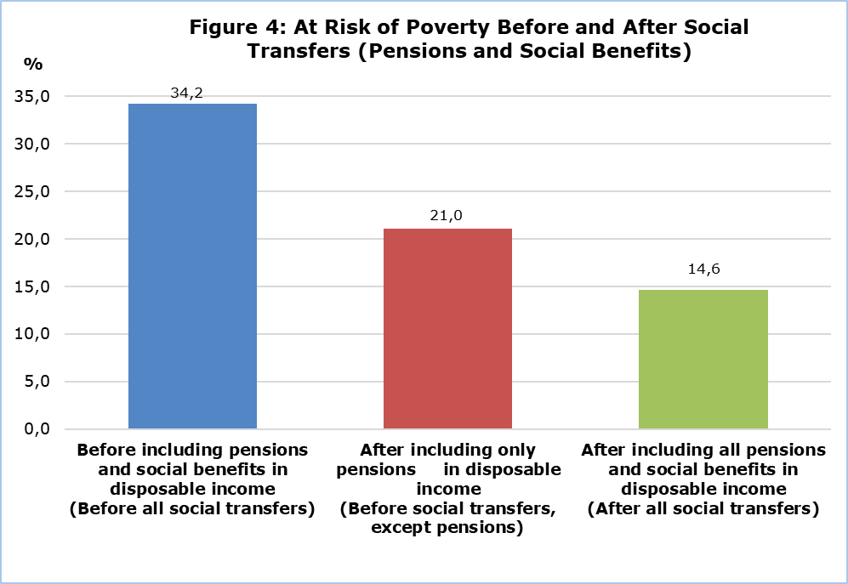

1 Social benefits: Minimum Guaranteed Income, maternity allowance, child allowance, single parent benefit, for the

disabled, unemployment benefit, allowance for the care of the elderly, etc.

2 Pensions: old age, widow’s, orphan’s, disability, etc.

|  |  |  |  |  |  |  |  |  |  |  |  |  |  |
| --- | --- | --- | --- | --- | --- | --- | --- | --- | --- | --- | --- | --- | --- |
| **Table** |  |  |  |  | |  | |  | |  | |  | |
| **Indicator** |  |  | **2015** | | **2020** | **2021** | **2022** | | **2023b** | | **2024** | |
| **At-risk-of-poverty or social exclusion rate (AROPE)** | **Total** | % | **22,8** | | **17,6** | **17,3** | **16,7** | | **17,4** | | **17,1** | |
| Men | % | 21,6 | | 16,6 | 15,8 | 15,3 | | 15,7 | | 15,6 | |
| Women | % | 24,0 | | 18,6 | 18,7 | 18,0 | | 19,0 | | 18,5 | |
| **At-risk-of-poverty threshold** | 1 person households | € | 8.276 | | 10.022 | 10.011 | 10.713 | | 11.548 | | 12.400 | |
| Households with 2 adults and 2 children younger than 14 years old | € | 17.380 | | 21.047 | 21.024 | 22.498 | | 24.250 | | 26.039 | |
| **At-risk-of-poverty rate by age (AROP)**  *(after social transfers)* | **Total** | **%** | **16,2** | | **14,3** | **13,8** | **13,9** | | **14,9** | | **14,6** | |
| 0-17 | % | 16,7 | | 16,1 | 15,8 | 14,9 | | 14,4 | | 12,6 | |
| 18-64 | % | 15,9 | | 12,0 | 11,9 | 11,9 | | 11,8 | | 10,6 | |
| 65+ | % | 17,3 | | 21,9 | 19,5 | 20,8 | | 26,9 | | 31,1 | |
| **At-risk-of-poverty rate before social transfers except pensions** | **Total** | **%** | **25,4** | | **21,9** | **22,1** | **20,1** | | **21,3** | | **21,0** | |
| **At-risk-of-poverty rate before all social transfers** | **Total** | **%** | **38,8** | | **35,2** | **35,8** | **33,3** | | **34,6** | | **34,2** | |
| **Severe material and social deprivation (SMSD)** | **Total** | % | **7,9** | | **3,2** | **2,6** | **2,7** | | **2,4** | | **2,5** | |
| **Percentage of population aged 0-64 living in households with very low work intensity, by sex (LWI)** | **Total** | **%** | **10,4** | | **5,3** | **5,8** | **4,1** | | **4,5** | | **4,2** | |
| Men | % | 9,9 | | 5,1 | 5,9 | 3,8 | | 4,0 | | 4,2 | |
| Women | % | 10,9 | | 7,1 | 5,8 | 4,4 | | 5,0 | | 4,2 | |
| **Mean annual disposable income of the household** |  | € | 29.959 | | 33.862 | 34.227 | 35.699 | | 37.821 | | 40.834 | |

b: Break in series (see Methodological Information)

**METHODOLOGICAL INFORMATION**

**Survey Identity**

The survey on Income and Living Conditions of the Households (EU-SILC) is conducted in accordance to Regulation (EC) No. 2019/1700 of the European Parliament and of the Council and is used by the European Statistical Service (EUROSTAT) as the main source of comparable information among the member states of the European Union (EU) on matters related to poverty and social exclusion.

The main objective of the survey is the study of various socio-economic indicators, which affect the living conditions of the population, the compilation of systematic statistics in relation to the income inequalities, the inequalities in living conditions of the households, poverty and social exclusion, as well as the compilation of structural social cohesion indicators.

**Coverage and Data Collection**

The survey conducted in 2024, with income reference period the year 2023, covered a sample of 4.301 households in all districts of Cyprus, in both urban and rural areas.

The survey is carried out since 2005 on an annual basis with a rotational sample and consists of two components, the cross-sectional and the longitudinal one. The cross-sectional refers to a point in time or period, whereas the longitudinal refers to the changes that arise on a personal level during a period of three to four years.

The data collection was carried out with personal and telephone interviews at the households using electronic questionnaires.

**Break in Series**

The data for the year 2023 have been revised on the basis of the results of the Census of Population and Housing of 2021 and corresponding revisions from 2019 to 2022 will be implemented by the end of June.

**Definitions**

**At risk of poverty or social exclusion rate (AROPE)**: At-risk-of-poverty or social exclusion rate is the percentage of the population who are at risk of monetary poverty or severely materially and socially deprived or living in a household with a very low work intensity. Persons are only counted once even if they are present in several sub-indicators.

The indicator at-risk-of-poverty or social exclusion is the main indicator to monitor the EU 2030 target on poverty and social exclusion. The relevant target refers to the reduction of the number of people at risk of poverty or social exclusion by at least 15 million by 2030, and out of them, at least 5 million should be children.

**At risk of poverty threshold**: The poverty threshold is set at 60% of the national median equivalised disposable income, which is calculated by dividing the total disposable income of the household (total disposable income of all its members after social transfers) by the equivalised household size, which is calculated using the following weights: First adult=1,0 unit, second and each subsequent household member aged 14 years and over=0,5 units and each household member aged under 14=0,3 units.

**At risk of poverty rate (AROP)**: The at-risk-of-poverty rate is the share of persons with an equivalised disposable income (after social transfers) below the at-risk-of-poverty threshold. It measures relative poverty and not absolute poverty.

**Severe material and social deprivation (SMSD):** Severely materially and socially deprived is the population who cannot afford a certain good, service or social activity. It refers to the population experiencing enforced lack of at least 7 out of 13 deprivation items (6 related to the individual and 7 related to the household):

At household level (information provided by the head of the household):

Cannot afford:

1) to face unexpected but necessary financial expenses

2) to pay one week holiday,

3) to pay on time utility bills or rent or loan (to be confronted with payment arrears),

4) a meal with meat, chicken, fish or vegetarian equivalent every second day,

5) to keep home adequately warm,

6) to have a car for personal use,

7) to replace worn-out furniture.

At individual level:

Cannot afford:

1) to have internet connection for personal use at home,

2) to replace worn-out clothes by new ones,

3) to have 2 pairs of properly fitting shoes (including a pair of all-weather shoes),

4) to spend a small amount of money each week on him/herself,

5) to participate regularly in leisure activities,

6) to get together with friends/relatives for a drink/meal at least once a month.

The 6 items at individual level are only collected for people aged 16 or over. For the children below 16 it is estimated by applying the rule: if at least half the number of adults in the household lack an item, then the children living in that household are considered deprived from that item as well.

**Very low work intensity (LWI)**: The percentage of the population aged 0-64 that was living in households whose adults aged 18-64 worked less than 20% of their work potential during the past year. From the adults are excluded the students aged 18-24, people who are retired according to their self-defined current economic status or who receive any pension (except survivor’s pension), people in the age bracket 60-64 who are inactive and living in a household where the main income is pensions (except survivor’s pension).

**Social transfers:** Are the social benefits/allowances and pensions. The ***social benefits/allowances*** include the Minimum Guaranteed Income, maternity allowance, child allowance, single parent benefit, benefit for the disabled, unemployment benefit, allowance for the care of the elderly, etc. ***Pensions*** include old age pensions, widow’s pension, orphan’s pension, disability pension, etc.

***For more information:***

CYSTAT Portal, subtheme [Living Conditions and Social Protection](https://www.cystat.gov.cy/en/SubthemeStatistics?s=44)

[Predefined Tables](https://www.cystat.gov.cy/en/KeyFiguresList?s=44) (Excel)

[Methodological Information](https://www.cystat.gov.cy/en/MethodologicalDetails?m=2100)

*Contact*

Charalambos Charalambous: Tel:+35722602241, Email: [chcharalambous@cystat.mof.gov.cy](mailto:chcharalambous@cystat.mof.gov.cy)

Demetra Costa: Tel:+35722605112, Email: [dcosta@cystat.mof.gov.cy](mailto:dcosta@cystat.mof.gov.cy)