27 March, 2026

PRESS RELEASE

SALES AND STOCKS OF PETROLEUM PRODUCTS: FEBRUARY 2026

Annual Change in Sales +0,1%

In February 2026, the total sales of petroleum products amounted to 111.922 tonnes, recording a marginal increase of 0,1% compared to February 2025. A rise was observed in the provisions of marine gasoil (133,7%) and aviation kerosene (24,9%), as well as in the sales of asphalt (69,5%), motor gasoline (5,0%) and road diesel (0,7%). On the contrary, a drop was observed in the sales of light and heavy fuel oil (-54,0% and -28,0%, respectively), kerosene (-48,0%), heating gasoil (-37,0%) and liquefied petroleum gases (-27,8%). As far as the sales from filling stations are specifically concerned, these have registered a drop of 5,8% to 54.016 tonnes.

The total sales of petroleum products in February 2026 compared to January 2026 recorded a fall of 5,5%. Indicatively, a drop was recorded in the provisions of aviation kerosene (-6,1%) as well as in the sales of motor gasoline (-0,8%) yet, there was a rise in the provisions of marine gasoil (2,5%) and road diesel (1,6%). The total stocks of petroleum products at the end of February 2026 increased by 7,3% compared to the end of the previous month.

During the period January – February 2026, the total sales of petroleum products increased by 5,5% compared to the corresponding period of the previous year.

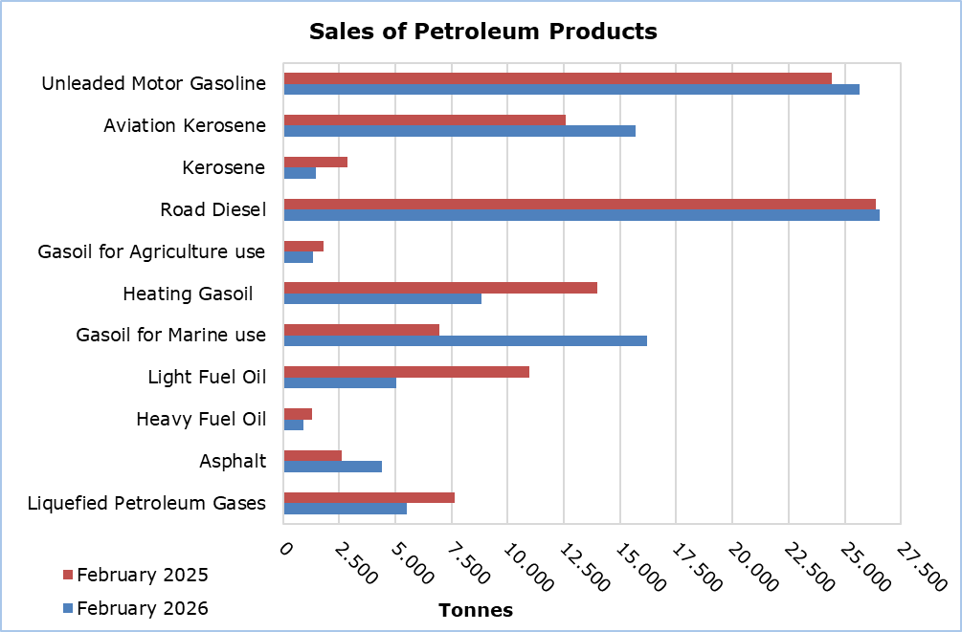

Table 1
Products | Total Sales (tonnes) |  |  |  |  | Percentage Change  (%)
Products | Feb  2026 | Feb  2025 | Jan - Feb 2026 | Jan - Feb 2025 |  | Feb 2026/2025 | Jan - Feb 2026/2025
Unleaded Motor Gasoline | 25.645 | 24.435 | 51.491 | 50.210 |  | 5,0 | 2,6
Aviation Gasoline | 2 | 2 | 3 | 3 |  | 0,0 | 0,0
Aviation Kerosene | 15.698 | 12.568 | 32.413 | 26.137 |  | 24,9 | 24,0
Kerosene | 1.487 | 2.857 | 4.345 | 4.865 |  | -48,0 | -10,7
Road Diesel | 26.550 | 26.376 | 52.692 | 52.931 |  | 0,7 | -0,5
Gasoil for Agriculture Use | 1.333 | 1.819 | 2.942 | 3.542 |  | -26,7 | -16,9
Heating Gasoil | 8.818 | 13.997 | 22.494 | 24.923 |  | -37,0 | -9,7
Gasoil for Marine Use | 16.223 | 6.941 | 32.048 | 12.689 |  | 133,7 | 152,6
Light Fuel Oil | 5.051 | 10.984 | 8.489 | 20.105 |  | -54,0 | -57,8
Heavy Fuel Oil | 929 | 1.290 | 1.743 | 2.216 |  | -28,0 | -21,3
Lubricants | 246 | 243 | 537 | 520 |  | 1,2 | 3,3
Asphalt | 4.425 | 2.610 | 7.856 | 5.642 |  | 69,5 | 39,2
Liquefied Petroleum Gases | 5.515 | 7.638 | 13.329 | 14.529 |  | -27,8 | -8,3
Total | 111.922 | 111.760 | 230.382 | 218.312 |  | 0,1 | 5,5

Table 2
Products | Sales from Filling Stations (tonnes) |  |  |  |  | Percentage Change  (%)
Products | Feb  2026 | Feb  2025 | Jan - Feb 2026 | Jan - Feb 2025 |  | Feb 2026/2025 | Jan - Feb 2026/2025
Unleaded Motor Gasoline | 25.368 | 24.245 | 50.977 | 49.869 |  | 4,6 | 2,2
Kerosene | 1.096 | 2.107 | 3.206 | 3.600 |  | -48,0 | -10,9
Road Diesel | 21.098 | 20.765 | 42.045 | 42.137 |  | 1,6 | -0,2
Gasoil for Agriculture Use | 942 | 1.264 | 2.036 | 2.362 |  | -25,5 | -13,8
Heating Gasoil | 5.378 | 8.807 | 13.968 | 15.593 |  | -38,9 | -10,4
Light Fuel Oil | 45 | 42 | 84 | 87 |  | 7,1 | -3,4
Lubricants | 89 | 96 | 200 | 196 |  | -7,3 | 2,0
Total | 54.016 | 57.326 | 112.516 | 113.844 |  | -5,8 | -1,2

METHODOLOGICAL INFORMATION

Scope and Coverage

The collection of data on Sales and Stocks of Petroleum Products is carried out on a monthly basis.

It concerns the sales of petroleum products from filling stations and the sales to government departments, to the British Bases and the United Nations, to ships and to other customers, as well as the stocks held at the end of each month.

Data Collection

The collection of data is conducted by the Statistical Service on a monthly basis by electronically receiving a purpose-designed questionnaire from each of the petroleum companies.

For more information:
CYSTAT Portal, subtheme Energy
CYSTAT-DB (Online Database)
Predefined Tables (Excel)
Methodological Information

The Predefined Tables, available in Excel format, include data up to December 2022. Data from January 2023 onwards are available only in the CYSTAT-DB Online Database.

Contact
Nafsika Apostolou: Tel.: +35722602199, E-mail: napostolou@cystat.mof.gov.cy

