27 February, 2026

PRESS RELEASE

SALES AND STOCKS OF PETROLEUM PRODUCTS: JANUARY 2026

Annual Change in Sales +11,2%

In January 2026, the total sales of petroleum products amounted to 118.460 tonnes, recording an increase of 11,2% compared to January 2025. A rise was observed in the provisions of marine gasoil (175,3%) and aviation kerosene (23,2%), as well as in the sales of heating gasoil (25,2%), liquefied petroleum gases (13,4%) and asphalt (13,2%). On the contrary, a drop was observed in the sales of light and heavy fuel oil (-62,3% and -12,1%, respectively) and road diesel (-1,6%). The sales of motor gasoline had no significant change (+0,3%). As far as the sales from filling stations are specifically concerned, these have registered a rise of 3,5% to 58.500 tonnes.

The total sales of petroleum products in January 2026 compared to December 2025 recorded a fall of 3,9%. Indicatively, a drop was recorded in the provisions of aviation kerosene (-10,0%) as well as in the sales of motor gasoline (-13,1%) and road diesel (-11,9%) yet, the provisions of marine gasoil increased by 15,6%.

The total stocks of petroleum products at the end of January 2026 fell by 33,0% compared to the end of the previous month.

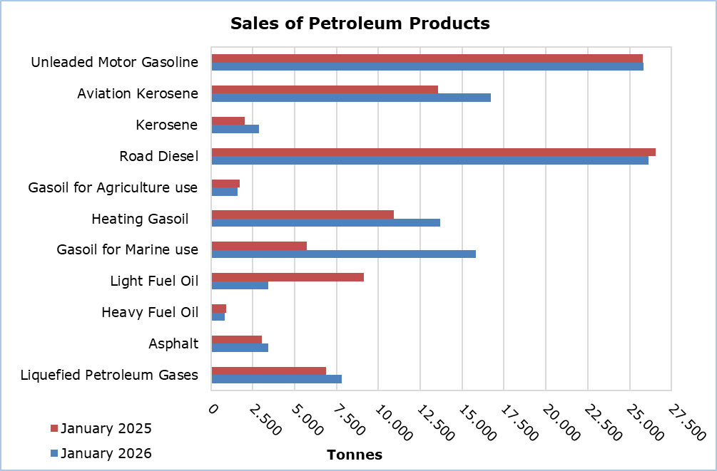

Table 1
Products | Total Sales (tonnes) |  |  |  |  | Percentage Change  (%)
Products | Jan  2026 | Jan  2025 | Jan - Dec 2025 | Jan - Dec 2024 |  | Jan 2026/2025 | Jan - Dec 2025/2024
Unleaded Motor Gasoline | 25.846 | 25.775 | 346.494 | 334.770 |  | 0,3 | 3,5
Aviation Gasoline | 1 | 1 | 19 | 16 |  | 0,0 | 18,8
Aviation Kerosene | 16.715 | 13.569 | 344.885 | 305.158 |  | 23,2 | 13,0
Kerosene | 2.858 | 2.008 | 9.910 | 9.339 |  | 42,3 | 6,1
Road Diesel | 26.142 | 26.555 | 359.043 | 349.513 |  | -1,6 | 2,7
Gasoil for Agriculture Use | 1.609 | 1.723 | 23.369 | 22.164 |  | -6,6 | 5,4
Heating Gasoil | 13.676 | 10.926 | 83.352 | 78.814 |  | 25,2 | 5,8
Gasoil for Marine Use | 15.825 | 5.748 | 164.990 | 86.720 |  | 175,3 | 90,3
Light Fuel Oil | 3.438 | 9.121 | 73.613 | 156.421 |  | -62,3 | -52,9
Heavy Fuel Oil | 814 | 926 | 12.994 | 14.773 |  | -12,1 | -12,0
Lubricants | 291 | 277 | 3.481 | 3.061 |  | 5,1 | 13,7
Asphalt | 3.431 | 3.032 | 43.646 | 37.743 |  | 13,2 | 15,6
Liquefied Petroleum Gases | 7.814 | 6.891 | 57.239 | 55.212 |  | 13,4 | 3,7
Total | 118.460 | 106.552 | 1.523.035 | 1.453.704 |  | 11,2 | 4,8

Table 2
Products | Sales from Filling Stations (tonnes) |  |  |  |  | Percentage Change  (%)
Products | Jan  2026 | Jan  2025 | Jan - Dec 2025 | Jan - Dec 2024 |  | Jan 2026/2025 | Jan - Dec 2025/2024
Unleaded Motor Gasoline | 25.609 | 25.624 | 343.099 | 331.739 |  | -0,1 | 3,4
Kerosene | 2.110 | 1.493 | 7.230 | 7.084 |  | 41,3 | 2,1
Road Diesel | 20.947 | 21.372 | 286.171 | 280.212 |  | -2,0 | 2,1
Gasoil for Agriculture Use | 1.094 | 1.098 | 16.007 | 15.087 |  | -0,4 | 6,1
Heating Gasoil | 8.590 | 6.786 | 48.734 | 46.997 |  | 26,6 | 3,7
Light Fuel Oil | 39 | 45 | 530 | 405 |  | -13,3 | 30,9
Lubricants | 111 | 100 | 1.421 | 1.266 |  | 11,0 | 12,2
Total | 58.500 | 56.518 | 703.192 | 682.790 |  | 3,5 | 3,0

METHODOLOGICAL INFORMATION

Scope and Coverage

The collection of data on Sales and Stocks of Petroleum Products is carried out on a monthly basis.

It concerns the sales of petroleum products from filling stations and the sales to government departments, to the British Bases and the United Nations, to ships and to other customers, as well as the stocks held at the end of each month.

Data Collection

The collection of data is conducted by the Statistical Service on a monthly basis by electronically receiving a purpose-designed questionnaire from each of these companies.

For more information:
CYSTAT Portal, subtheme Energy
CYSTAT-DB (Online Database)
Predefined Tables (Excel)
Methodological Information

The Predefined Tables, available in Excel format, include data up to December 2022. Data from January 2023 onwards are available only in the CYSTAT-DB Online Database.

Contact
Nafsika Apostolou: Tel.: +35722602199, E-mail: napostolou@cystat.mof.gov.cy

