27 April, 2026

PRESS RELEASE

SALES AND STOCKS OF PETROLEUM PRODUCTS: MARCH 2026

Annual Change in Sales +18,6%

In March 2026, the total sales of petroleum products amounted to 127.272 tonnes, recording an increase of 18,6% compared to March 2025. A rise was observed in the provisions of marine gasoil (156,3%) and aviation kerosene (8,6%), as well as in the sales of kerosene (149,5%), heating gasoil (70,9%), asphalt (68,0%), liquefied petroleum gases (50,4%), road diesel (8,0%) and motor gasoline (4,6%). On the contrary, a drop was observed in the sales of heavy and light fuel oil (-65,5% and -48,3%, respectively). As far as the sales from filling stations are specifically concerned, these have registered a rise of 12,5% to 62.528 tonnes.

The total sales of petroleum products in March 2026 compared to February 2026 recorded an increase of 13,7%. Indicatively, an increase was recorded in the provisions of aviation kerosene (16,9%) and marine gasoil (9,1%), as well as in the sales of road diesel (15,7%) and motor gasoline (11,2%). The total stocks of petroleum products at the end of March 2026 increased by 4,1% compared to the end of the previous month.

During the period January – March 2026, the total sales of petroleum products increased by 9,8% compared to the corresponding period of the previous year.

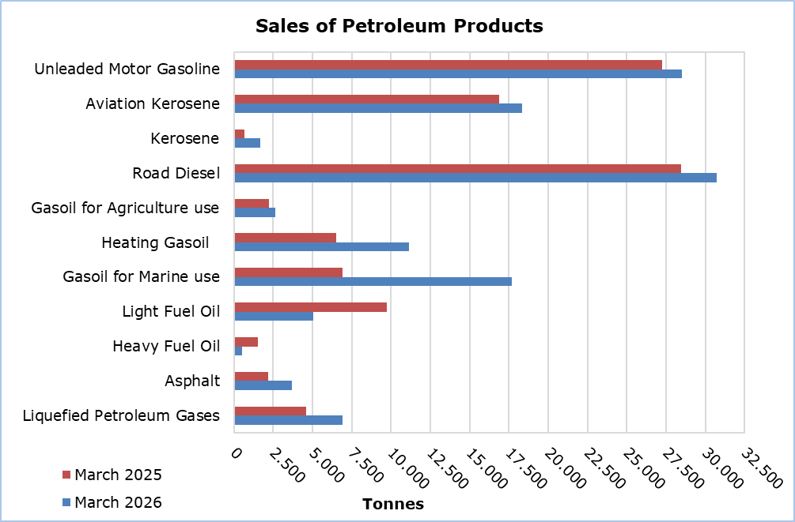

Table 1
Products | Total Sales (tonnes) |  |  |  |  | Percentage Change  (%)
Products | Mar  2026 | Mar  2025 | Jan - Mar 2026 | Jan - Mar 2025 |  | Mar 2026/2025 | Jan - Mar 2026/2025
Unleaded Motor Gasoline | 28.505 | 27.254 | 79.996 | 77.464 |  | 4,6 | 3,3
Aviation Gasoline | 0 | 2 | 3 | 5 |  | -100,0 | -40,0
Aviation Kerosene | 18.353 | 16.896 | 50.766 | 43.033 |  | 8,6 | 18,0
Kerosene | 1.679 | 673 | 6.024 | 5.538 |  | 149,5 | 8,8
Road Diesel | 30.724 | 28.448 | 83.416 | 81.379 |  | 8,0 | 2,5
Gasoil for Agriculture Use | 2.667 | 2.235 | 5.609 | 5.777 |  | 19,3 | -2,9
Heating Gasoil | 11.154 | 6.526 | 33.648 | 31.449 |  | 70,9 | 7,0
Gasoil for Marine Use | 17.703 | 6.906 | 49.751 | 19.595 |  | 156,3 | 153,9
Light Fuel Oil | 5.045 | 9.761 | 13.534 | 29.866 |  | -48,3 | -54,7
Heavy Fuel Oil | 533 | 1.546 | 2.276 | 3.762 |  | -65,5 | -39,5
Lubricants | 301 | 248 | 838 | 768 |  | 21,4 | 9,1
Asphalt | 3.687 | 2.194 | 11.543 | 7.836 |  | 68,0 | 47,3
Liquefied Petroleum Gases | 6.921 | 4.602 | 20.250 | 19.131 |  | 50,4 | 5,8
Total | 127.272 | 107.291 | 357.654 | 325.603 |  | 18,6 | 9,8

Table 2
Products | Sales from Filling Stations (tonnes) |  |  |  |  | Percentage Change  (%)
Products | Mar  2026 | Mar  2025 | Jan - Mar 2026 | Jan - Mar 2025 |  | Mar 2026/2025 | Jan - Mar 2026/2025
Unleaded Motor Gasoline | 28.256 | 27.016 | 79.233 | 76.885 |  | 4,6 | 3,1
Kerosene | 1.287 | 502 | 4.493 | 4.102 |  | 156,4 | 9,5
Road Diesel | 24.001 | 22.606 | 66.046 | 64.743 |  | 6,2 | 2,0
Gasoil for Agriculture Use | 1.886 | 1.464 | 3.922 | 3.826 |  | 28,8 | 2,5
Heating Gasoil | 6.931 | 3.836 | 20.899 | 19.429 |  | 80,7 | 7,6
Light Fuel Oil | 40 | 52 | 124 | 139 |  | -23,1 | -10,8
Lubricants | 127 | 108 | 327 | 304 |  | 17,6 | 7,6
Total | 62.528 | 55.584 | 175.044 | 169.428 |  | 12,5 | 3,3

METHODOLOGICAL INFORMATION

Scope and Coverage

The collection of data on Sales and Stocks of Petroleum Products is carried out on a monthly basis.

It concerns the sales of petroleum products from filling stations and the sales to government departments, to the British Bases and the United Nations, to ships and to other customers, as well as the stocks held at the end of each month.

Data Collection

The collection of data is conducted by the Statistical Service on a monthly basis by electronically receiving a purpose-designed questionnaire from each of the petroleum companies.

For more information:
CYSTAT Portal, subtheme Energy
CYSTAT-DB (Online Database)
Predefined Tables (Excel)
Methodological Information

The Predefined Tables, available in Excel format, include data up to December 2022. Data from January 2023 onwards are available only in the CYSTAT-DB Online Database.

Contact
Nafsika Apostolou: Tel.: +35722602199, E-mail: napostolou@cystat.mof.gov.cy

