27 October, 2026

PRESS RELEASE

SALES AND STOCKS OF PETROLEUM PRODUCTS: SEPTEMBER 2026

Annual Change in Sales +1,5%

In September 2026, the total sales of petroleum products amounted to 146.963 tonnes, recording a rise of 1,5% compared to September 2025. An increase was observed in the provisions of aviation kerosene (1,4%), as well as in the sales of liquified petroleum gases (12,1%), asphalt (5,1%), light fuel oil (1,6%) and motor gasoline (1,5%). On the contrary, a decrease was observed in the provisions of marine gasoil (-3,6%) and in the sales of heating gasoil (-6,0%) and road diesel (-1,4%). As far as the sales from filling stations are specifically concerned, these have increased by 1,7% to 62.557 tonnes.

The total sales of petroleum products in September 2026 compared to August 2026 recorded an increase of 20,8%. Indicatively, a rise was recorded in the provisions of marine gasoil (51,3%) and aviation kerosene (1,9%), as well as in the sales of road diesel (21,4%) and motor gasoline (10,0%). The total stocks of petroleum products at the end of September 2026 dropped by 16,2% compared to the end of the previous month.

During the period January – September 2026, the total sales of petroleum products increased by 0,7% compared to the corresponding period of the previous year.

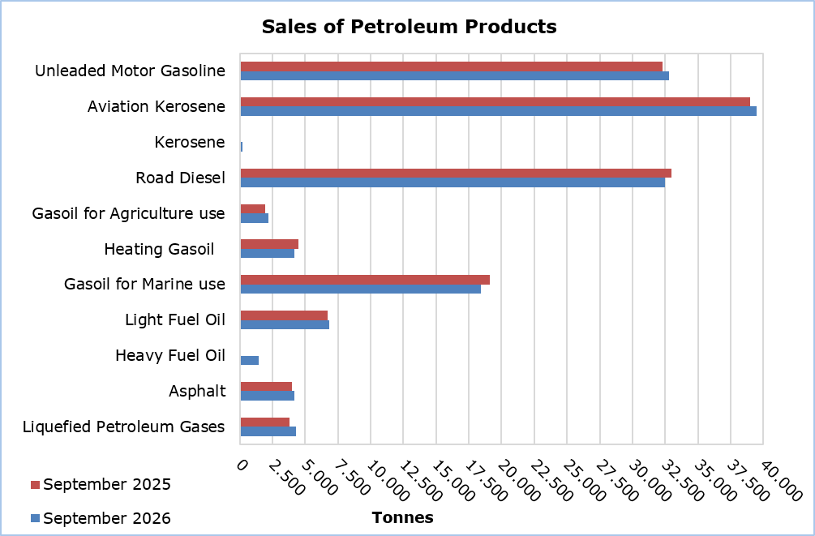

Table 1
Products | Total Sales (tonnes) |  |  |  |  | Percentage Change  (%)
Products | Sep  2026 | Sep  2025 | Jan-Sep 2026 | Jan-Sep 2025 |  | September2026/2025 | Jan-Sep 2026/2025
Unleaded Motor Gasoline | 32.781 | 32.285 | 264.523 | 258.695 |  | 1,5 | 2,3
Aviation Gasoline | 2 | 1 | 12 | 15 |  | 100,0 | -20,0
Aviation Kerosene | 39.514 | 38.987 | 261.140 | 265.718 |  | 1,4 | -1,7
Kerosene | 239 | 116 | 6.955 | 6.263 |  | 106,0 | 11,0
Road Diesel | 32.493 | 32.954 | 268.025 | 268.013 |  | -1,4 | 0,0
Gasoil for Agriculture Use | 2.185 | 1.950 | 17.398 | 17.387 |  | 12,1 | 0,1
Heating Gasoil | 4.196 | 4.462 | 58.172 | 58.321 |  | -6,0 | -0,3
Gasoil for Marine Use | 18.412 | 19.090 | 139.563 | 121.358 |  | -3,6 | 15,0
Light Fuel Oil | 6.854 | 6.743 | 42.027 | 60.314 |  | 1,6 | -30,3
Heavy Fuel Oil | 1.474 | - | 10.831 | 9.287 |  | - | 16,6
Lubricants | 335 | 319 | 2.720 | 2.556 |  | 5,0 | 6,4
Asphalt | 4.178 | 3.977 | 31.205 | 28.651 |  | 5,1 | 8,9
Liquefied Petroleum Gases | 4.300 | 3.836 | 43.598 | 41.690 |  | 12,1 | 4,6
Total | 146.963 | 144.720 | 1.146.169 | 1.138.268 |  | 1,5 | 0,7

Table 2
Products | Sales from Filling Stations (tonnes) |  |  |  |  | Percentage Change  (%)
Products | Sep  2026 | Sep  2025 | Jan-Sep 2026 | Jan-Sep 2025 |  | September2026/2025 | Jan-Sep 2026/2025
Unleaded Motor Gasoline | 32.430 | 31.933 | 261.817 | 256.211 |  | 1,6 | 2,2
Kerosene | 176 | 86 | 5.129 | 4.595 |  | 104,7 | 11,6
Road Diesel | 25.903 | 25.629 | 213.160 | 213.843 |  | 1,1 | -0,3
Gasoil for Agriculture Use | 1.536 | 1.348 | 12.115 | 11.848 |  | 13,9 | 2,3
Heating Gasoil | 2.343 | 2.361 | 34.098 | 33.352 |  | -0,8 | 2,2
Light Fuel Oil | 31 | 47 | 349 | 399 |  | -34,0 | -12,5
Lubricants | 138 | 133 | 1.113 | 1.059 |  | 3,8 | 5,1
Total | 62.557 | 61.537 | 527.781 | 521.307 |  | 1,7 | 1,2

METHODOLOGICAL INFORMATION

Scope and Coverage

The collection of data on Sales and Stocks of Petroleum Products is carried out on a monthly basis.

It concerns the sales of petroleum products from filling stations and the sales to government departments, to the British Bases and the United Nations, to ships and to other customers, as well as the stocks held at the end of each month.

Data Collection

The collection of data is conducted by the Statistical Service on a monthly basis by electronically receiving a purpose-designed questionnaire from each of the petroleum companies.

For more information:
CYSTAT Portal, subtheme Energy
CYSTAT-DB (Online Database)
Predefined Tables (Excel)
Methodological Information

The Predefined Tables, available in Excel format, include data up to December 2022. Data from January 2023 onwards are available only in the CYSTAT-DB Online Database.

Contact
Nafsika Apostolou: Tel.: +35722602199, E-mail: napostolou@cystat.mof.gov.cy

