6 July, 2022

PRESS RELEASE

RESULTS OF THE SERVICES AND TRANSPORT SURVEY 2020

According to the results of the Services and Transport Survey, the tertiary sector of the economy presented a mixed picture in 2020 compared to 2019, with some sectors expanding and other shrinking.

In particular, production value showed a decrease of 9,5% in transportation and storage (sector H), 53,9% in accommodation and food service activities (sector I) and 10,2% in administrative and support service activities (sector N). On the contrary, an increase of 19,1% was displayed in information and communication (sector J), 0,8% in real estate activities (sector L) and 4,4% in professional, scientific and technical activities (sector M).

Value added at current prices recorded a decrease of 27,0% to €653,4 million in transportation and storage, 71,1% to €380,9 million in accommodation and food service activities, 4,8% to €126,1 million in real estate activities and 13,3% to €394,3 million in administrative and support service activities. An increase of 18,8% to €1.645,6 million was observed in information and communication and 1,8% to €1.398,8 million in professional, scientific and technical activities.

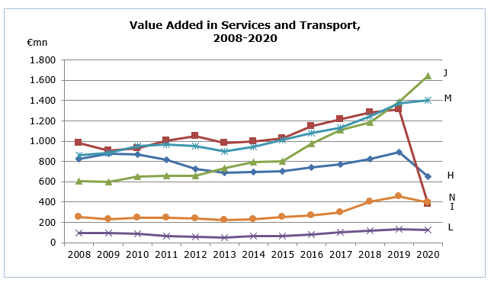

Employment in transportation and storage stood at 16.402 persons recording a decrease of 18,4%, in accommodation and food service activities 36.099 (-29,0%), in real estate activities 2.847 (-1,6%) and in administrative and support service activities 13.980 persons (-5,2%). The number of persons engaged in information and communication increased to 14.090 (+3,9%) and in professional, scientific and technical activities to 32.884 persons (+4,0%).

Table
NACE Rev.2 | Economic Activity | Production Value |  | Value Added at Current Prices |  | Employment
NACE Rev.2 | Economic Activity | €mn | %* | €mn | %* | Number | %*
H | Transportation and Storage | 3.071,6 | -9,5 | 653,4 | -27,0 | 16.402 | -18,4
I | Accommodation and Food Service Activities | 1.206,2 | -53,9 | 380,9 | -71,1 | 36.099 | -29,0
J | Information and Communication | 5.543,1 | 19,1 | 1.645,6 | 18,8 | 14.090 | 3,9
L | Real Estate Activities | 210,4 | 0,8 | 126,1 | -4,8 | 2.847 | -1,6
M | Professional, Scientific and Technical Activities | 2.560,8 | 4,4 | 1.398,8 | 1,8 | 32.884 | 4,0
N | Administrative and Support Service Activities | 665,1 | -10,2 | 394,3 | -13,3 | 13.980 | -5,2
* Annual percentage change of 2020 compared to 2019.

METHODOLOGICAL INFORMATION

Definitions

Employment – The average number of all persons employed during the year, in full time equivalent terms.

Production value – The value of services produced, net receipts from the sale of goods sold in the same condition as purchased and other income.

Value added at current prices – Derived by deducting from the production value the production expenses as well as the administrative expenses and rents paid for buildings and machinery.

Coverage and collection of data

The Services and Transport Survey is carried out on an annual basis and covers enterprises with the main activity falling under sections H (Transportation and storage), I (Accommodation and food service activities), J (Information and communication), L (Real estate activities), M (Professional, scientific and technical activities) and N (Administrative and support service activities) of the classification system of economic activities NACE Rev. 2 of the European Union.

The Survey for 2020 covered a sample of around 2.610 enterprises. The collection of data by the Statistical Service was done with the use of a special questionnaire.

For more information:
CYSTAT Portal, subtheme Services
Predefined Tables (Excel)
Methodological Information

Contact
Margarita Georgiou: Tel: +35722602217, Email: mgeorgiou@cystat.mof.gov.cy
Kalomyra Frangou: Tel: +35722602220, Email: kfrangou@cystat.mof.gov.cy

