8 July, 2025

PRESS RELEASE

RESULTS OF THE SERVICES AND TRANSPORT SURVEY 2023

Large increase in all sectors of economic activity

According to the results of the Services and Transport Survey, the tertiary sector of the economy registered in 2023 a positive growth rate compared to 2022.

In particular, production value during 2023 showed an increase of 6,7% in transportation and storage (sector H), 20,5% in accommodation and food service activities (sector I), 17,4% in information and communication (sector J), 16,3% in real estate activities (sector L), 10,0% in professional, scientific and technical activities (sector M), 16,9% in administrative and support service activities (sector N), 10,9% in education (sector P), 8,7% in human health and social work activities (sector Q), 13,3% in arts, entertainment and recreation (sector R) and 9,3% in other service activities (sector S).

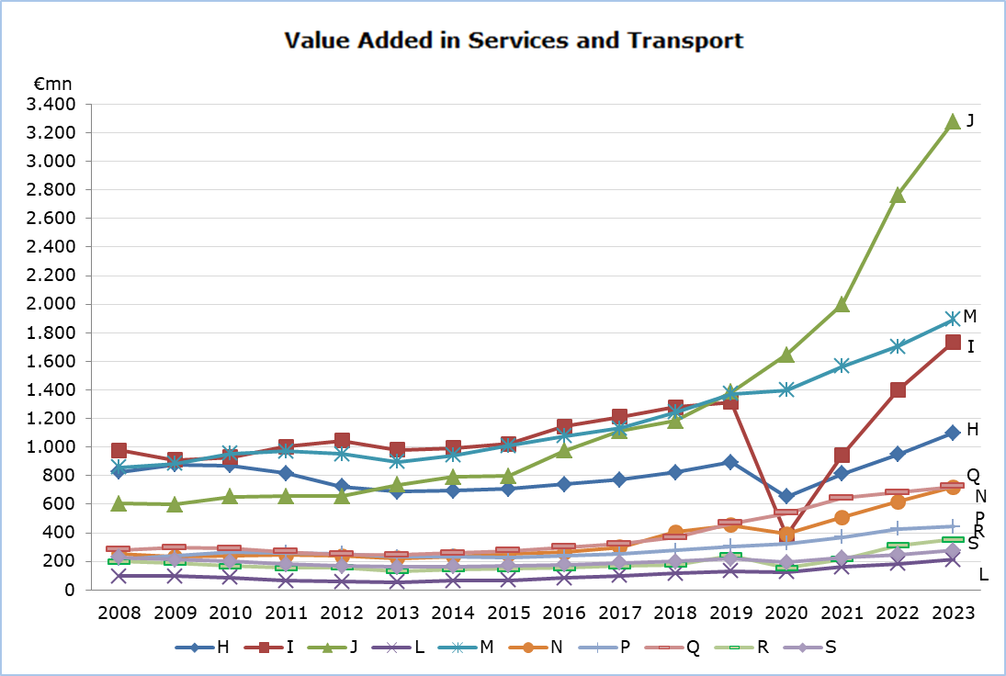

Regarding the value added at current prices, increases were recorded in all sectors. Notable increases were recorded in accommodation and food service activities by 24,3%, reaching €1.736,9 million and in information and communication by 18,6% to €3.277,7 million. Significant increases were also observed in administrative and support service activities by 16,5% to €719,4 million, in transportation and storage by 15,8% to €1.099,5 million and in real estate activities by 15,6% to €213,0 million.

In 2023, employment increased in all economic sectors. The highest employment is registered in accommodation and food service activities with 56.483 persons, followed by professional, scientific, and technical activities with 41.667 persons, information and communication with 26.258 persons, transportation and storage with 22.482 persons and administrative and support service activities with 19.939 persons.

Table: Main Aggregates for 2023
NACE Rev.2 | Economic  Activity | Employment |  | Production Value |  | Value Added at Current Prices
NACE Rev.2 | Economic  Activity | Number | %* | €mn | %* | €mn | %*
H | Transportation and Storage | 22.482 | 8,7 | 5.105,7 | 6,7 | 1.099,5 | 15,8
I | Accommodation and Food Service Activities | 56.483 | 8,1 | 3.682,0 | 20,5 | 1.736,9 | 24,3
J | Information and Communication | 26.258 | 24,9 | 12.064,6 | 17,4 | 3.277,7 | 18,6
L | Real Estate Activities | 4.318 | 14,4 | 360,9 | 16,3 | 213,0 | 15,6
M | Professional, Scientific and Technical Activities | 41.667 | 8,8 | 3.842,5 | 10,0 | 1.894,6 | 11,1
N | Administrative and Support Service Activities | 19.939 | 11,1 | 1.294,2 | 16,9 | 719,4 | 16,5
P | Education | 13.211 | 5,7 | 783,2 | 10,9 | 443,9 | 3,6
Q | Human Health and Social Work Activities | 17.731 | 5,5 | 1.190,8 | 8,7 | 724,2 | 6,2
R | Arts, Entertainment and Recreation | 9.195 | 17,2 | 735,6 | 13,3 | 353,8 | 13,7
S | Other Service Activities | 13.426 | 5,4 | 469,0 | 9,3 | 275,6 | 10,8

* Annual percentage change of 2023 compared to 2022.

METHODOLOGICAL INFORMATION

Definitions

Employment – The average number of employees and self-employed persons during the year, in full time equivalent terms.

Production value – The value of services and goods produced, net receipts from the sale of goods sold in the same condition as purchased, other operating income and changes in the value of work-in-progress at the end of the year.

Value added at current prices – Derived by deducting from the production value the production expenses as well as the administrative expenses and rents paid for buildings and machinery.

Coverage and collection of data

The Services and Transport Survey is carried out on an annual basis and covers enterprises with the main activity falling under sectors H (Transportation and storage), I (Accommodation and food service activities), J (Information and communication), L (Real estate activities), M (Professional, scientific and technical activities), N (Administrative and support service activities), P (education), Q (Human Health and Social Work Activities), R (Arts, Entertainment and Recreation) and S (Other Service Activities) of the classification system of economic activities NACE Rev. 2 of the European Union.

The Survey for 2023 covered a sample of around 4.000 enterprises. The collection of data by the Statistical Service is done by email, by personal interviews, by phone interviews and using administrative sources.

For more information:
CYSTAT Portal, subtheme Services
Predefined Tables (Excel)
Methodological Information

Contact
Margarita Georgiou: Tel: +35722602217, Email: mgeorgiou@cystat.mof.gov.cy
Kalomyra Frangou: Tel: +35722602220, Email: kfrangou@cystat.mof.gov.cy

