5 March, 2025

**PRESS RELEASE**

TURNOVER VALUE INDEX OF SERVICES: **4th QUARTER 2024**

The Turnover Value Index during the fourth quarter of 2024 recorded increases in the sectors of accommodation and food service activities (8,9%), administrative and support service activities (7,0%), information and communication activities (6,5%), real estate activities (5,0%) and professional, scientific and technical activities (3,7%) compared to the corresponding quarter of 2023.

During the period January-December 2024, increases relative to the corresponding period of 2023 were observed in the Turnover Value Indices of administrative and support service activities (8,9%), accommodation and food service activities (8,2%), information and communication (8,0%), real estate activities (6,5%) and professional, scientific and technical activities (2,5%).

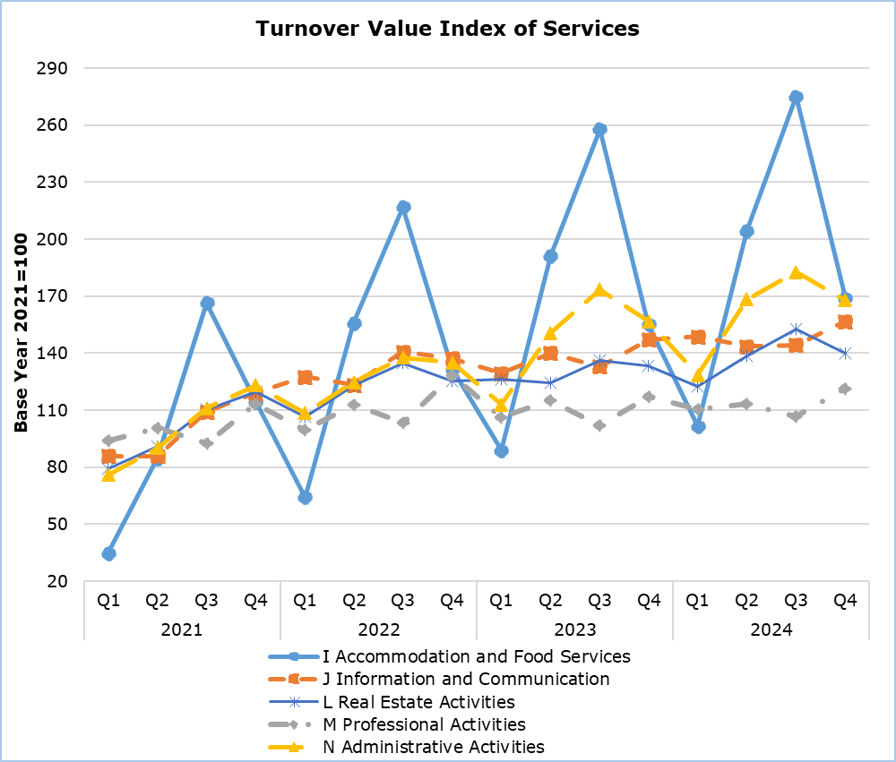

|  |  |  |  |  |  |  |
| --- | --- | --- | --- | --- | --- | --- |
| **Table 1** |  |  | |  |  | |
| **Code NACE Rev. 2** | **Sector of Economic Activity** | **Turnover Value Index**  **(2021=100)** | |  | **Percentage Change (%)** | |
| **Oct-Dec 2023** | **Oct-Dec 2024** |  | **Oct-Dec 2024/2023** | **Jan-Dec 2024/2023** |
| **I** | Accommodation and food service activities (hotels & restaurants) | 155,1 | 168,9 |  | 8,9 | 8,2 |
| **J** | Information and communication | 147,1 | 156,7 |  | 6,5 | 8,0 |
| **L** | Real estate activities | 133,3 | 140,0 |  | 5,0 | 6,5 |
| **M** | Professional, scientific and technical activities | 117,1 | 121,5 |  | 3,7 | 2,5 |
| **N** | Administrative and support service activities | 156,8 | 167,7 |  | 7,0 | 8,9 |

|  |  |  |  |
| --- | --- | --- | --- |
| **Table 2** | | | |
| **Code NACE Rev. 2** | **Division of Economic Activity** | **Percentage Change (%)** | |
| **Oct-Dec 2024/2023** | **Jan-Dec 2024/2023** |
| **I 55** | Accommodation | 8,5 | 8,5 |
| **I 56** | Food and beverage service activities | 9,2 | 7,9 |
| **J 58** | Publishing activities | 0,4 | 6,2 |
| **J 59** | Motion picture, video and television programme production, sound recording and music publishing | -0,3 | 2,5 |
| **J 60** | Programming and broadcasting activities | 3,9 | 3,5 |
| **J 61** | Telecommunications | 3,8 | 3,6 |
| **J 62** | Computer programming, consultancy and related activities | 9,1 | 7,7 |
| **J 63** | Information service activities | 39,5 | 51,8 |
| **L 68** | Real estate activities | 5,0 | 6,5 |
| **M 69** | Legal and accounting activities | -3,2 | -3,1 |
| **M 70** | Activities of head offices; management consultancy activities | 5,4 | 5,2 |
| **M 71** | Architectural and engineering activities; technical testing and analysis | 4,0 | 4,9 |
| **M 73** | Advertising and market research | 8,9 | 3,9 |
| **M 74** | Other professional, scientific and technical activities | -4,8 | 6,9 |
| **N 77** | Rental and leasing activities | 3,0 | 6,7 |
| **N 78** | Employment activities | 8,1 | 6,0 |
| **N 79** | Travel agency, tour operator reservation service and related activities | 20,3 | 10,0 |
| **N 80** | Security and investigation activities | 5,2 | 10,9 |
| **N 81** | Services to buildings and landscape activities | 10,7 | 8,6 |
| **N 82** | Office administrative, office support and other business support activities | 4,8 | 10,8 |

**METHODOLOGICAL INFORMATION**

**Scope**

The purpose of the Turnover Value Index in Services is to monitor short-term developments in activities classified under the sectors of accommodation and food service activities (NACE I), information and communication (NACE J), real estate activities (NACE L), professional, scientific and technical activities (NACE M) and administrative and support service activities (NACE N).

**Data Collection**

The Statistical Service collects data monthly by telephone enquiries or e-mail, from a sample of enterprises active in the sectors mentioned above.

**Compilation Method**

The Index is using 2021 as the base year, meaning that it shows the quarterly changes in turnover in relation to the quarterly turnover average of the year 2021. In the base year, the average of the Turnover Index for the four quarters is 100,0. For example, a quarterly Turnover Index of 105,3 means that the turnover for the specific quarter has increased by 5,3% in relation to the average quarterly turnover of 2021. The Index is calculated at current prices.

The Turnover Index is produced for the various divisions of the Statistical Classification of Economic Activities (NACE Rev. 2) that constitute the services sector. The aggregated sector indices are a weighted average of the indices of the various divisions, as defined in NACE Rev. 2. The weights used are derived from the results of the annual Services Survey in the base year (2021) and reflect the share of turnover of each division in relation to the total turnover of the activities of each sector.

The compilation of the Index follows the provisions of Regulation (EU) 2019/2152 on European business statistics. The Index is transmitted to the Statistical Office of the European Union (Eurostat). In addition to gross data, both seasonally and calendar adjusted data are transmitted. The Indices are published at national level only in their gross form.

***For more information:***

CYSTAT Portal, subtheme [Services](https://www.cystat.gov.cy/en/SubthemeStatistics?s=50)

[CYSTAT-DB](https://cystatdb.cystat.gov.cy/pxweb/en/8.CYSTAT-DB/8.CYSTAT-DB__Services__) (Online Database)

[Predefined Tables](https://www.cystat.gov.cy/en/KeyFiguresList?s=50) (Excel)

[Methodological Information](https://www.cystat.gov.cy/en/MethodologicalDetails?m=2310)

**Data for base year 2021=100 are available only in the CYSTAT-DB Online Database.**

*Contact*  
Panagiotis Lymperopoulos: Tel: +357 22605130, E-mail: [plymperopoulos@cystat.mof.gov.cy](mailto:plymperopoulos@cystat.mof.gov.cy)