11 May, 2026

PRESS RELEASE

STATE EMPLOYEES BY CATEGORY: APRIL 2026

Total Employment: 55.571

In April 2026, the total number of State Employees reached 55.571, recording an increase of 81 employees (0,1%) compared to April 2025. Employment in the Civil Service declined by 1,0%, while it increased by 1,7% in the Educational Service and remained stable in the Security Forces.

Compared to April 2025, the largest increase in total State Employees is observed in the category of employees with contracts of indefinite duration (1,8%) and the largest decrease is observed in the category of employees with contracts of definite duration (-2,3%). Focusing on employee categories by Service, the largest percentage increase in employment is recorded in employees with contracts of indefinite duration in the Educational Service (24,8%), while the largest percentage decrease in employment is observed for employees with contracts of definite duration in the Security Forces (-86,9%).

It is noted that the significant decrease observed in the number of employees with contracts of definite duration in the Security Forces (-86,9%) is mainly attributed to the completion and non-renewal of specific definite duration contracts in July 2025.

For the period January – April 2026 the average total number of State Employees increased by 0,2% compared to the corresponding period of 2025.

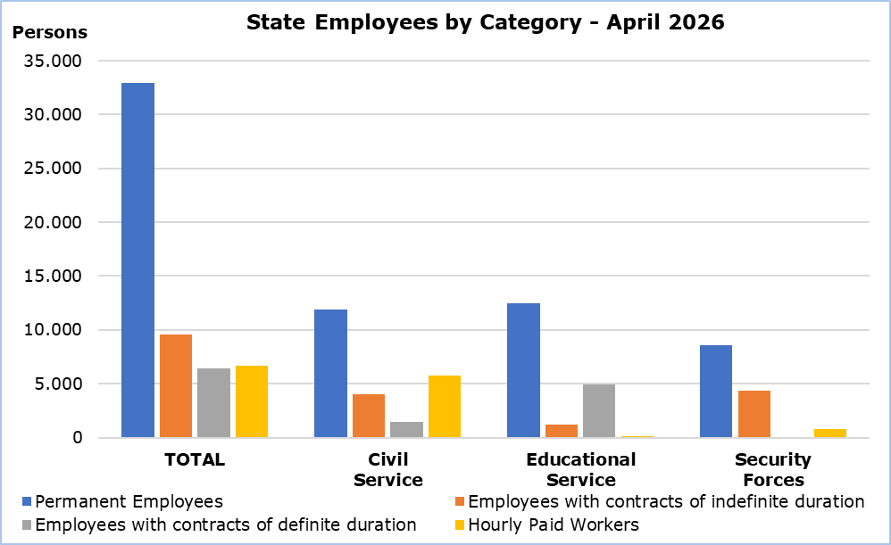

Table
Personnel Category |  | Number of Persons |  |  | Change (%)
 |  | Apr  2025 | Apr  2026 |  | Apr 26/ Apr 25 | Jan–Apr 26/ Jan-Apr 25
Civil Service | Total | 23.357 | 23.122 |  | -1,0 | -0,9
Civil Service | Permanent Employees | 11.960 | 11.926 |  | -0,3 | -0,5
Civil Service | Employees with contracts of indefinite duration | 4.141 | 4.024 |  | -2,8 | -3,0
Civil Service | Employees with contracts of definite duration | 1.458 | 1.441 |  | -1,2 | 1,9
Civil Service | Hourly Paid Workers | 5.798 | 5.731 |  | -1,2 | -1,0
Educational  Service | Total | 18.373 | 18.693 |  | 1,7 | 1,8
Educational  Service | Permanent Employees | 12.461 | 12.440 |  | -0,2 | -0,1
Educational  Service | Employees with contracts of indefinite duration | 947 | 1.182 |  | 24,8 | 24,8
Educational  Service | Employees with contracts of definite duration | 4.824 | 4.924 |  | 2,1 | 2,4
Educational  Service | Hourly Paid Workers | 141 | 147 |  | 4,3 | 1,4
Security  Forces | Total | 13.760 | 13.756 |  | 0,0 | -0,2
Security  Forces | Permanent Employees | 8.430 | 8.583 |  | 1,8 | 1,6
Security  Forces | Employees with contracts of indefinite duration | 4.304 | 4.352 |  | 1,1 | 1,1
Security  Forces | Employees with contracts of definite duration | 267 | 35 |  | -86,9 | -86,1
Security  Forces | Hourly Paid Workers | 759 | 786 |  | 3,6 | 3,6
Total | Total | 55.490 | 55.571 |  | 0,1 | 0,2
 | Permanent Employees | 32.851 | 32.949 |  | 0,3 | 0,2
 | Employees with contracts of indefinite duration | 9.392 | 9.558 |  | 1,8 | 1,7
 | Employees with contracts of definite duration | 6.549 | 6.400 |  | -2,3 | -1,5
 | Hourly Paid Workers | 6.698 | 6.664 |  | -0,5 | -0,4

METHODOLOGICAL INFORMATION

Coverage

State Employees include the Civil Service, Educational Service and Security Forces staff. Civil Service includes employees of the Ministries, Departments and Services. Educational Service includes the employees of school units and the staff of the Cyprus Productivity Center and the Higher Hotel Institute of Cyprus. Security Forces include the Police Service, Fire Service and the National Guard staff. In all three categories the employees are classified in permanent employees, employees with contracts of indefinite and definite duration and hourly paid workers (regular, casual and seasonal staff).

The members of the House of Representatives are not included in the data.

Collection of Data

Data concerning State Employees is provided by the Treasury of the Republic and refers to the number of persons that were paid in the current month, irrespective of the period and duration of employment.

Break in the Series

As from January 2024 the classification for permanent and casual staff was discontinued. CYSTAT has adjusted the structure of government personnel to permanent, employees with contracts of indefinite duration, employees with contracts of definite duration and hourly paid workers. Therefore, there is a break in the series and data from previous months are not comparable.

Definitions

As of March 2026, the term “Government” has been replaced by the term “State Employees” for greater accuracy. The methodology and the comparability of the data over time are not affected.

For more information:
CYSTAT Portal, subtheme Labour Market
CYSTAT-DB (Online Database)
Methodological Information

Contact
Maria Kkoushi: Tel: +357-24205857, Email: mkkoushi@cystat.mof.gov.cy

